Easy Staircase

15 min 1 participant

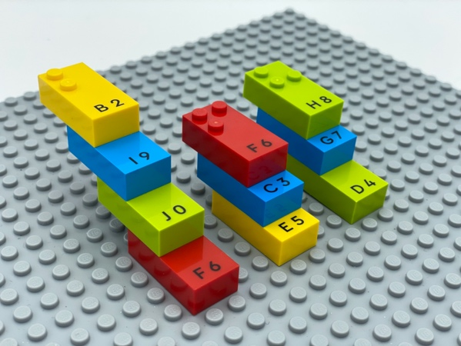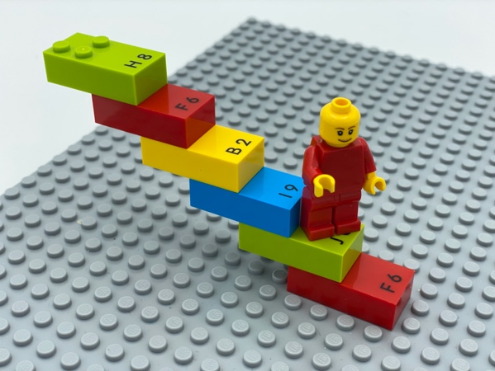

Let’s play
- Build a staircase with smooth steps on the base plate.
- Make it as high as possible.
- Climb the staircase with a LEGO mini figure or your fingers!

How to prepare
- 1 base plate
- 16 bricks randomly chosen from the first decade "A" to " J". These bricks provide the largest flat space because they contain only the first 2 rows of dots - 1, 2, 4, 5
- 1 bowl
- 1 LEGO mini figure
Place the bricks in the bowl.

Facilitation tips
- The depth of the steps may vary (1 stud or 2), depending on staircase assembly.
- Ask “Where does your staircase go?”.
- Suggest finding a real staircase to feel the flat steps.

Possible variations
- Use only letter “G" (easy to feel the difference between the portion with studs and the portion without).
- Change the bricks: letters with dot 3 and dot 6 provide the smallest space for steps.

Children will develop these holistic skills
- COGNITIVE - Recognize and use notions of alignment, right angle, equality of lengths, middle, symmetry
- PHYSICAL - Explore and investigate to get information about the tactual properties of an object
- PHYSICAL - Organize: find objects, sort or categorize by placement, function, attribute
- EMOTIONAL - Control motor skills and emotional commitment to succeed in simple actions

Did you know
- Children have different learning interests and needs. A great facilitator combines practices - free play, guided play and instruction - to meet children where they are and support their continued desire to grow and learn through play.

