Add, subtract, multiply

20 min 2 participants

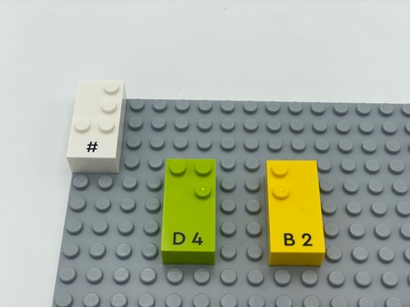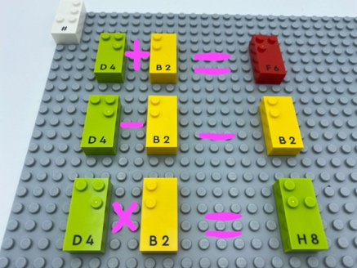

Let’s play
- Take 2 bricks.
- Add their numbers (the answer can be said or written).
- Subtract them.
- Multiply them.

How to prepare
- 1 base plate
- Number bricks
- 1 number sign brick
- 1 bowl
Number sign is located on the top left corner of the base plate to indicate the bricks represent numbers.
Place all the other bricks in the bowl.

Facilitation tips
- This activity can be:
  - A math exercise,
  - A competitive game, between 2 or more children,
  - A warm-up activity for the whole class,
- Ask “How can you more efficiently perform this activity?”.

Possible variations
- Add a timer.
- The child takes 4 bricks and carries out the activity with two 2-digit numbers.

Children will develop these holistic skills
- COGNITIVE - Calculate with numbers: add and subtract numbers with up to 3 digits and use multiplication tables to multiply and divide.
- PHYSICAL - Learn through action, observation, analysis of personal action and observed activity: appropriate methods and tools to learn.
- SOCIAL - Plan and carry out routine or non-routine activities requiring multiple steps
- EMOTIONAL - Follow courteous behavior.

Did you know
- Learning goes beyond memorizing academic content, by highlighting that children need to develop a breadth of skills. A holistic approach which also includes their physical, social, emotional, cognitive and creative skills is essential.

