Find 2-Stud Bricks
10 min 1 participant

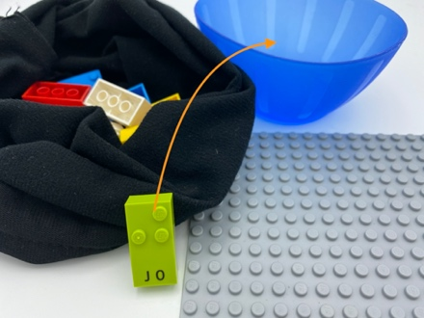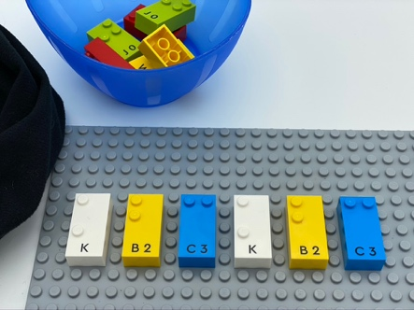

Let’s play
- Pick a random brick from the bag.
- If it is a 2-stud bricks, attach it the to the base plate.
- If not, place it inside the bowl.

How to prepare
- 1 base plate
- 6 bricks with only 2 studs (e.g. “B”, “C”, “E”, “I”, “K”)
- 6 bricks with greater or less than 2 studs
- 1 bowl
- 1 bag
Hide the 12 bricks in the bag.

Facilitation tips
- Make sure the child uses both his hands during the activity: they need to practice two-hand movements as good bilateral coordination is essential for braille reading.
- Encourage light tactile exploration of the bricks. You can say: “You will feel much better the stud if you caress them than if you crush your finger on it”.
- Choose an easier preparation mode: use another bowl instead of the bag, place all the bricks on the base plate at the beginning (no bag, just 1 bowl).

Possible variations
- Change the number of studs on the bricks.
- Repeat the activity selecting 2 and 3-stud bricks.
- Add more bricks with greater or less than 2 studs in the bag.
- Peer play: take in turns, search the bag for a brick with a specific number of studs. If it’s correct, attach it to the base plate.

Children will develop these holistic skills
- COGNITIVE - Use numbers to count, organize, locate, compare
- CREATIVE – Reproduce, assemble, organize, link graphic patterns and then create new ones
- PHYSICAL – Locate objects by touch: intentionally search for an object
Explore and investigate to get information about the tactual properties of an object

Did you know
- To read in braille with efficiency, it is important to have a light touch: the sensory cells of the fingertip should not be crushed in order to get the best results.
- Children can practice spatial skills through playful activities, including block building, puzzle games and playing with materials of all kinds of shapes and sizes, and benefit from adults joining and supporting their play.

