Even, Odd Numbers

10 min 1 participant

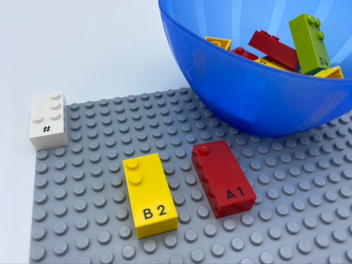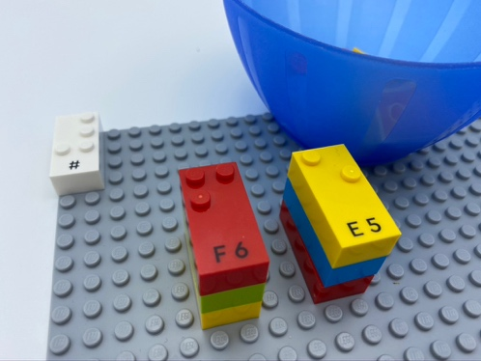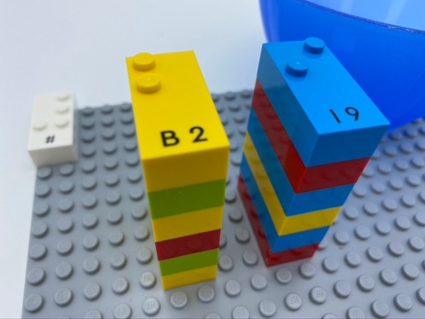

Let’s play
- Pick a number from the bowl.
- Read the number and say whether it is an even number or an odd number.
- Build 2 towers on the base plate: one with even, the other with odd.

How to prepare
- 1 base plate
- 1 bowl
- 12 number bricks (6 odds, 6 evens)
- 1 number sign brick
Place the number sign brick in the top left corner of the base plate to indicate the bricks are numbers.
Place the remaining bricks in the bowl.

Facilitation tips
- Explain that we are not going to put the number sign in front of each brick. The number sign in the top left corner of the base plate indicates that all the bricks are numbers.
- Ask “How can you make the activity more fun?”.
- Ask “How can you do this activity with friends?”.

Possible variations
- Change the number or selection of bricks.
- Use a brick that doesn't fit the pattern e.g. a brick that doesn't represent a number.
- Use a timer.
- Encourage collaborative play with peers.

Children will develop these holistic skills
- COGNITIVE - Calculate with numbers: recognize odd and even numbers
- EMOTIONAL - Know the purpose of the activity
- CREATIVE - Identify various leisure activities to be done alone or with other people
- SOCIAL - Plan and carry out routine or non-routine activities requiring multiple steps

Did you know
- Inherently joyful and iterative nature of playful activities appears to fuel and boosts children’s engagement and learning.

