Train Track

10 min 1 participant

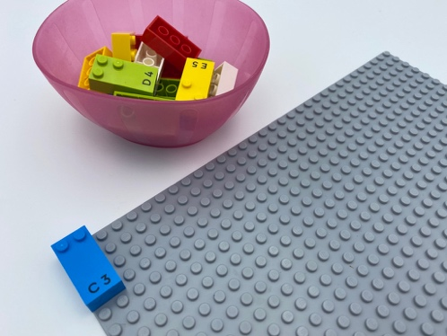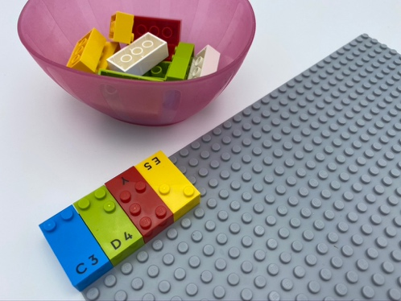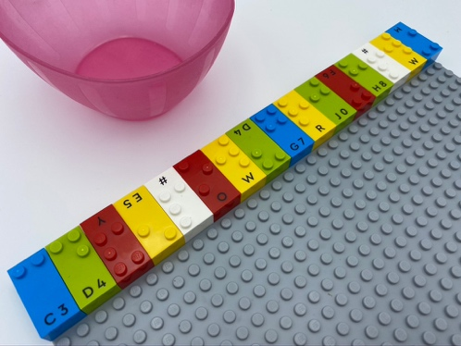

Let’s play
- Add bricks to finish the long train track at the top of the base plate.
- Pretend your finger is a train moving along the track.

How to prepare
- 1 base plate
- 16 bricks
- 1 bowl
Place one brick on the base plate: reading position, at the top left corner, to begin the train track.

Facilitation tips
- Ask “Where is the train going?”.
- Affix the base plate to the wall in a vertical plane to change perspective and facilitate understanding spatial notion.

Possible variations
- Change the starting number of bricks.
- Add more tracks.

Children will develop these holistic skills
- PHYSICAL - Learn through action, observation, analysis of personal actions and observed activity: repeat a gesture for stabilization and effectiveness
- EMOTIONAL - Control motor skills and emotional commitment to succeed in simple actions
- CREATIVE - Utilize adapted games/materials during free time
- COGNITIVE - Recognize size concepts and relationships: length, width, height
- SOCIAL - Comply with directions and limits from adults

Did you know
- Children have different learning interests and needs, and a great facilitator combines practices (free play, guided play and instruction) to meet children where they are and support them to grow.

