Numbers Staircase

20 min 1 participant

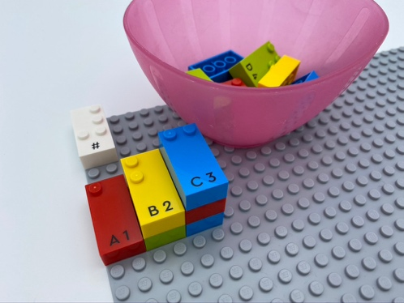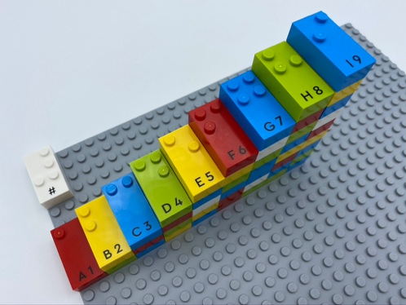

Let’s play
- Find the number “1” brick in the bowl and begin to build a staircase using it as the first step.
- Continue building the staircase with the bricks from the box and the bowl. The top brick of each step must be the number brick equal to the number of bricks in the step.
- Check to be sure the steps are numbered “1” to “9”.

How to prepare
- 1 base plate
- All the bricks
- 1 number sign brick
- 1 bowl
Place 9 number bricks (”1” to “9”) in the bowl.
Place number sign in the top left corner of the base plate to indicate the bricks represent numbers.

Facilitation tips
- Ask “What strategy did you use to build the staircase?”.
- Ask “What could you find at the top of the staircase?”.
- Propose collaboration.

Possible variations
- Change the size of the staircase.
- Begin with a number “9” step and build downward.
- Use only number bricks requiring all bricks in each step to be the same number.

Children will develop these holistic skills
- COGNITIVE – Use the number to show a rank, a position
Identify the braille characters: numerals 0-9
- SOCIAL - Cooperate and share: organize work in a group to develop a common task and/or collective production and make own skills and knowledge available to others
- PHYSICAL - Recognize and discriminate SIZE by touch: compare sizes; sort by sizes

Did you know
- Socially interactive activities involve learners working together in groups, using strategies that have been designed to maximize the benefit of cooperative learning.

