Listen and Pick a Letter

10 min 2 participants

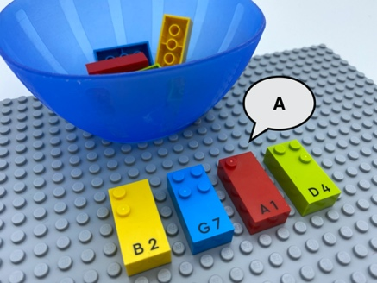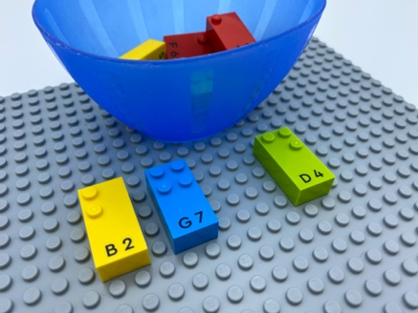

Let’s play
Player 1
- Pick 4 bricks from the bowl and place them near each other on the base plate.
- Read the letters silently.
- Make the sound of one of the 4 letters.
- Pass the base plate to player 2.
Player 2
- Find the letter matching the sound made by player 1.
- Read it aloud.
- Remove the brick.

How to prepare
- 1 base plate
- 10 letter bricks (“A” to “J”)
- 1 bowl
Place the bricks in the bowl.

Facilitation tips
- Allow enough time for brick exploration.
- Choose letters of a child’s name, common object (p for piano, t for table…).
- Reminder: letters can make multiple sounds.

Possible variations
- Place bricks in different arrangements.
- Change the number of letters.
- Change the number of players or work in pairs.
- Choose letters relative to current curriculum.
- Make a sound and find the matching letter in the bowl.

Children will develop these holistic skills
- COGNITIVE - Identify letters and their order; and then, depending on the letter, its sound value
- CREATIVE - Make the sound of a letter and count the phonic syllables of a word
Explore vocal sounds
- EMOTIONAL - Solicit information/assistance from appropriate persons in various settings

Did you know
An iterative activity gives learners the opportunity to explore and investigate new concepts: to try, and fail, and try again. They can also share their ideas with each other and revise them.

