3-Digit Number Rectangle

15 min 1 participant

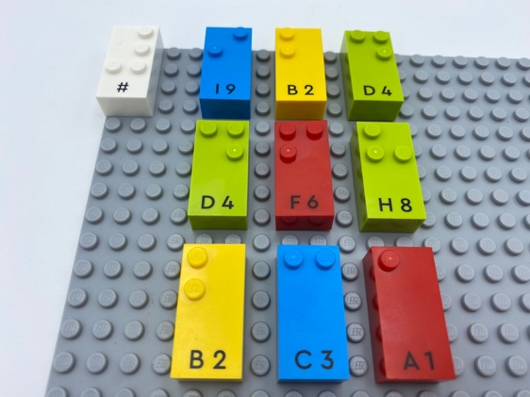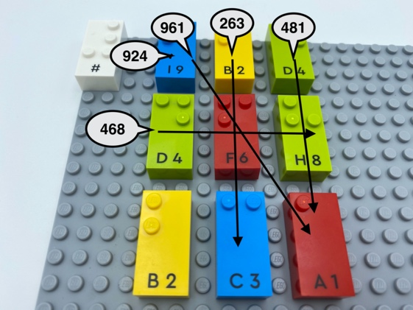

Let’s play
- Find and read all the 3-digit numbers in the rectangle: they can be read in row, column or diagonal format.

How to prepare
- 1 base plate
- 9 random number bricks (some may be the same number)
- 1 number sign brick
Make a 3 by 3 grid on the base plate with the 9 bricks leaving spaces between for easier reading the numbers.
Place the number sign brick in the top left corner of the base plate to indicate the bricks are numbers.

Facilitation tips
- Tactile examination of the bricks requires more time than visual perception. Allow plenty of time for exploration!
- Ask “How can you make this activity more fun? More interactive?”.
- Ask “How can you play this activity with your friends?”.

Possible variations
- Change the number of bricks.
- Change instructions: read the 3-digit numbers backwards, find a prime number, the largest/smallest 3-digit number, a multiple of 5, only numbers that include the middle brick …

Children will develop these holistic skills
- COGNITIVE – Use the number to show a rank, a position: recognize the place value of each digit in a four-digit number (thousands, hundreds, tens, and ones)
- COGNITIVE – Learn how to track with fingers: a line of dots from left to right, rows of dots, a line of braille and locate the next line, using two hand separately
- PHYSICAL - Learn through action, observation, analysis of personal action and observed activity: appropriate methods and tools to learn; learn to preplan actions
- EMOTIONAL - Follow courteous behavior

Did you know
- Despite numeracy being serious business, it can be learned in many playful engaging ways.

