Pick a Number!

20 min 2 participants

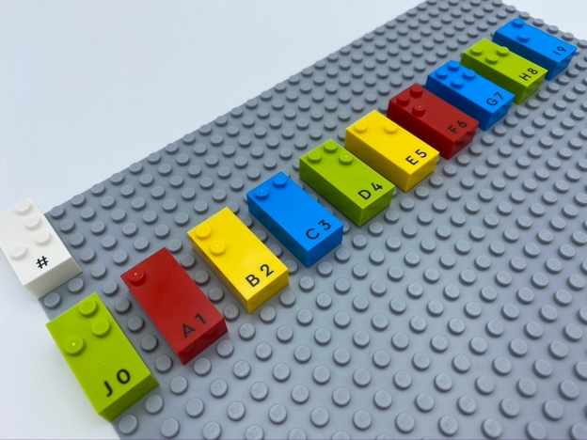

Let’s play
Player 1
- Think of a number between 0 and 9 in your head.
- Clap your own hands together equal to the number you have in mind.
Player 2
- Count the claps.
- Find the brick matching the number of claps.
Both players
- Discuss the answer.

How to prepare
- 1 base plate
- 10 number bricks “0” to “9”
- 1 number sign brick
Place number sign in the top left corner of the base plate to indicate the bricks represent numbers.
Align bricks from “0” to “9” on the base plate horizontally.

Facilitation Tips
- Ask “How do you identify bricks representing numbers? How do you know they are not letters?”.
- Allow enough time for brick exploration.

Possible variations
- Change the number of bricks.
- Remove bricks once identified.
- Place the bricks randomly on the base plate.
- Play “Simon Says” style. If Player 1 says “Simon Says” before clapping, Player 2 must find the correct brick, if Player 1 does not say “Simon Says”, Player 2 does nothing.

Children will develop these holistic skills
- COGNITIVE - Name, read, write and represent numbers
Identify the braille characters: numerals 0-9
- SOCIAL - Ask relevant questions to extend understanding and knowledge
- PHYSICAL - Identify spatial relationship within a braille cell, a line, a page

Did you know
- Numeracy is not only about numbers: it also relies on self-regulation or executive functions and spatial skills.

