Fence

15 min 1 participant

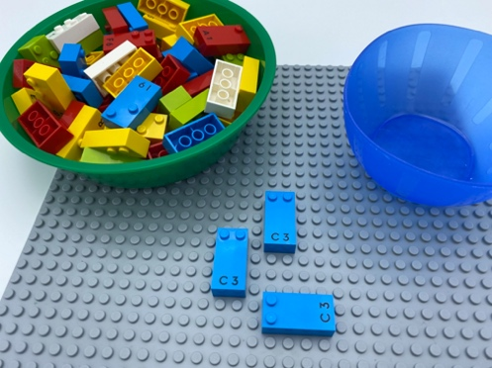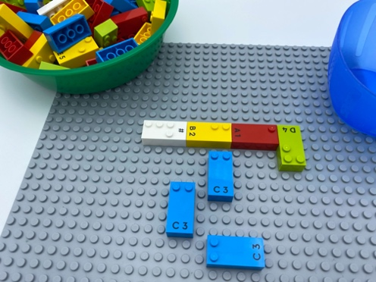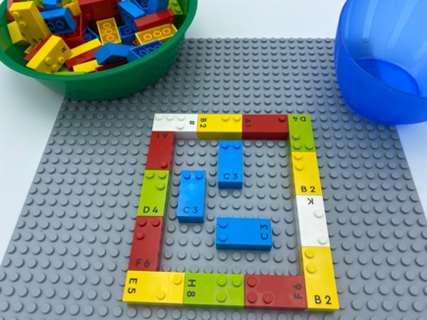

Let’s play
- Pick 3 bricks from the bowl to be the cows.
- Place the cow bricks in the center of the base plate.
- Build the smallest rectangular shaped fence possible to surround the cows.

How to prepare
- 1 base plate
- 3 letter “C” bricks
- All the other bricks
- 1 bowl
Place 3 letter “C” bricks in the bowl.

Facilitation tips
- Suggest building a square fence and compare capacity.
- Ask “What happens if the gate is left open?”.
- Suggest “The 3 bricks are not cow and the other bricks are not a fence. What else could they be?”.

Possible variations
- Suggest building a square fence.
- Use a pre-determined amount of bricks for building the fence.
- Add mandatory rules: cows cannot touch the fence; cows cannot touch each other …
- Peer play: one player places the cows, the other builds the fence.

Children will develop these holistic skills
- COGNITIVE - Practice scientific and technological approaches: utilize appropriate tools and methods
- PHYSICAL - Recognize real situations that can be modeled by geometric relationships (alignment, parallelism, perpendicularity, symmetry)
- SOCIAL - Articulate and justify answers, arguments and opinions
- EMOTIONAL - Understand rules
- CREATIVE - Retell or create simple stories

Did you know
- Well-designed games can lead to literacy and numeracy skills.
- What the students feel and think matters: they must get the feeling that they are part of their own learning and mastery of the content. Use open ended and guiding question techniques to support and encourage them.

