Upper Case Letters

15 min 1 participant

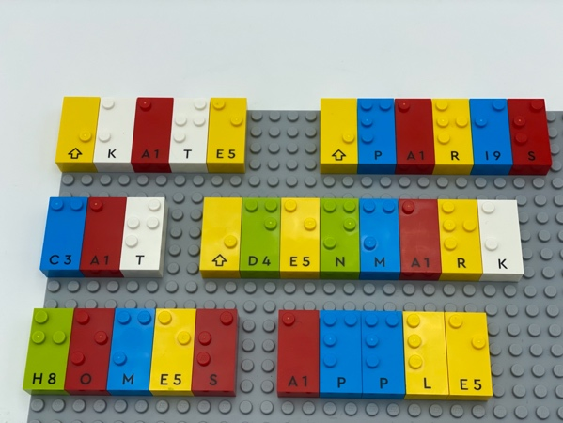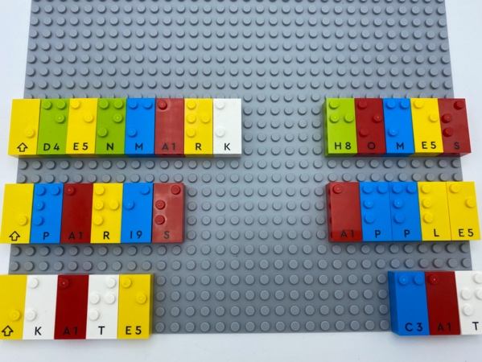

Let’s play
- Read the words.
- Remove each proper noun and place it in a column on the left bottom side of the base plate.
- Place the common nouns in a second column.

How to prepare
- 1 base plate
- Letter bricks
- Capital letter sign bricks
- 1 bowl
Write 6 words on the base plate, mixing proper and common nouns. Don’t forget to add “capital letter sign” when needed!

Facilitation tips
- Correct brick manipulation to recreate the nouns is difficult without a plan.
- Ask “How did you remember where to place the letters?”.
- Ask “Tell a story using the 6 words and choose a way to indicate when you say a word that starts with an upper-case letter, e.g. “stand up”, “clap your hands”.

Possible variations
- Add more words.
- Add words that can be both proper or common nouns such as Braille/braille.
- Multiple classification: first sort proper or common ... and then sort within the category using capital letter sign (persons’ names, cities’ names …).
- Peer play: one makes the words, the other sorts them.

Children will develop these holistic skills
- COGNITIVE – Develop understanding of concepts such as: leaving spaces between words, joining words and joining clauses, learning correct punctuation, including capital letters
- CREATIVE - Describe an organization produced or observed
- EMOTIONAL - Understand rules
- PHYSICAL - Organize: find objects, sort or categorize by placement, function, attribute

Did you know
- Engaged learners demonstrate motivation and commitment towards their learning, often extending themselves beyond set goals and expectations.

