Egg Carton Finger Twister

10 min 1 participant

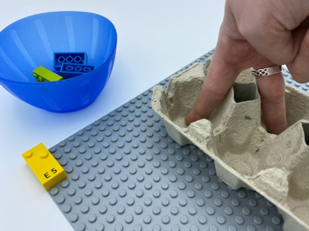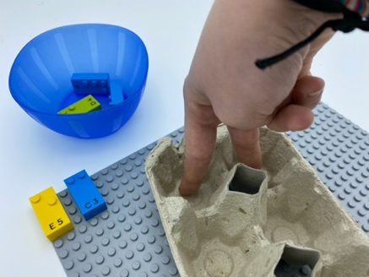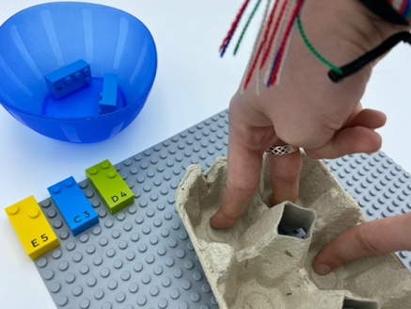

Let’s play
- Pick a brick and place it on the top left corner of the base plate.
- Feel the studs on the brick.
- Make your finger recreate the pattern of dots by placing one finger in each matching place in the braille cell egg carton.
- Use as many fingers as you need. For some letters you might need to use two hands!

How to prepare
- 1 base plate
- 5 bricks: “C”, “D”, “E”, “G”, “P”
- 1 bowl
- 1 carton for 6 eggs in portrait orientation, as a braille cell (e.g. 2 columns of 3 dots)
Place the bricks in the bowl.

Facilitation tips
- Identify all of the locations in the braille cell egg carton.
- Confusion between dot’s position in the braille cell, how we represent numbers in braille and the number of dots in the constellation can be avoided by saying “dot 2” and not only “2”.

Possible variations
- Choose bricks with different numbers of dots.
- Peer play: one child is in charge of “dot 1”, “dot 2” and “dot 3”, the other child “dot 4”, “dot 5” and “dot 6”.

Children will develop these holistic skills
- COGNITIVE - Build a suite identical to a proposed ordered suite
Relate numbers 1 through 6 with braille cell positions/dot number:
- Identify the spatial position of dots in a braille cell
- Identify the dot number of a specific dot in a braille cell
- PHYSICAL - Develop finger isolation: single finger use
- CREATIVE - Spontaneously engage in free and then guided exploration of different tools and different media

Did you know
- The egg carton is an excellent tool: it is a giant braille cell! Children will learn the 6 positions and eventually the braille characters.
- Cognitive skills are about concentration, problem solving, and flexible thinking by learning to tackle complex tasks and building effective strategies to identify solutions.

