Musical Letters

20 min 1 participant

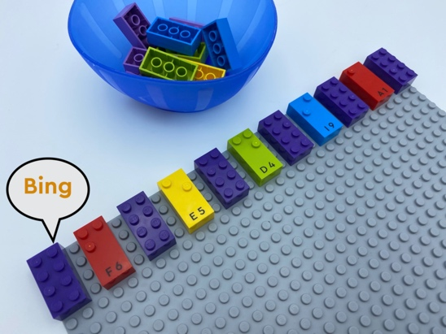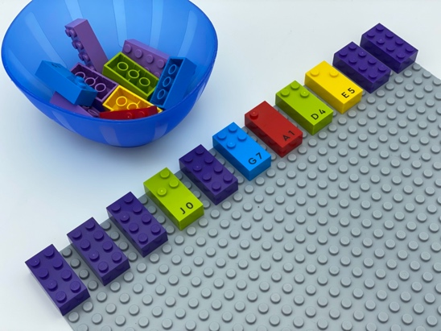

Let’s play
- Track the line of bricks with your index fingers.
- Pronounce each letter as you touch it.
- Make a beat box sound (e.g. “bing” or “bang” ...) for each brick that is not a letter.

How to prepare
- 1 base plate
- 10 letter bricks, from “A” to “J”
- 10 Classic LEGO bricks (4x2)
- 1 bowl
Align 11 bricks across the top of the base plate, alternating Classic and braille bricks and leaving a space between each of them.
Place the other bricks in the bowl.

Facilitation tips
- Ask “How can you tell the difference between letters and the other bricks?”.
- Suggest “Imagine and sing a song or a rhythm”.
- Suggest “Tell a story in relation to your song”.

Possible variations
- Change the number of letters/rows/spaces/columns.
- Change the pattern /rhythms.
- Encourage personal creation of musical composition.

Children will develop these holistic skills
- CREATIVE - Imagine graphic representations to organize a succession of sounds and sound events
- EMOTIONAL - Develop an interest in art, works of art
- SOCIAL - Listen and respond appropriately to adults and peers: adapt speaker/listener postures: accept turns, wait to speak
- COGNITIVE - Use hands and fingers in braille reading: use two hands to track braille, from left to right
- PHYSICAL - Improve auditory awareness skills: isolate sounds/words/phrases among environmental sounds

Did you know
- Creative activities - coming up with ideas, expressing them and transforming them into reality by creating associations, symbolizing and representing ideas can provide meaningful experience for others.
- Teachers can create learning environments that empower young children to realize their potential.

