Reproduce in an Egg Carton

10 min 1 participant

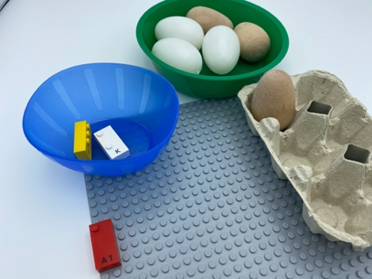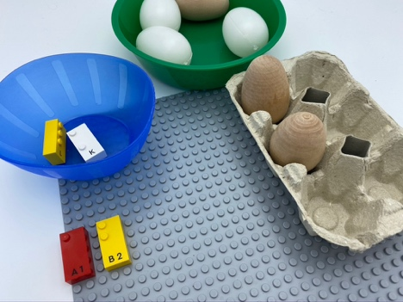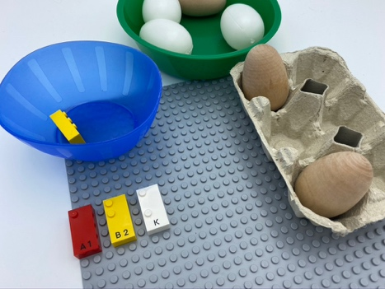

Let’s play
- Pick a brick from the bowl and place it on the base plate.
- Feel the studs on it.
- Using the eggs, copy in the egg box the same pattern of dots you felt.

How to prepare
- 1 base plate
- 4 bricks: “A”, “B”, “K”, “L”
- 2 bowls
- 1 carton for 6 eggs in portrait orientation, as a braille cell (e.g. 2 columns of 3 dots)
- 6 eggs or 6 similar size objects
Place the 6 eggs in a bowl.
Place the 4 bricks in the other bowl.

Facilitation tips
- Start with letters that have dots in the first column i.e. dots 1, 2 3.
- Choose 2 different type of eggs (material, shape): one for the left column (dot 1,2, 3) and another for the right (dot 4, 5, 6).

Possible variations
- Place the bricks on the plate in advance.
- Choose letter bricks with dots 4, 5 or 6.
- Peer play.
- Add mini figures instead of eggs and ask them to tell a story of their figurine’s journey in the egg box.

Children will develop these holistic skills
- EMOTIONAL - Know the purpose of the activity
- CREATIVE - Reproduce, assemble, organize, link graphic patterns and then create new ones
- COGNITIVE - Relate numbers 1 through 6 with braille cell positions/dot number
- PHYSICAL - Compare - discover similarities, differences, and preferences: sort and match
- SOCIAL - Plan and carry out routine or non-routine activities requiring multiple steps

Did you know
- Children can play with the constellation of dots even if they don't know how to count to 6 yet. It’s all about giving a name to a spot: first place on top left is named dot 1.
- When children are engaged, they bring themselves into a learning activity, often by thinking of ways to enrich the experience and take the activity even further.
- Children need a deep, conceptual understanding of content knowledge together with skills that enable them to apply what they know.

