Build a Fence

10 min 1 participant

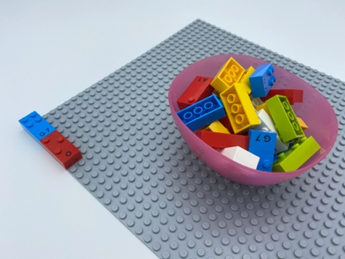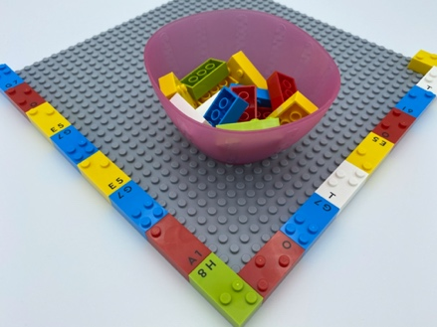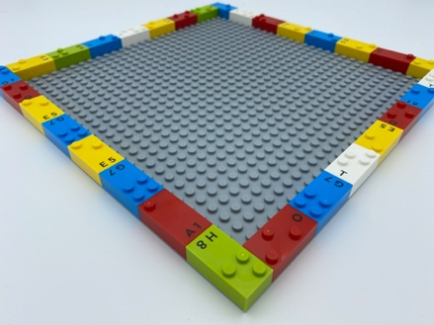

Let’s play
- Pick bricks to build a thin fence around the garden plate.
- Build it all the way around the garden, along the edges...

How to prepare
- 1 base plate
- 30 random bricks
- 1 bowl
Place 2 bricks on the base plate: vertically, in the top left corner, to begin a vertical column.
Place the 28 bricks in the bowl.

Facilitation tips
- Ask “What's your fence for? Can you show me?”.
- Ask “What did you do to go around the corner?”.
- Add LEGO mini figures to play with.

Possible variations
- Change the number of starting bricks for the fence.
- Change the size of the base plate.
- Peer play: add base plates and build a bigger fence.

Children will develop these holistic skills
- PHYSICAL - Learn through action, observation, analysis of personal action and activity: repeat a gesture for stabilization and effectiveness
- CREATIVE - Retell or create simple stories
- EMOTIONAL - Control motor skills and emotional commitment to succeed in simple actions
- COGNITIVE - Recognize spatial relationships
- SOCIAL - Anticipate potential problems, identify steps for resolution including alternative solutions

Did you know
- Playful experiences encourage curiosity and enthusiastic engagement in early education.
- Children at play try harder, persist for longer and think more deeply.

