Roll and Pick Numbers

Search, identify and collect specific number bricks on a base plate in a peer-play activity.
10 min 2 participants

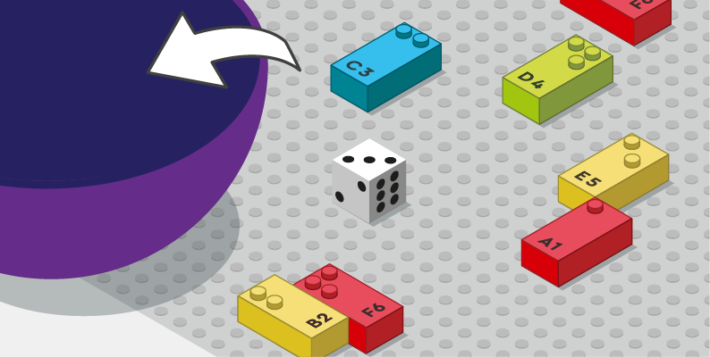

Let’s play
Player 1
- Roll the die, read it
- Find all the bricks on the base plate that are the same number you rolled.
- Place them in your bowl
Player 2
- Follow the same directions and take turns until no bricks remain on the baseplate.
The winner is the player with the most bricks.

How to prepare
- 1 base plate
- 1 number sign brick
- 12 number bricks (2x “1”, 2x “2”… 2x “6”)
- 2 bowls
- 1 die

Place all the number bricks anywhere on the baseplate, in various positions (vertical, horizontal)

Facilitation tips
- Explain “Number sign brick placed once on the top left corner of the baseplate indicates all bricks are numbers.”
- Suggest “Can you imagine a math story using the same rules?”

Possible variations
- Use 2 dice and write numbers up to 12
- Place uneven numbers of equal bricks

- Children will develop these holistic skills
- COGNITIVE: Stabilize knowledge of small numbers: Associate the written number, constellations of dice, finger configurations, dot cards corresponding to a counted quantity (up to 10)
- CREATIVE: Engage in solitary play activities for an appropriate amount of time
- EMOTIONAL: Share rules, roles and responsibilities
- SOCIAL: Participate with other students in both leadership and follower roles
- PHYSICAL: Discover the “spatial organization of a page”: Take reference points in the page

Did you know
- « Play is intrinsic to the human being from birth. It is a source of knowledge, relationships, interactions and learning. It is from play that every child comes to form his or her individuality and role in the community. » Jennifer Vega

