Putting Numbers in Their Place
Recognize place value of digits in a series of numbers. Sort digits into correct columnar placement on a base plate.
10 min 2 participants

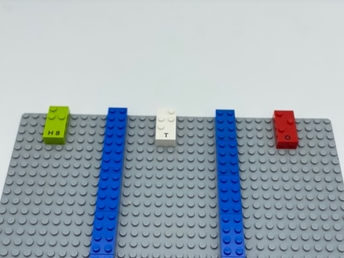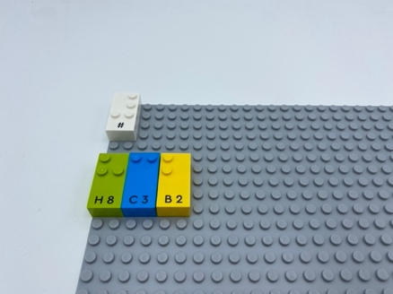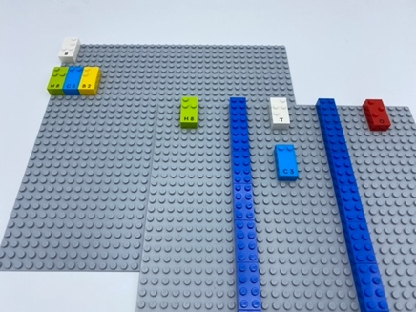

Let’s play
Player 1
- Think of a 3-digit number on your baseplate. Don’t tell it!
- Give indications such as the number of tens is …, the one for hundreds is … and the one for ones is
Player 2
- Place correctly each relevant brick at the correct position on the base plate
- read the 3-digit number
Both players
- Compare your numbers

How to prepare
- 1 base plate
- Classic LEGO bricks
- All number bricks
- 3 letter bricks: “O”, “T”, “H”
- 1 number sign brick
- 1 bowl
Use the classic bricks to build a grid dividing the base plate into 3 columns (ones, tens, hundreds)
Place all the number bricks in the bowl.

Facilitation tips
- Explain “Number sign brick placed once on the top left corner of the baseplate indicates all bricks are numbers.”
- Explain numerical values of each column; i.e. left column equals hundreds…
- Ask “How can you perform the activity without physically drawing the columns?”

Possible variations
- Increase the number of columns to work on millions, thousands…
- Use the same activity to perform math operations on three- to six-digit numbers.

- Children will develop these holistic skills
- COGNITIVE: Recognize the place value of each digit in a four-digit number (thousands, hundreds, tens, and ones)
- CREATIVE: Put into words procedures in peer-to-peer exchanges
- EMOTIONAL: Follow courteous behavior: Give compliments to others
- SOCIAL: Articulate and justify answers, arguments and opinions: Ask relevant questions to extend understanding and knowledge
- PHYSICAL: Organize: find objects in their usual place; return them to their usual place; sort or categorize by placement, function, attribute; gather materials for a task

Did you know
- Physical play is linked to spatial skills and mathematics.
- The United Nations Sustainable Development Goals (SDGs) reflect the growing consensus among education experts of the need for education to be of high quality and to foster learner’s holistic development.

