Number Creation

10 min 1 participant

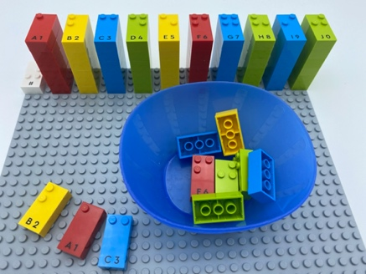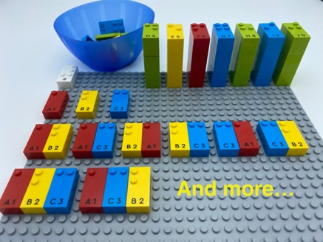

Let’s play
- Pick 3 bricks from the bowl.
- Choose the identical bricks from your towers.
- Make as many numbers as you can using 1, 2 or 3 bricks and place them on your empty base plate.
- Read them aloud.

How to prepare
- 2 base plates
- Number bricks
- 2 number sign bricks
- 1 bowl
Place a number sign brick in the top left corner of each base plate indicating the bricks are numbers.
Place 10 number bricks (“0” to “9”) in the bowl.
Build number brick towers “0” thru “9” in order, on one base plate for ease in finding the numbers.

Facilitation tips
- Allow self-exploration for strategy development: trial-and-error, well-organized …
- Ask “How well do you think you performed?”.

Possible variations
- Change the number of bricks.
- Change instructions: read your numbers in ascending order, guess the highest/lowest number you can make using three bricks without removing any bricks from the towers.
- Change the number of players: player 1 picks and makes the numbers, player 2 guesses which bricks were picked by player 1.

Children will develop these holistic skills
- COGNITIVE – Use the number to show a rank, a position: recognize the place value of each digit in a four-digit number (thousands, hundreds, tens, and ones)
- PHYSICAL - Learn through action, observation, analysis of personal action and observed activity: appropriate methods and tools to learn
- CREATIVE - Utilize adapted games/materials during free time
- EMOTIONAL - Follow courteous behavior: respond to someone who is initiating a conversation
- SOCIAL - Plan and carry out routine or non-routine activities requiring multiple steps

Did you know
- Children who engage in active learning demonstrate motivation and commitment beyond set goals and expectations.

