Marble Road

10 min 1 participant

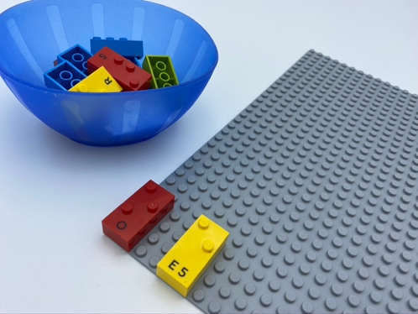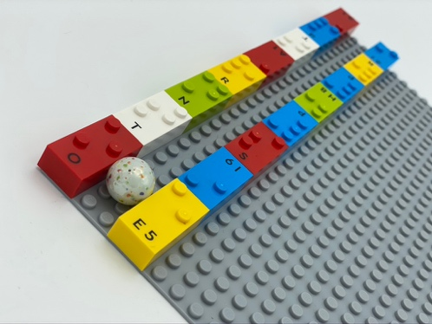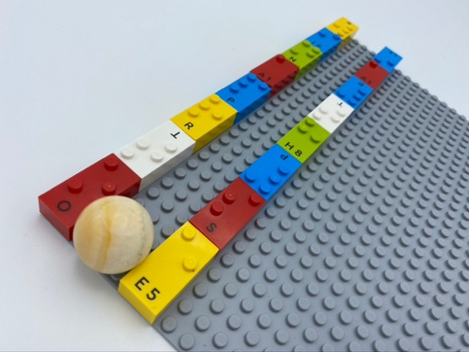

Let’s play
- Explore the base plate to find the edges of the road being built.
- Finish the road construction using the bricks from the bowl.
- Let your marble roll safely on your road, from one end to the other.
- Have a free play session!

How to prepare
- 1 base plate
- 16 or more random bricks
- 1 bowl
- 1 marble
Place one horizontal brick in the top left corner of the base plate, and another one 2 spaces below.
Place the other bricks in the bowl.

Facilitation tips
- Ask “Where does your road go?”.
- Ask “What’s going on over there?”.

Possible variations
- Change marble size or use a ball: adapt space between the sides of the road.
- Extend the road and create tuns.
- Peer play: build together.

Children will develop these holistic skills
- COGNITIVE - Recognize and use notions of alignment, right angle, equality of lengths, middle, symmetry
- CREATIVE - Organize objects in play: play with several different hand-held toys
- PHYSICAL - Develop finger isolation: single finger use
- PHYSICAL - Recognize movement: go, start, stop…
- SOCIAL - Anticipate potential problems, identify steps for resolution including alternative solutions

Did you know
- Play gives children opportunity to develop skills, to learn, to solve problems and grow healthy relationships.
- Spatial skills allow us to imagine objects in our minds and rotate or manipulate them, and to navigate them.

