Build a Rectangular Tower

15 min 1 participant

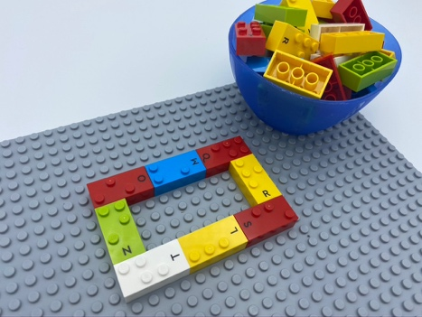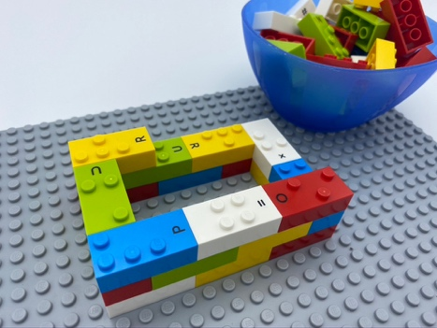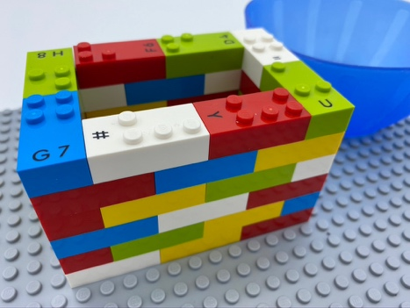

Let’s play
- Build the walls of a rectangular tower using all the bricks.

How to prepare
- 1 base plate
- 48 bricks with more than 3 studs each, to ensure a strong building
- 1 bowl
On the base plate, build a 3x1 rectangle with 8 bricks.

Facilitation tips
- Sometimes, there may not be a stud on with to attach the next brick. In that case, simply replace this brick with one that has more studs.
- Suggest the idea of a scenario: “It is the first building of a future city. You can enlarge it by adding other buildings”.

Possible variations
- Make several floors in preparation.
- Build several towers.
- Use a timer.
- Make bigger rectangles.
- Peer play: build the tower together or build several towers.

Children will develop these holistic skills
- PHYSICAL - Develop motor skills and build body language: acquire specific techniques to improve efficiency
- CREATIVE - Engage in solitary play activities for an appropriate amount of time
- COGNITIVE – Recognize, classify and sort shapes in 3 dimensions
- EMOTIONAL - Comply with simple directions and limits from adults
- SOCIAL - Plan and carry out routine or non-routine activities requiring multiple steps

Did you know
- The LEGO Braille brick has 2X4 studs. It is the iconic size for LEGO brick. Its length is twice its width and that allows to easily build geometrical shapes.
- Children can learn to carry out multi-step activities, resist distractions and choose tasks suited to their interests and skill level, just as they can learn to use more advanced problem-solving strategies.

