Drawing with Dots

20 min 1 participant

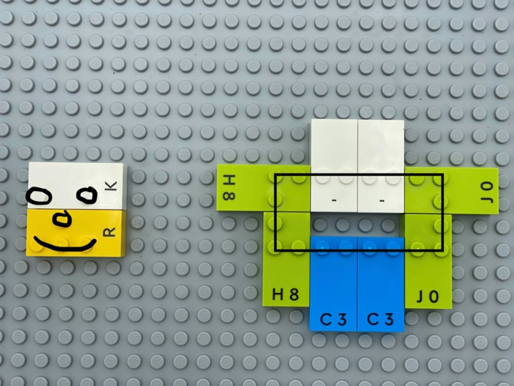

Let’s play
- Use only the dots of the bricks to draw:
- a rectangle
- a 2D drawing
- emojis

How to prepare
- 1 base plate
- All the bricks
All the bricks are in the box.

Facilitation tips
- Encourage trial and error activity to improve tactile and manipulation skills. Children may encounter difficulties positioning the dots as they wish.
- Suggest sharing and exploring drawings created by peers to discover new techniques and ideas.
- Ask “What is the story about your drawing?”
- Pre-design a drawing for an example on a base plate.

Possible variations
- Free play drawings.
- Copy a pre-designed drawing from a base plate.

Children will develop these holistic skills
- COGNITIVE - Explain how to operate in a realistic situation: by stating a few key words describing action
- PHYSICAL - Recognize real situations that can be modelled by geometric relationships (alignment, parallelism, perpendicularity, symmetry)
- EMOTIONAL - Develop an interest in art, works of art
- CREATIVE - Create and engage in creative dramatics and activities
- SOCIAL - Anticipate potential problems, identify steps for resolution including alternative solutions

Did you know
- Adults can join children’s play to extend the learning possibilities through questioning or suggestions.
- Guidance may help learners to focus their attention on important features or details in an activity.

