Domino Cross

15 min 2 participants

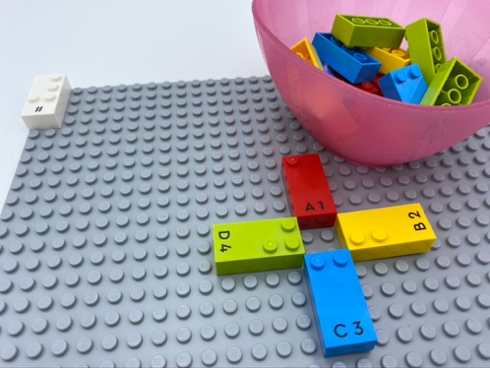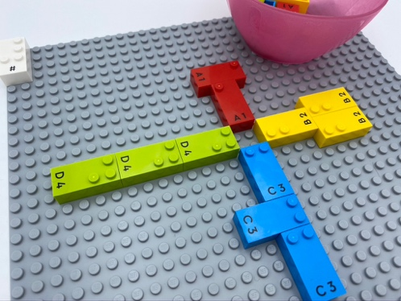

Let’s play
Player 1 and Player 2
- Take 6 bricks from the bowl.
- Place your bricks on the base plate, while taking turns.
- Place only identical bricks next to each other.
- Pass if you cannot play a brick.
Winner - the first to run out of bricks.
Tie - when brick number 5 is the only remaining brick in the bowl.

How to prepare
- 1 base plate
- 17 number bricks (4 with “1”, 4 with “2”, 4 with “3”, 4 with “4” and 1 with “5”)
- 1 number sign brick
- 1 bowl
Number sign is located on the top left corner of the base plate to indicate the bricks represent numbers.
Place 4 bricks, numbered from “1” to “4”, in cross formation on the base plate.
The 13 other bricks are in the bowl.

Facilitation tips
- Remind visually impaired players that other players with vision may be able to see their bricks if they are not hidden.

Possible variations
- Change the numbers used e.g. 1, 3, 5, 7 instead of 1, 2, 3, 4.
- Make 2 crosses with 8 different numbers.
- When unable to match a brick, players take an extra brick from the bowl.

Children will develop these holistic skills
- COGNITIVE - Name, read, write and represent numbers
- PHYSICAL - Learn through action, observation, analysis of personal and observed activity: learn to preplan actions
- EMOTIONAL - Know the purpose of the activity
- CREATIVE - Engage in solitary play activities for an ability appropriate amount of time
- SOCIAL - Request and accept help from others, use peers as a resource

Did you know
- Playful moments naturally harness characteristics that propel children’s learning: being active and minds-on, finding meaning and joy in experience, trying out ideas and interacting with others.

