Missing Number!

5 min 1 participant

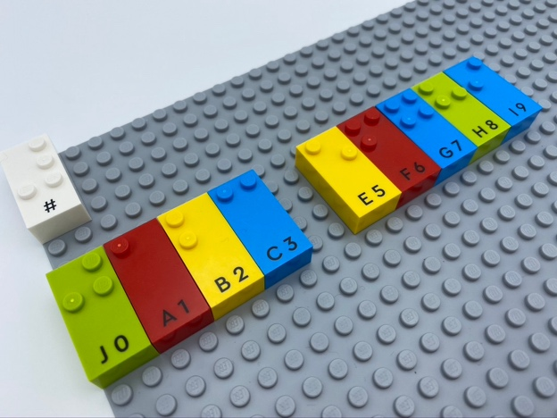

Let’s play
- Align numbers in the correct order from 0 to 9.
- Leave a blank space for the place where the number is missing.
- Fill the gap, by clapping your hands the number of times equal to the missing number.

How to prepare
- 1 base plate
- 9 number bricks (one number is not present)
- 1 number sign brick
- 1 bowl
Number sign is located on the top left corner of the base plate indicating the bricks represent numbers.
Place the 9 other bricks in the bowl.

Facilitation tips
- Provide real or virtual reminders, e.g. list of numbers embossed on a paper, song.
- Ask “What strategy did you use to show the missing number?”.

Possible variations
- Suggest tower constructions, starting with bricks number 1, 2…
- Change the number of bricks.

Children will develop these holistic skills
- COGNITIVE - Count, read and write numbers up to 10, forwards and backwards
Identify the braille characters: numerals 0-9
- CREATIVE - Describe an organization produced or observed
- PHYSICAL - Identify spatial relationship within a braille cell, a line, a page

Did you know
- Well-planned and intentional instruction with use of effective techniques can lead to improved academic outcomes and socio-emotional skills.

