Park the Car

10 min 1 participant

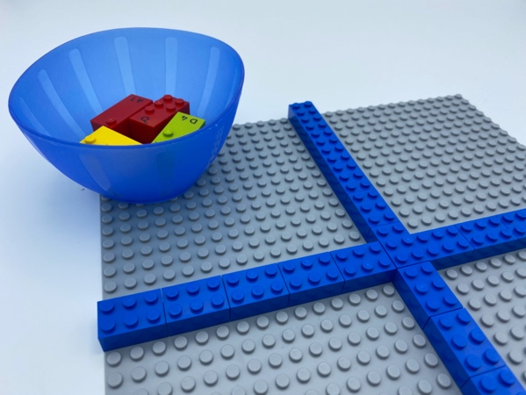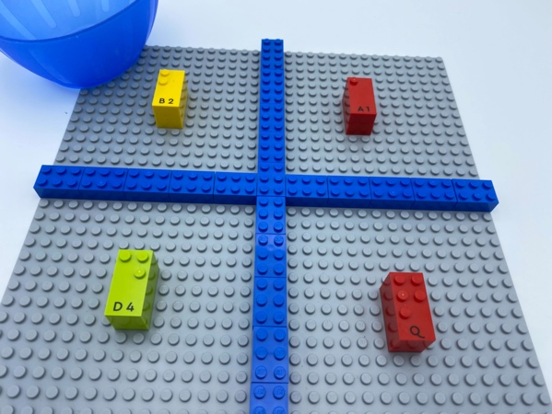

Let’s play
- Pick a car with 2 passengers from the bowl and park it in the top left parking spot.
- Pick a car with 5 passengers and park it in the bottom right spot.
- Pick a car with 1 passenger and park it in the top right spot.
- Pick a car with 3 passengers and park it in the bottom left spot.
- Have a free play with cars!

How to prepare
- 1 base plate
- 8 letter bricks: 2 “B”, 2 “Q”, 2 “A”, 2 “D”
- 16 or more random bricks or classic LEGO bricks
- 1 bowl
Create 4 cars with the 4 pairs of identical bricks and place them in the bowl. .
Build a cross with the random bricks, in the middle of the base plate, to create a 4-car parking lot.

Facilitation tips
- Attaching 2 bricks together make the car taller and easier to feel when parked on the base plate!
- Preliminary exercise: explore the parking lot and name the locations of each spot - top left, bottom right…

Possible variations
- Change number of spots.
- Create cars with only 1 passenger.
- Change the number of passengers.
- Park several cars in the same spot.

Children will develop these holistic skills
- COGNITIVE - Recognize spatial relationships
- CREATIVE - Organize objects in play: use a toy resembling a “real” object to represent that object
- PHYSICAL – Improve listening comprehension skills: understand vocabulary
- EMOTIONAL - Control motor skills and emotional commitment to succeed in simple actions
- SOCIAL - Listen and respond appropriately to adults and peers

Did you know
- When playing in an imaginary store, children use mathematical abilities and oral language skills.

