The Bull Pen

15 min 2 participants

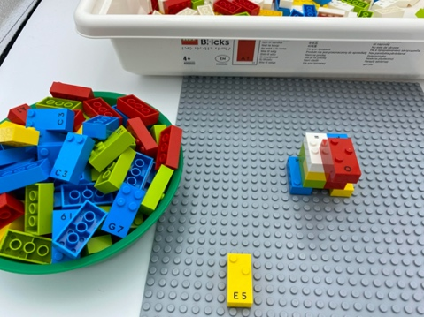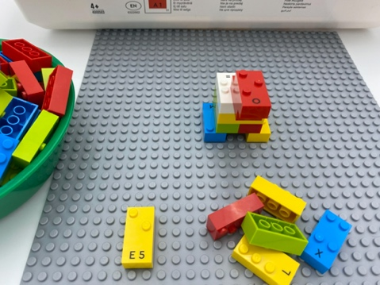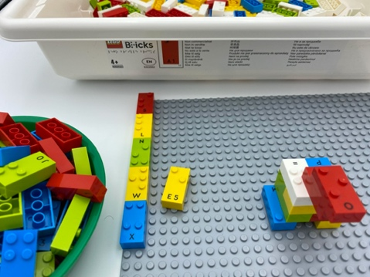

Let’s play
Both players
- Remove 10 bricks from the box to build a bull in the center of the base plate.
Both players (taking turns)
- Pick a number brick from the bowl.
- Read the number.
- Take the same number of bricks from the box.
- Build a fence with these bricks around the complete perimeter of the base plate because the bull needs lots of room to roam.
- Complete the fence first, you win! Be careful: you need to finish the fence with the exact number of bricks necessary to perfectly surround the bull. If the number you choose from the bowl is too large, you cannot build the fence and must skip your turn.

How to prepare
- 2 base plates (one per player)
- All the bricks
- 1 bowl
Remove the all number bricks and place them in the bowl, keep the others in the box.

Facilitation tips
- Ask “What else could you build a fence around?”.
- Encourage personal strategy development and multiple solution exploration.

Possible variations
- Suggest different types of constructions: a 2-story wall, a 5 by 4 rectangle, a square…
- Change the size of the base plate.
- Place only low numbers in the bowl.

Children will develop these holistic skills
- COGNITIVE - Interpret a success/failure by explaining the causes or consequences of an activity, use of a tool
- PHYSICAL - Engage in the activity over time and explore different possibilities, using manipulated objects
- EMOTIONAL - Recognize self-value
- CREATIVE - Utilize adapted games/materials during free time
- SOCIAL - Anticipate potential problems, identify steps for resolution including alternative solutions

Did you know
- Adults have important roles to help young children with game play, including introduction of the rules and the process of taking turns.

