Where is Lily?

Help Alfie find Lily, through a tactile exploration of plate in search of a brick with a given constellation of dots.
15 min 1 participant

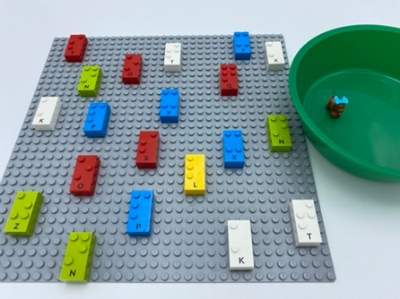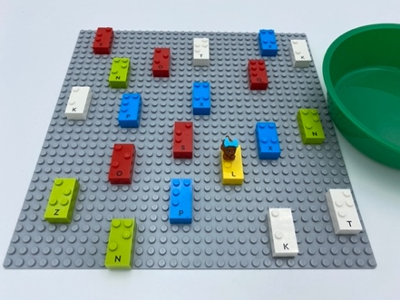

Let’s play
- Lily is the only brick on the base plate with dot 1, 2 and 3
- Lily has a dog, Alfie, who loves her. Unfortunately, Alfie can’t find Lily because there are so many people on the beach
- Explore the beach to help Alfie find Lily
- When you find Lily, take Alfie from the bowl and put him with her friend

How to prepare
- 1 base plate
- 20 bricks, including only one letter brick “L”
- A small object to symbolize a dog
- A bowl
Place 20 bricks in correct reading position, all over the base plate.
Place the dog object in the bowl.

Facilitation tips
- Provide an example of the Lily brick (a letter brick “L”)
- Perform activity without the notion of the dog, only looking for Lily.
- Offer tactile research strategies: “Explore as if you were reading a text on a page, that is to say from left to right and top to bottom.”

Possible variations
- Change the letter brick, choose a letter bricks “A” for Alfie instead of a small object
- Hide several Lily-bricks and place several dog-bricks in the bowl
- Hide Lily among classic LEGO bricks instead of other LEGO Braille Bricks

Children will develop these holistic skills
COGNITIVE - Identify the spatial position of dots in a braille cell.
EMOTIONAL - Control motor skills and emotional commitment to succeed in simple actions.
CREATIVE - Spontaneously engage in free and then guided exploration of different tools and different media.
PHYSICAL - Locate objects by touch: intentionally search for an object
SOCIAL - Comply with simple directions and limits from adults.

Did you know
- Meaningful is when the child can relate new experiences to something already known. In play, children often explore what they have seen and done, or noticed others do, as a way of grasping what it means. By doing so, they can express and expand their understanding through a variety of media, symbols and tools.

