Identical Letter Towers

5 min 1 participant

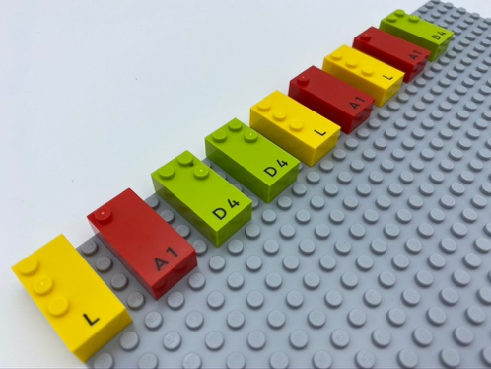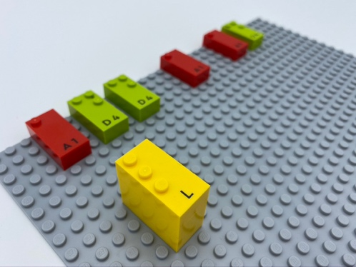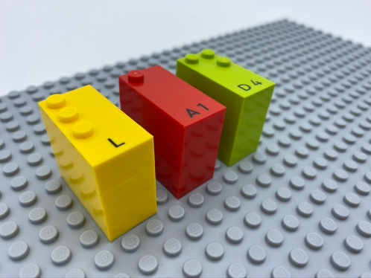

Let’s play
- Choose a brick.
- Read the letter.
- Find the other 2 bricks with the same letter and build a tower.
- Make 2 more towers the same way.

How to prepare
- 1 base plate
- 9 bricks (3 groups of 3 identical letters)
9 bricks randomly aligned, horizontally, in correct reading position, on the base plate.

Facilitation tips
- Ask “How do you know you have built each tower correctly?”.

Possible variations
- Choose letters tactually different for easier activity and tactually closer for more difficult activity.
- Increase the number of letters.
- Build the towers with friends.
- Build the highest tower possible using only vowels or letters in the child's name.
- 2 children collaborate: one, building tower B, the other, tower C.
- Try same activity but with a different number of identical letters (4 “A”, 5 “B” and 3 “C”) to work on concepts such as taller, longer, smaller, shorter…

Children will develop these holistic skills
- COGNITIVE - Recognize and name the majority of letters of the alphabet
- PHYSICAL - Read each letter, combine several letters together, produce a series of identical letters
- EMOTIONAL - Solicit information/assistance from appropriate persons in various settings
- CREATIVE - Engage in solitary play activities for an appropriate amount of time

Did you know
- This can be a collaborative game: social interaction is a powerful tool for both learning and play.
- By communicating their thoughts, understanding others through direct interaction and sharing ideas, children are not only able to enjoy being with others, but also to build deeper understanding and more powerful relationships.

