Play on Words

20 min 2 participants

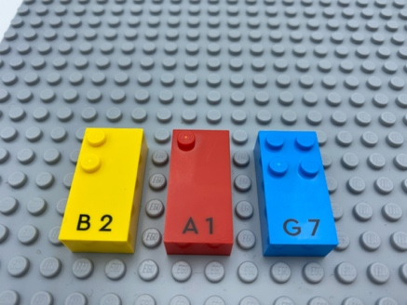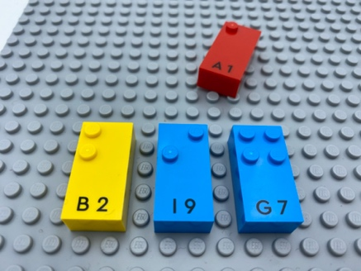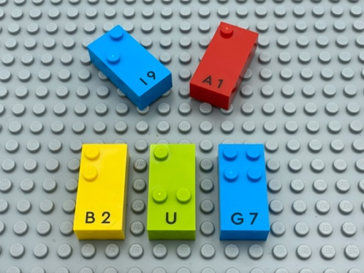

Let’s play
Place letters, one at a time, to create new words.
Player 1
- Think of a 3-letter word and find the letters to write the word on the base plate.
Player 2
- Change the word by removing and replacing a brick with a new letter or by adding an additional brick.
Both players
- Continue taking turns until no more words can be created.

How to prepare
- 1 base plate
- All the letter bricks

Facilitation tips
- Additional letters can be pre-arranged in alphabetical order on an additional base plate. Could be a warm-up activity!
- Encourage collaborative help between players.

Possible variations
- Begin the activity with a prompted word.
- Change the number of letters in the starting word.
- Remove, replace or add more than one letter.

Children will develop these holistic skills
- COGNITIVE - Discover the function of the written word: participate in the writing of certain words
- CREATIVE - Perform operations on letters and word syllables: remove, add, reverse, locate, substitute
- EMOTIONAL - Develop vocabulary and understanding in reading: discuss word meanings, link new meanings to those already known
- PHYSICAL – Develop tactile tracking skills: locate, read an identified number of word or letter on a line
- SOCIAL - Anticipate potential problems, identify steps for resolution including alternative solutions

Did you know
- A critical requirement is that children must experience agency and be supported rather than directed. This means seeing children as capable and providing opportunities to exert their thinking and actions in a social context where others have the same rights.

