Build a Square Tower

10 min 1 participant

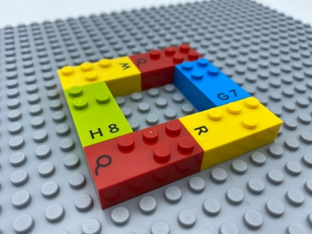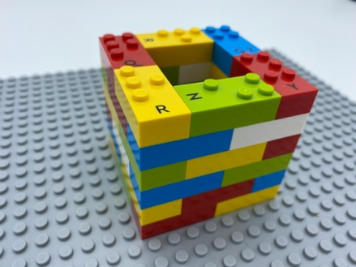

Let’s play
- Add more floors to the tower, to make it taller and equal on all 4 sides.

How to prepare
- 1 base plate
- 36 bricks with more than 3 studs each, to ensure a strong building
- 1 bowl
Build a square with 6 bricks on the base plate.
Place the 30 other bricks in the bowl.

Facilitation tips
- Ask “How tall can you build this tower?”
- Ask “What could happen if you drop a brick or a LEGO mini figure in the tower?”

Possible variations
- Make several floors beforehand.
- Increase the number of towers to be built.
- Use a timer.
- Change the size of the square.
- Peer play.

Children will develop these holistic skills
- PHYSICAL - Use and produce representations of solids and spatial situations
- PHYSICAL - Develop motor skills: and build body language: acquire specific techniques to improve efficiency
- COGNITIVE – Recognize, classify and sort basic shapes in 2 dimensions
- SOCIAL - Plan and carry out routine or non-routine activities requiring multiple steps

Did you know
- LEGO Braille bricks are equal in size to the most common LEGO bricks. Its length is twice its width and allows easy construction.
- Iteration - trying out possibilities, revising hypotheses and discovering the next question - leads to increased learning.

