Move from Hoop to Hoop

30 min 3 participants

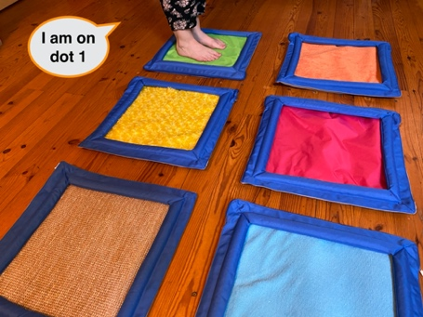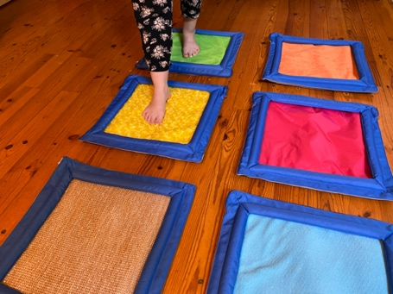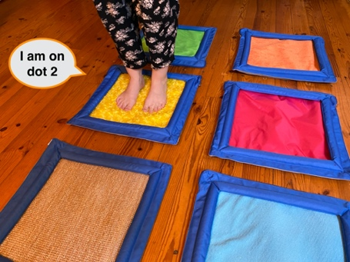

Let’s play
- Pick a brick from the bowl.
- Feel the dots on it.
- Go to the dots you felt on the brick and say their names
I.e.: if you pick letter “B” – dot 1 and dot 2- go to hula hoop 1 and say “I am on dot 1”, then go to hula hoop 2 “I am on dot 2”.

How to prepare
- 1 base plate
- 5 different bricks in a bowl: “A”, “B”, “C”, “K”, “L”
- 1 bowl
- 6 hula hoops
Arrange the 6 hoops like a braille cell, and tape them on the floor.
Add a tactile marker on hoop number 1.
Place the bricks in the bowl.

Facilitation tips
- Make some preliminary exercises:
- Walk in a braille cell with child and tell where you are.
- “Can you go in the dot 5?”, “Can you join me? I am in dot 2”, “Can you go from dot number 1 to dot 6?”, “Can you tell me in which dot I am?”, “Can you put one foot in dot 4 and another in dot 5?”, …
- Choose 2 different kinds of hula hoops to make a distinction between the rows of dot 1-2-3 and dot 4-5-6.
- Confusion between dot’s position in the braille cell, how we represent numbers in braille and the number of dots in the constellation can be avoided by saying “dot 2” and not only “2”.

Possible variations
- Peer play: “Everyone in dot 2!”, “Everyone in a dot, but no-one in dot 5!”…

Children will develop these holistic skills
- COGNITIVE – Use the number to show a rank, a position
Relate numbers 1 through 6 with braille cell positions/dot number
- EMOTIONAL - Know the purpose of the activity
- PHYSICAL - Identify spatial relationships within a braille cell, a line, a page

Did you know
- An actively engaging activity: using own's body in learning helps to better integrate concepts, especially those related to space.
- Actively engaged learners demonstrate motivation and commitment towards their learning, often extending themselves beyond set goals and expectations.

