Build a Wall

10 min 1 participant

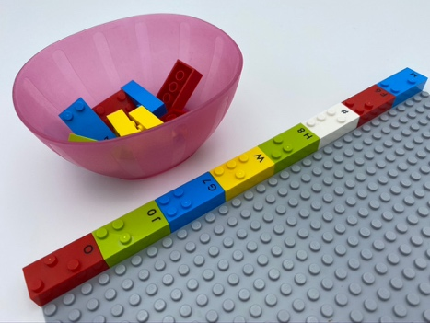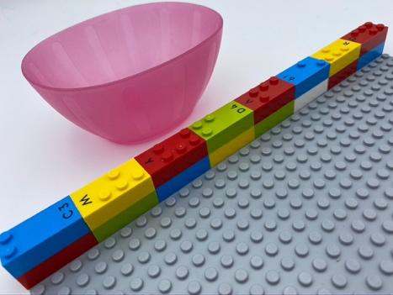

Let’s play
- Complete the wall by adding one brick on top of each brick, building your wall higher from left to right.
- Go for a free play session!

How to prepare
- 1 base plate
- 16 bricks
- 1 bowl
Make a horizontal line with 8 horizontal bricks, beginning in the top left corner, as foundation for the wall.
Place the other 8 bricks in the bowl.

Facilitation tips
- Explain the wall must be straight, with all the bricks in the same direction.
- Suggest tactile exploration along the wall to ensure proper alignment.

Possible variations
- Change the height and/or length of the wall.
- Pre-construct a model of a wall on the base plate.
- Use a timer.
- Peer play: “Who is going to make the tallest? Who wants to build with me?”.

Children will develop these holistic skills
- PHYSICAL - Use and produce representations of location
Coordinate several motor skills in one activity
- CREATIVE – Adapt a project according to constraints and audience
- COGNITIVE - Recognize spatial relationships

Did you know
- Getting into the habit of going from left to right and from top to bottom, helps to acquire the reading and writing direction.
- When children are engaged, they bring themselves into a learning activity, often by thinking of ways to enrich the experience and take the activity even further.
- Learning through play incorporates free or voluntary play, guided play, construction play, collaborative play, learning through games, physical play, and digital play, among others.

