Body Braille

20 min 1 participant

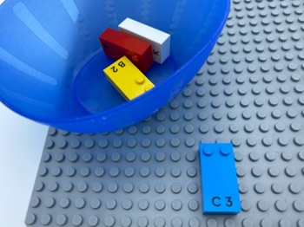

Let’s play

- Pick a brick from the bowl and place it on the base plate.
- Feel the dots on the brick.
- Show on your body all the dots you found on the brick. For example, if you pick letter “C” show your right shoulder (dot 1) and your left shoulder (dot 4).

How to prepare
- 1 base plate
- 4 bricks (“A”, “B”, “C”, “K”)
- 1 bowl
Place the bricks in the bowl.
Imagine that your body is a braille cell: dot 1 = right shoulder, dot 2 = right hip, dot 3 = right knee, dot 4 = left shoulder, dot 5 = left hip, dot 6 = left knee.

Facilitation tips
- Make some preliminary exercises:
  - Show me your dot 2, dot 4, dot 1 and 2! …
  - Which braille dot is your left knee?
- Suggest lying down on the floor to visualize own body is like a LEGO Braille brick on a base plate.
- Propose the child to put the brick on own chest and feel the studs on it before showing the different parts corresponding to the studs on own body.

Possible variations
- Do the activity with a doll, a tactile drawing, someone else…
- Repeat the activity with other braille characters.

Children will develop these holistic skills

- CREATIVE – Describe an organization produced or observed
- PHYSICAL - Develop motor skills and build body language
- COGNITIVE - Relate numbers 1 through 6 with braille cell positions/dot number
- EMOTIONAL - Comply with simple directions and limits from adults

- SOCIAL - Follow courteous behavior

Did you know
- Using one's body in learning helps to better integrate concepts, especially those related to space.
- Physical skills means being physically active, understanding movement and space through practicing sensory-motor skills, developing spatial understanding and nurturing and active and healthy body.

