Secret Code

15 min 2 participants

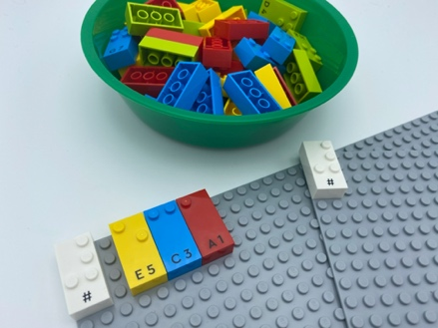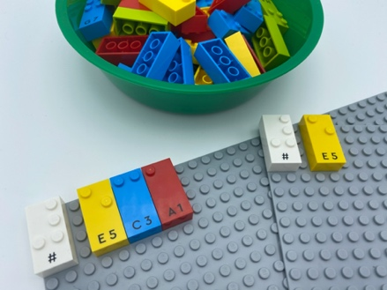

Let’s play
Player 1
- Write a secret number using 3 or less bricks, on your base plate.
Player 2
- Guess the secret number by asking relevant questions: e.g. How many bricks are used? Is it an even number? Is the number in the tens place odd or even? Does it start with a 7? Is it higher or lower than 500?

How to prepare
- 2 base plates
- Number bricks
- 2 number sign brick
- 1 bowl
Place the number sign brick in the top left corner of each base plate to indicate the bricks are numbers.
Place the remaining bricks in a bowl to share.
Give a base plate to each player.

Facilitation tips
- Suggest manipulation of bricks.
- Discuss strategy: “How can you remember all of your questions and answers?”, “Which questions work best?”.

Possible variations
- Determine a time limit or a maximum number of questions.
- Increase the number of players: more than one player asks questions.
- Increase the number of bricks in the secret code.

Children will develop these holistic skills
- COGNITIVE - Solve problems: engage in an approach, observe, question, manipulate, experiment, make hypotheses, by utilizing familiar mathematical tools or procedure
- PHYSICAL - Learn through action, observation, analysis of personal action and observed activity: learn by trial and error, cause and effects
- EMOTIONAL - Control motor skills and emotional commitment to succeed in simple actions
- CREATIVE - Identify various leisure activities to be done alone or with other people
- SOCIAL - Anticipate potential problems, identify steps for resolution including alternative solutions

Did you know
- Development of cognitive skills helps build effective strategies to tackle complex tasks and identify solutions. Activities requiring concentration, problem solving, and flexible thinking boost children’s cognitive skills.

