What Animal is it?

20 min 2 participants

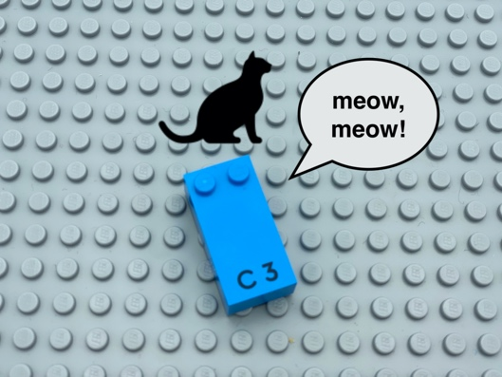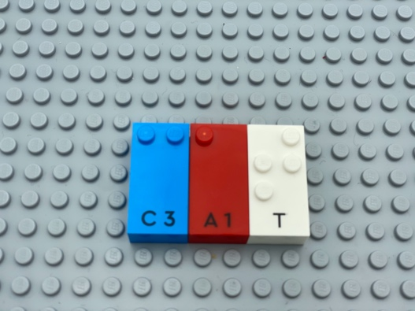

Let’s play
Player 1
- Pick a brick at random.
- Think of an animal starting with this letter.
- Describe your animal with sound or motion.
Player 2
- Guess what animal it is.
Both players
- Work together to pick the right bricks from the box to write the name of the animal on the base plate.

How to prepare
- 1 base plate
- All the letter bricks
Place the box of letter bricks and the base plate between the players.

Facilitation tips
- Ask “Can you imagine being in a zoo or in the jungle? What do you hear?”

Possible variations
- Find words in a given subject (geography, history, physics…), instead of animal.
- Arrange the letters in alphabetical order on an extra base plate for ease in finding.

Children will develop these holistic skills
- COGNITIVE - Discover the function of the written word: participate in the writing of certain words
- CREATIVE - Use spoken language to develop understanding through speculating, hypothesizing, imagining and exploring ideas
- CREATIVE - Engage in solitary play activities for an appropriate amount of time
- EMOTIONAL - Comply with simple directions and limits from adults

Did you know
- Children tend to discuss detailed features during playful building activities with peers and demonstrate higher level of self-regulation during small-group activities and play.

