Read the Number

10 min 1 participant

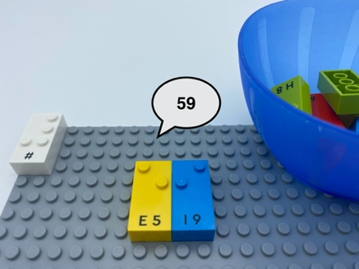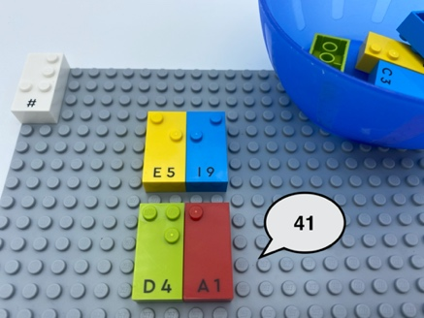

Let’s play
- Pick 2 bricks.
- Read what is on each brick.
- Place the 2 bricks next to each other on the base plate.
- Read the new number (e.g. 25 or 52) you have made.

How to prepare
- 1 base plate
- 10 number bricks (“0” to “9”)
- 1 number sign brick
- 1 bowl
Place the number sign brick in the top left corner of the base plate to indicate the bricks are numbers.
Place the remaining bricks in the bowl.

Facilitation tips
- Explain that we are not going to put the number sign in front of each brick. The number sign in the top left corner of the base plate indicates that all the bricks are numbers.
- Ask “How can you create a more engaging activity?”, e.g. throw 3 bricks -like dice- and carry out the activity with the bricks that are not upside down.

Possible variations
- Increase the number of digits by picking more bricks.
- Arrange all the bricks on the base plate and ask the child to write a given number.

Children will develop these holistic skills
- COGNITIVE – Use the number to show a rank, a position
- PHYSICAL - Learn through action, observation, analysis of personal action and observed activity: appropriate methods and tools to learn
- EMOTIONAL - Share rules, roles and responsibilities
- CREATIVE - Identify various leisure activities to be done alone or with other people
- SOCIAL - Anticipate potential problems, identify steps for resolution including alternative solutions

Did you know
- Because child development is beautifully complex, we take a holistic view and highlight the importance of children’s physical, social, cognitive, creative and emotional skills and how these complements and interact with one another.
- This activity promotes development of these holistic skills.

