Words and Space
20 min 2 participants

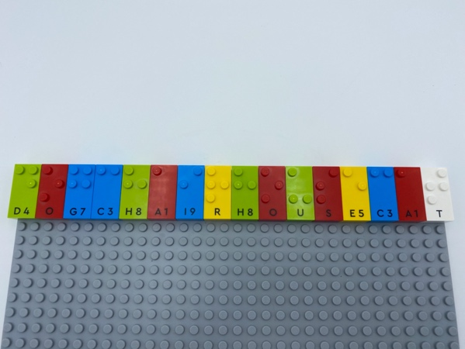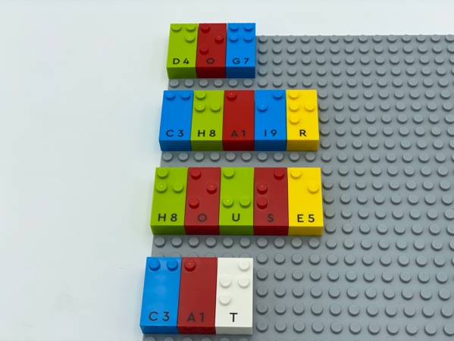

Let’s play
Player 1:
- Write a row of words across the top of the base plate without leaving spaces between the words.
Player 2:
- Read the letters.
- Identify words from left to right.
- Remove each word and place them in a column under the row of bricks.
Both players
- Compare and discuss the words.

How to prepare
- 2 base plates
- Letter bricks

Facilitation tips
- Arrange several of each letter in alphabetical order on an additional storage base plate for ease in finding letters. This can be prepared in advance or a warm-up activity for the child.
- Ask “What was your strategy to manipulate bricks, displace words and reposition them?”

Possible variations
- Suggest mandatory letters.
- Specify words must be verbs, nouns, adjectives, relative to current lessons…
- Change the length/number of rows.
- Find the 3rd word, the 2nd letter of the 4th word…

Children will develop these holistic skills
- COGNITIVE - Develop understanding of the concepts such as leaving spaces between words…
- CREATIVE - Perform operations on letters and word syllables: remove, add, reverse, locate, substitute
- EMOTIONAL - Develop vocabulary and understanding in reading
- PHYSICAL - Develop bilateral hand use
- SOCIAL - Participate with other students in both leadership and follower roles

Did you know
- Word games are a chance to practice literacy skills.
- Children learn more when they are actively engaged as opposed to passive activity, when activities are meaningful to them and when they learn together with others.

