Finish the Road

10 min 1 participant

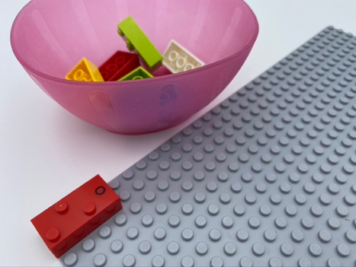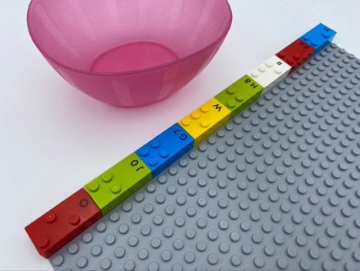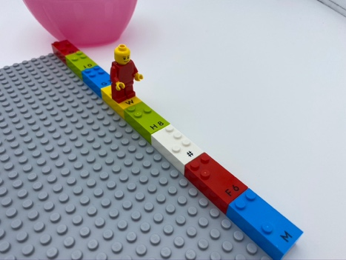

Let’s play
- Add bricks to finish the road across the top of the base plate – don’t leave any cracks to fall through.
- Add a LEGO mini figure: make it walk or jump across the road, from left to right.
- Feel the bumps in the road.

How to prepare
- 1 base plate
- 8 random bricks
- 1 bowl
Place one brick on the base plate: horizontally, at the top left corner, to begin the road.

Facilitation tips
- Suggest “Show me how you follow the road with your index finger!”.
- Ask “Can you tell me where there are a lot of studs and where you feel just a few?”.
- Affix the base plate to the wall in a vertical plane to change perspective and facilitate understanding spatial notion.

Possible variations
- Change the starting number of bricks.
- Add more roads.
- Create a vertical road, one with turns, …

Children will develop these holistic skills
- COGNITIVE - Recognize and use notions of alignment, right angle, equality of lengths, middle, symmetry
- EMOTIONAL - Control motor skills and emotional commitment to succeed in simple actions
- PHYSICAL – Manipulate, make an intentional movement with an object
- CREATIVE - Engage in solitary play activities for an ability appropriate amount of time
- SOCIAL - Request and accept help from others, use peers as a resource

Did you know
- Playful experiences are worthwhile in early education because children find them highly engaging-driven by an inner curiosity and enthusiasm, they try harder, persist for longer and think more deeply.

