Free Play

15 min 1 participant

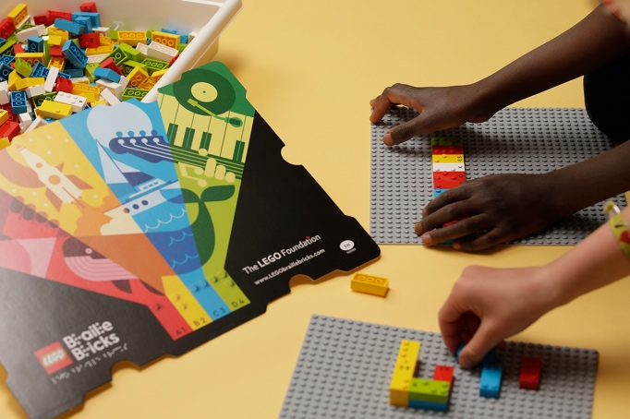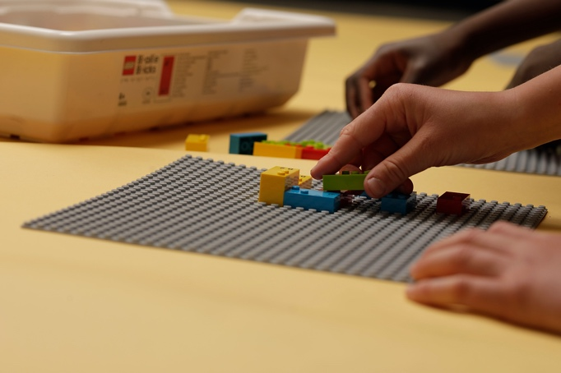

Let’s play
- Let’s have a free play session with the entire toolkit!

How to prepare
- 1 toolkit

Facilitation tips
- Observe, listen to and acknowledge children during play.
- Provide inspiration, support and encouragement.
- Suggest new experiences and challenges if free play becomes repetitive.

Possible variations
- Peer play: share the toolkit to cooperate, collaborate, co-create.

Children will develop these holistic skills
- COGNITIVE - Solve problems: anticipate the result of a manipulation, calculation or measurement
- CREATIVE - Identify various leisure activities to be done alone or with other people
- PHYSICAL – Manipulate, make an intentional movement with an object
- EMOTIONAL - Express emotions and feelings in a socially acceptable way
- SOCIAL - Distinguish between personal and collective interests

Did you know
- Free play is often physically active, highly joyful and meaningful to children.
- Free play is linked to executive functions, self-regulation, social skills, self-esteem, health and well-being.
- Children set own goals in the play, following their interests. They are often very active: exploring, asking what if, re-inventing ideas and creating new meanings.

