Building Operation

Improve math computation and placement skills. Plan and carry out multiple operations to create and construct a tall building.

15 min 1 participant

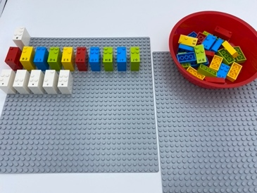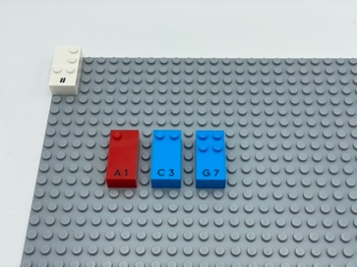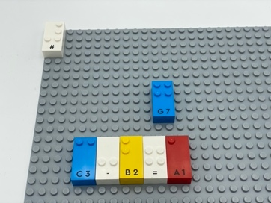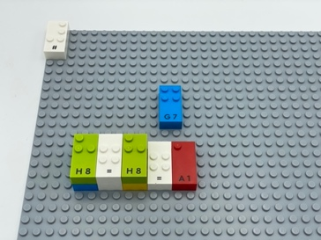

Let’s play
- Pick three Number bricks
- Use them to create a correct math equation if possible. If not possible, continue picking one brick at a time until a correct equation can be made from 3 or more bricks
- Build the first floor of the building by correctly writing the equation on the base plate
- Repeat above directions and include left-over bricks to build more floors for the building

How to prepare
- 2 base plates
- All Number and math bricks
- Number sign brick

Arrange all the numbers and math sign on a storage base plate to ease in finding characters.

Facilitation tips
- Explain “Number sign brick placed once on the top left corner of the baseplate indicates all bricks are numbers.”
- Ask “What is your strategy to build the highest building?”

Possible variations
- Include math operation bricks
- Add a timer
- Make it a collaborative activity

- Children will develop these holistic skills
- COGNITIVE: Stabilize knowledge of small numbers: verbalize the decomposition of the number
- CREATIVE: Engage in solitary play activities for an appropriate amount of time
- EMOTIONAL: Share rules, roles and responsibilities
- SOCIAL: Cooperate and share: Work together to facilitate individual learning
- PHYSICAL: Develop tactile tracking skills: Use both hands to track across broken lines on a page and identify space between lines

Did you know
- Physical play is linked to spatial skills and mathematics.

