Water Turtle or Lizard

Search, find, discriminate and help animals return to their favorite homes.

15 min 1 participant

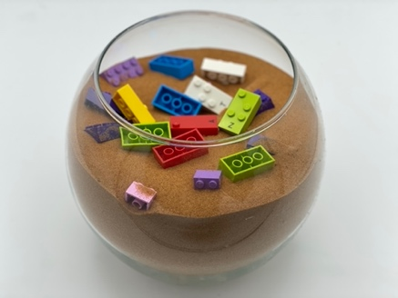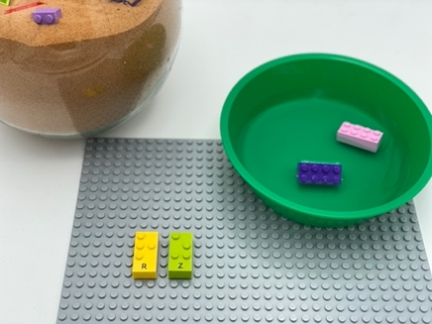

Let’s play
- Search the beach for 20 animals hidden in the sand. LEGO Braille Bricks are lizards, other bricks are water turtles
- Find a lizard? Attach it to its favorite home: the base plate
- Find a water turtle? Release it in the ocean, its favorite home
- Encourage the animals to tell us about their homes!

How to prepare
- 1 base plate
- 1 bowl full of water
- 1 large bin or box full of sand
- 10 random LEGO Braille Bricks
- 10 LEGO classic bricks or DUPLO bricks
Hide the 20 bricks in the sand.

Facilitation tips
- Find and encourage discussion about turtles and lizard, animal characteristics, and living environment…
- Provide a tangible example of the animals (plastic, stuffed animals, figurines…)
- Place animals in a bowl without sand to avoid exploration for “tactile defensive” players.
- Offer choice to attach lizard: to a disc of playdough, or another surface...

Possible variations
- Change the number of bricks, or the distribution among the animals
- Use other objects for the turtles, for easier discrimination (balls, marbles, cubes…)
- Change the size and shape of the turtles (mix classic bricks or DUPLO of different shapes)
- Play with peers, taking turns

Children will develop these holistic skills
COGNITIVE - Recognize, classify and sort shapes in 3 dimensions
CREATIVE - Retell or create simple stories
PHYSICAL - Compare - discover similarities, differences, and preferences: sort and match
EMOTIONAL - Control motor skills and emotional commitment to succeed in simple actions
SOCIAL - Participate in discussions, presentations, performances, role play, improvisations and debates

Did you know
- Through this fun activity, children share new sensory experiences, learn to explore, manipulate, imagine, sort... while having fun!

