Apple Trees

10 min 1 participant

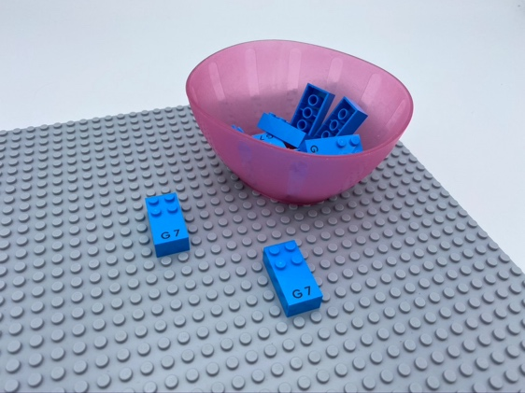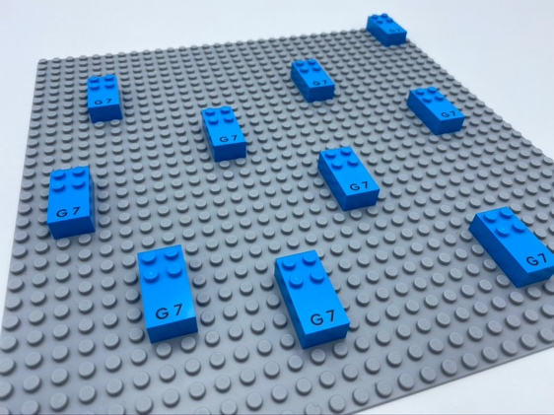

Let’s play
- Pick an apple tree brick from the bowl.
- Look for the studs on the brick: they are the apples! The smooth part of the brick is the trunk.
- Attach the apple tree to the base plate. Make sure your tree is not upside down!
- Plant as many trees as you can to make an orchard!

How to prepare
- 1 base plate
- 10 letter bricks “G”
- 1 bowl
Place the 10 bricks in the bowl.

Facilitation tips
- Encourage and demonstrate tactile exploration of the brick. Identify the flat space as the bottom of the brick and explain braille brick orientation: space at the bottom, studs on top!

Possible variations
- Choose others LEGO Braille bricks, not only “G”.
- Preplant apple trees on the base plate.

Children will develop these holistic skills
- COGNITIVE - Recognize spatial relationships
- CREATIVE - Express self through craft, artwork: explore various crafting activities
- PHYSICAL - Develop hand and finger strength
- EMOTIONAL - Implement an artistic project
- SOCIAL - Distinguish between personal and collective interests

Did you know
- Facilitating children’s learning is different from thinking of teaching as « delivering content », because the goal is for the young children to understand concepts and develop a breadth of skills they can apply.

