Dice

30 min 3 participants

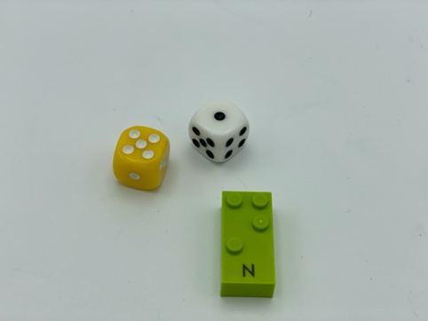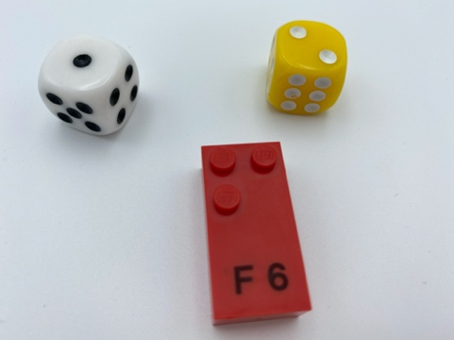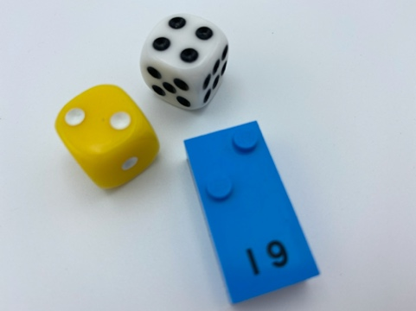

Let’s play
Players taking turns:
- Roll the 2 dice and read the numbers.
- Find a brick with at least 2 of the dot numbers on your dice:
i.e. roll a 2 and 5 - find a brick with at least dot 2 and dot 5 (G, H, Q, R…).
- Store the brick on your base plate.
- Roll doubles? Roll again.
Keep playing until all players have at least 10 bricks.

How to prepare
- 1 base plate per player
- All the bricks
- 2 dice

Facilitation tips
- Encourage light tactile exploration of the bricks, “Don’t try to crush them!”.
- Confusion between dot’s position in the braille cell, how we represent numbers in braille and the number of dots in the constellation can be avoided by saying “dot 2” and not only “2”

Possible variations
- Change the number of dice.
- Change the rules: find bricks without the studs equal to the numbers rolled.

Children will develop these holistic skills
- COGNITIVE - Relate numbers 1 through 6 with braille cell positions/dot number
- CREATIVE - Reproduce, assemble, organize, link graphic patterns and then create new ones
- PHYSICAL - Recognize and discriminate SHAPES by touch: recognize and interpret tactually solid embossed shapes, outlines of objects, raised lines, raised symbols
- EMOTIONAL - Identify consequences of behaviors in social interactions
- SOCIAL - Understand, respect and enforce rules and regulations

Did you know
- Children need high-quality interactions with peers and adults for this learning to take place.
- Young children show instances of regulating their thinking, feelings and behavior; they can stay focused during play, engage with peers, remember events, care for others and learn to wait for their turn.

