Enchanted Forest

10 min 1 participant

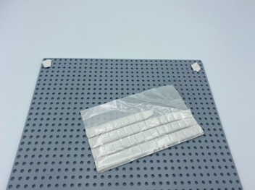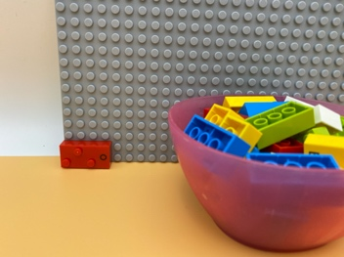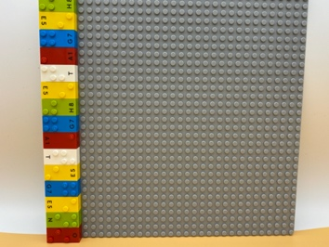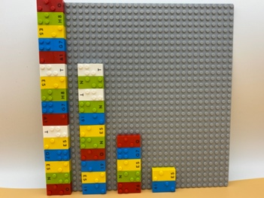

Let’s play
- Add bricks to the base plate to help the tree grow
- Let’s have a free play session!

How to prepare
- 1 base plate
- 1 bowl
- 16 random bricks or more
Apply adhesive putty to the back of the base plate and stick it to a wall.
Attach one brick horizontally to the base plate: in the bottom left corner.

Facilitation tips
- Suggest creation of an entire enchanted forest.
- Ask “What makes it an enchanted forest?”.

Possible variations
- Start the tree with more than one brick.
- In preparation, start several trees.
- Do not put the first brick and leave the base plate empty.
- Play with peers.

Children will develop these holistic skills
- COGNITIVE - Recognize and use notions of alignment, right angle, equality of lengths, middle, symmetry
- EMOTIONAL - Implement an artistic project
- PHYSICAL - Develop bilateral hand use
- SOCIAL - Engage in game, pretend play activities, verbal play with peers

Did you know
- Creative skill means coming up with ideas, expressing them and transforming them into reality by creating associations, symbolizing and representing ideas and providing meaningful experience for others.

