Snake
Count the dots on the tail snake and pick an equal number to make the reptile grow!
15 min 2 participants

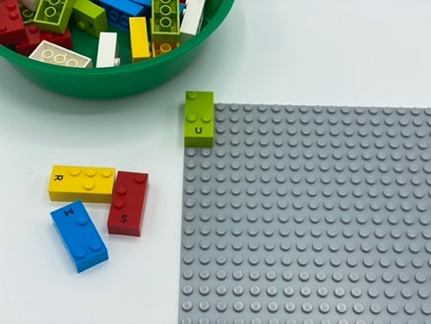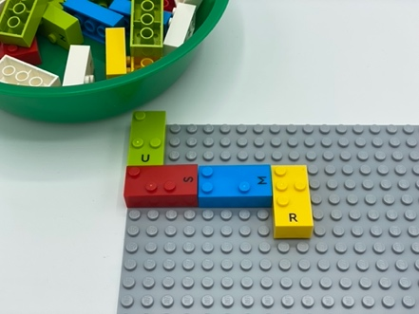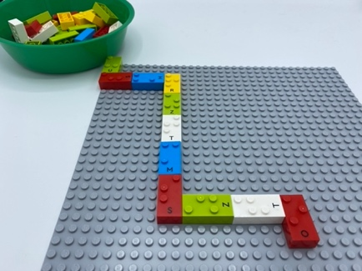

Let’s play
Player 1
- Find the brick on the base plate. It is the head of the snake
- Count the dots on the brick
- Pick an equal number of bricks from the box: ie 3 dots on the brick? Pick 3 bricks!
- Make the snake grow longer by attaching the bricks to its head. It can grow in all possible directions, but the last brick must be placed in the correct reading position.
Player 2
- Find the tail of the snake
- Count the dots on the tail
- Pick an equal number of bricks from the box
- Make the snake grow longer by attaching the bricks to its tail, in all possible directions. Remember the last brick must be placed in the correct reading position.
Both players
- Continue play until you can’t make the snake any longer.

How to prepare
- 1 base plate
- All bricks
Attach one brick at the top left corner of the base plate, in the correct reading position.

Facilitation tips
- Make a snake with playdough: roll the clay into a rope. Explore the various possibilities of the snake's body position (coiled, straight, wavy, curvy…).
- Add a tactile marker to the head (small ball of play dough, another brick to make a pile…), not to confuse it with the tail.

Possible variations
- Take a bigger base plate or use several ones
- Select bricks with a few dots and place them in a bowl
- Can be played alone or with many players

Children will develop these holistic skills

COGNITIVE - Stabilize knowledge of small numbers: Build a collection using counting.
CREATIVE - Organize objects in play: Use a toy resembling a “real” object to represent that object.
PHYSICAL - Explore and discriminate to get information about the tactual properties of an object.
SOCIAL - Cooperate and share: Organize work in a group to develop a common task and/or collective production and make own skills and knowledge available to others.
EMOTIONAL - Control motor skills and emotional commitment to succeed in simple actions.

Did you know
- Guided play can lead to higher gains on literacy, numeracy, social skills and self-regulation skills than instruction or free play alone.

