Hula hoops words

30 min 3 participants

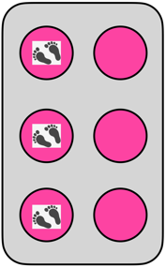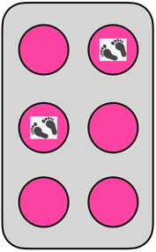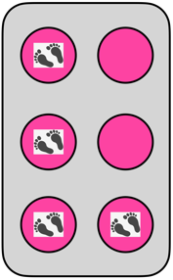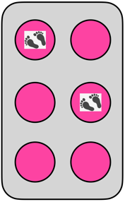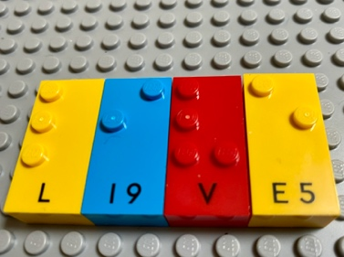

Let’s play
Team 1
- Think of a secret word containing up to 4 letters.
- Write the word by placing people from the team in the braille cell hula hoops to represent each letter. (Balls can be used as markers in the Hoops if necessary).
Team 2
- Read the jumbo secret word and write it with braille bricks on the base plate.
Both Teams
- Compare and discuss the word.

How to prepare
- 1 base plate
- Letter bricks
- 24 Hula hoops
- A few balls or objects
Arrange the 24 hoops like 4 braille cells on the floor.
Divide the group into 2 teams.

Facilitation tips
- Familiarize players with the hula hoop braille cell concept: walk in the “Hula Hoop braille cell” and ask about the dot numbers and how to represent a specific letter.
- Confusion between dot’s position in the braille cell, how we represent numbers in braille and the number of dots in the constellation can be avoided by saying “dot 2” and not only “2”.
- Ask “What was your team strategy for making decisions during the game?”.

Possible variations
- Instruct teams to produce and guess only one letter at the time by using only one hula hoop braille cell.
- Preselect mandatory letters.

Children will develop these holistic skills
- COGNITIVE - Copy and write, from memory, simple words and sentences
- PHYSICAL - Engage in the activity over time and explore different possibilities, using manipulated objects: build a construction, copy from a reference manipulated or observed model
- CREATIVE - Reproduce, assemble, organize, link graphic patterns and then create new ones
- EMOTIONAL - Indicate awareness of own visual abilities and limitations
- SOCIAL - Negotiate with others to resolve problems

Did you know
- This game allows inclusion of a blind child in a physical group activity and introduces sighted children to Braille and visual impairment in a playful way.
- Over time, children should experience moments of joy and surprise, a meaningful connection, be active and absorbed, iterate, develop the game, and engage with others.

