Higher Education from Cambridge University Press
Information for instructors and faculty staff
Higher Education from Cambridge University Press (cambridge.org/highereducation), is the home for Cambridge textbooks.
Within this website, the Cambridge University Press eReader, Cambridge Spiral, provides access to a full range of eTextbooks, alongside all available supplementary learning materials.
Access to an eTextbook collection has been provided by your institutional library subscription.
This document is intended for instructors and faculty members at an institution with a Cambridge eTextbooks subscription. It will help you login for the first time, and will walk through the functionality for instructors.

Contents
How to Log In 3
Personal account login (recommended) 4
Setting up a Personal Higher Education Account 4
Registering your account as an instructor profile 5
Features of your Higher Education Account 6
Using your Personal Higher Education account 7
How to start reading books within the Textbook Subscription 7
Installing the Cambridge Spiral App 8
‘Read-only’ access via guest login 9
Login as Guest 10
How to find textbooks on the Higher Education website 12
Search on the Homepage 12
Refining Search Results 13
Subject area search 15
Textbook Landing Pages 16
Resources 17
Instructor Resources 18
Requesting an examination copy 20
Website functionality and tools 21
Bookmarking 21
Citations 23
Linking textbooks within your Learning Management System 24
Deep links: list textbooks or individual chapters in your syllabi with ease 25
Reading a book (Cambridge Spiral eReader) 27
Functionality within Spiral eReader 28
Adding Bookmarks 29
Bookmark menu 30
Creating Annotations 31
Editing Annotations: Annotations Menu 32
Printing pages 33
Increasing the font size 34
Group Mode: Sharing annotations with a Student Group 35
Creating a Group 35
Template text: provision of Group Code to a Student Group 38
Group Mode: Accessing a group using an Group Code 39
Bulk Annotation Sharing 40
The Cambridge Spiral App 41
Offline and Online reading 43
Adding books to your offline bookshelf 44
Sync functionality 45
Reading on tablet or mobile 46
Information for Students 47
Key contacts and further information 47

How to Log In
Cambridge Spiral, our pedagogically designed eReader, provides digital reading access to the content within the Cambridge Higher Education offering.
There are two options for logging in to enable reading on Cambridge Spiral.
Personal account login (recommended)
“Read-only” access via guest login
Details are provided below on these two options.
A more detailed visualisation of the comparison between these two types of login is also available on our website.

Personal account login (recommended)
By creating a personal account, you will have access to the enhanced functionality within the Cambridge Spiral eReader, including the ability to:
- Make personalised bookmarks, highlights, annotations, and links as you study, then use the Annotations tab to manage and review
- Copy and print up to 20% of any eTextbook
- Login to the Cambridge Spiral App, which enables you to read textbooks online and offline on desktop, mobile and tablet devices. This enables you to download and read textbook content while away from your institution’s campus or when you wish to be offline.

Setting up a Personal Higher Education Account
You can set up an account by selecting the ‘Register” icon in the top right hand corner of the Higher Education website, or simply click here to create an account
You will be directed to the Cambridge Core platform to fill out a short form asking for your name, institutional email address, organisation and country.
Already have a Cambridge Core account?
If you have been reading Cambridge University Press journals and research books, you may already have a Cambridge Core account.
Please ensure that you have selected “I am an instructor” within your Account Settings, found within the Account Dashboard.
You can use the same email address and password details to login to the Higher Education website.
Have you forgotten your login details? Please request a new password.

Registering your account as an instructor profile
If you are an instructor please also remember to select “I am an Instructor” when registering.

This will send a request to our team requesting that your account is setup as under an instructor profile.

This will enable your examination copy requests to be fast-tracked and will also enable you to request access to locked instructor resources.

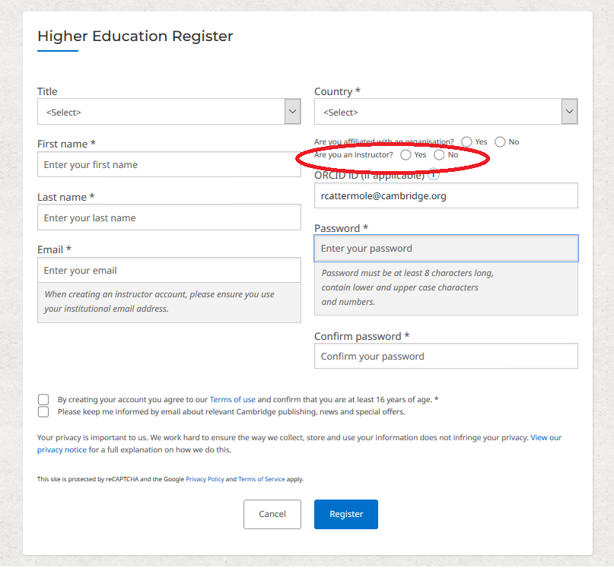

Features of your Higher Education Account

Once you have registered, you will be able to manage your account through the My Account dashboard area. Use the dashboard to manage:
- Examination copy requests (Instructor only)
- Instructor resource requests (Instructor only)
- Your offline bookshelf
- Your bookmarks
- Your order history
- Access Codes that you have used
- Account settings

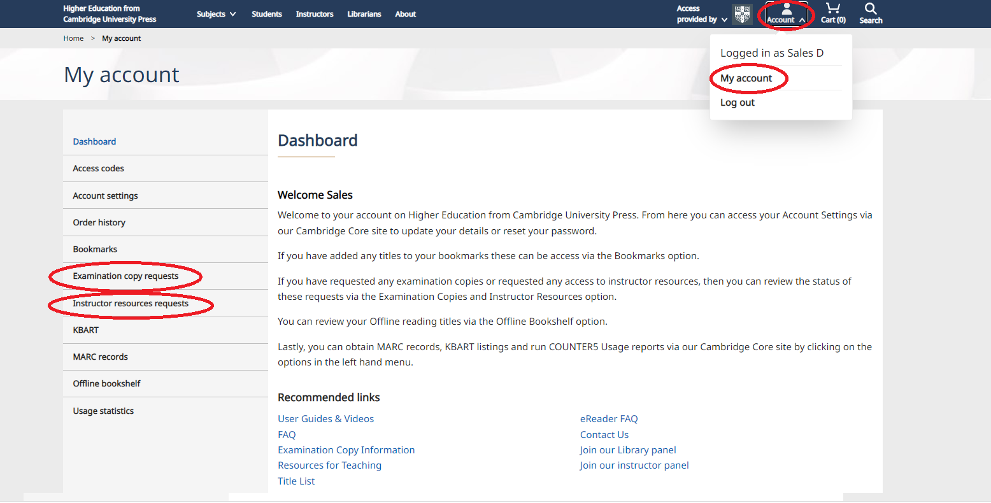

Using your Personal Higher Education account

How to start reading books within the Textbook Subscription
Log onto your university’s library system in the usual way (via your institution’s IP authentication, for example Open Athens, Shibboleth, Raven).
Then open a new tab and go to the Cambridge login page, and enter the login details that you set up in the stage above.
Search for books via our website catalogue, or click on a book link that your instructor has provided to you.
To read a book, click the Read online button on the book landing page, and if your institution’s subscription includes access to this book, this will automatically take you into the Cambridge Spiral eReader.
When accessing via the institutional subscription, unlimited students can read at once.
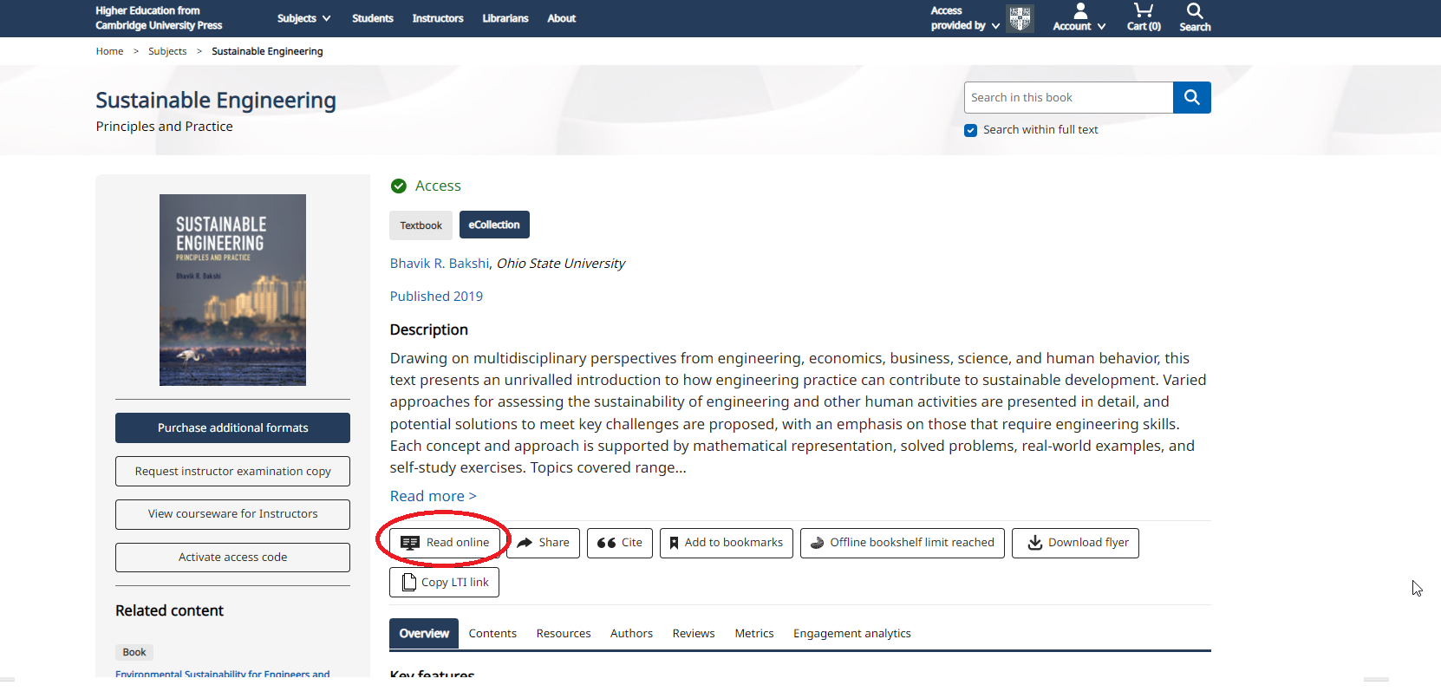

Installing the Cambridge Spiral App
The Spiral App will enable you to read online and offline, on campus and off campus.
Mobile and tablet versions of the app are available to download from Apple’s App Store and Google Play. Desktop versions are also available to download for Windows and Mac.
Click here to view the Cambridge Spiral App download links.
When you install the App for the first time, this may take up to 5-10 minutes to complete.
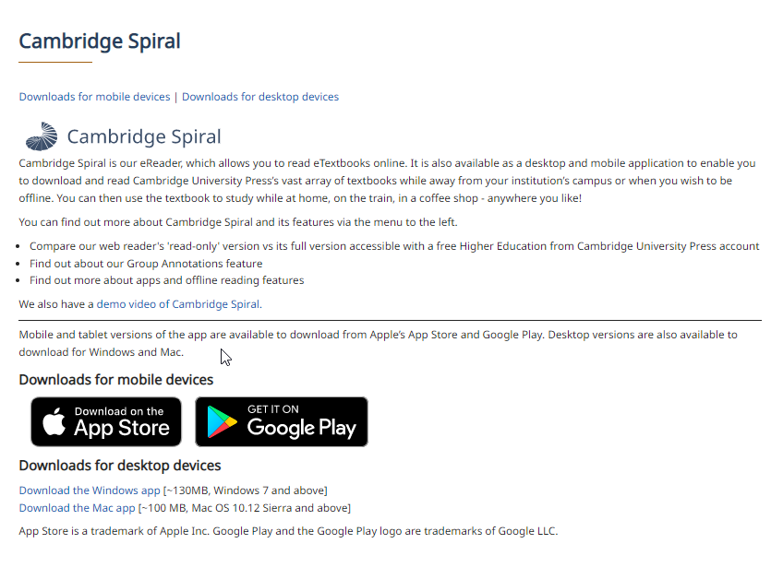
More information about the Cambridge Spiral App is available later in this document.

‘Read-only’ access via guest login
There is an option for ‘guest’ access that does not require a personal login.
Through ‘guest access’ login, you can read books on the online web reader using the read-only version of Cambridge Spiral.
The guest login is only available for reading textbooks with internet access only (it does not allow offline reading).
Guest access does not provide access to the advanced functionality of Cambridge Spiral.

Login as Guest

Log in to your university’s library system in the usual way (via your institution’s IP authentication, for example Open Athens, Shibboleth, Raven).
Then, go to the Cambridge website where your access will be provided via your library system.
Search for books via our website catalogue, or click on a book link that your instructor has provided to you
To read a book, click the Read online button on the book landing page

Click ‘Continue as guest’ and this will automatically take you into the read-only online Spiral eReader.
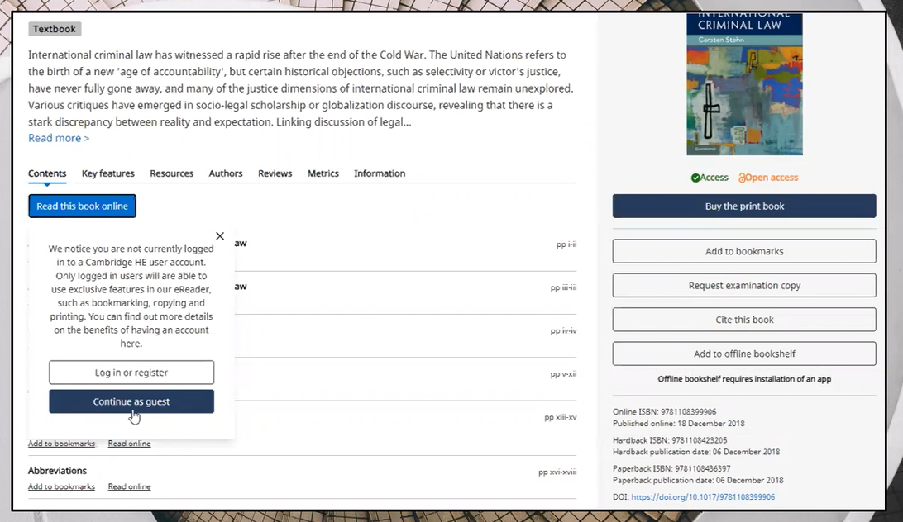

How to find textbooks on the Higher Education website

Search on the Homepage
To perform a search, navigate to the Higher Education website homepage.
Enter your terms in the search box, and select the search icon to view your results. Predictive search has been enabled on the search box.
Typing in a search term will return a selection of results with titles relating to the term.
Predictive search also works by author name. You can enter a name and see the selection of titles authored appear under the search bar.
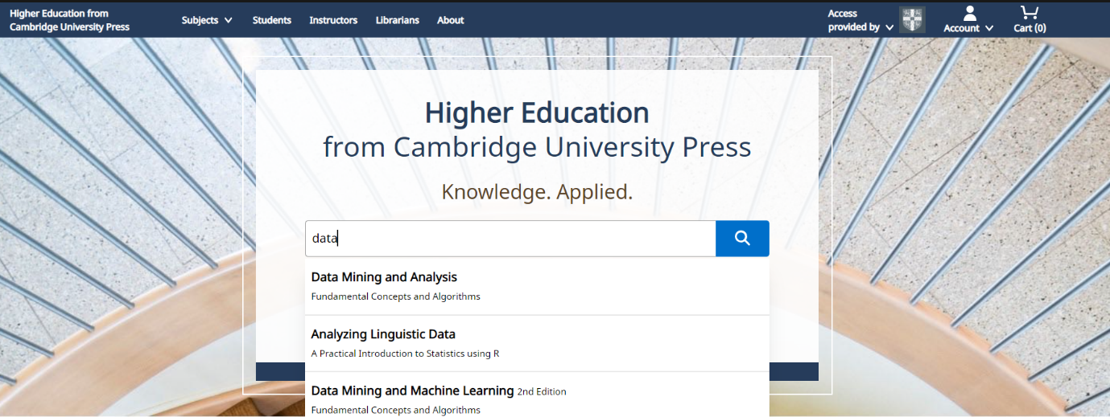

Refining Search Results

You can refine your search results using the filters on the left-hand-side. You can filter by content that you have access to, refine the publication date, and narrow down by sub-subject.

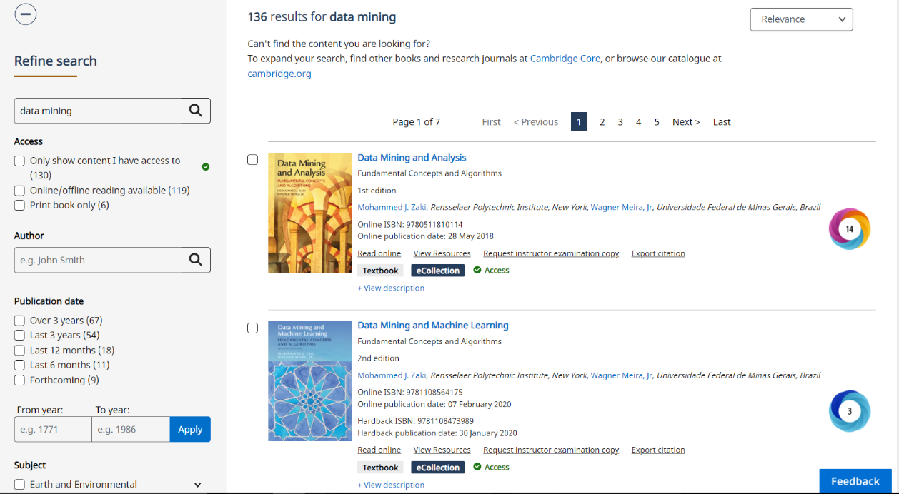

The green Access icon will show you if you have access to the textbook digitally.

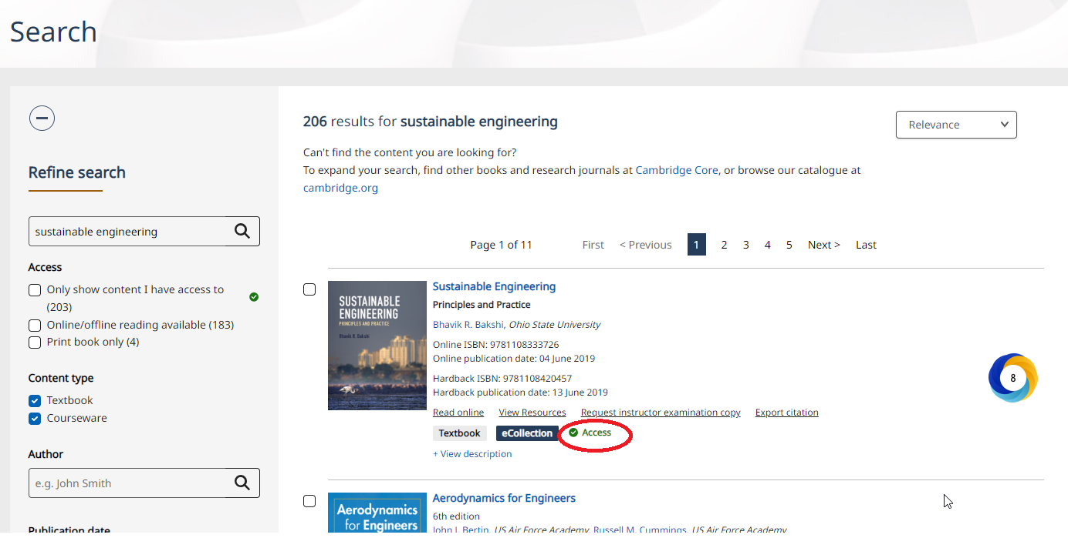

Subject area search

To see a selection of our latest textbooks and a list of subjects that we publish, scroll down the homepage. You will see a list of subject areas.

When you click on a subject area, you will be taken to a page with more sub-subject areas to browse.

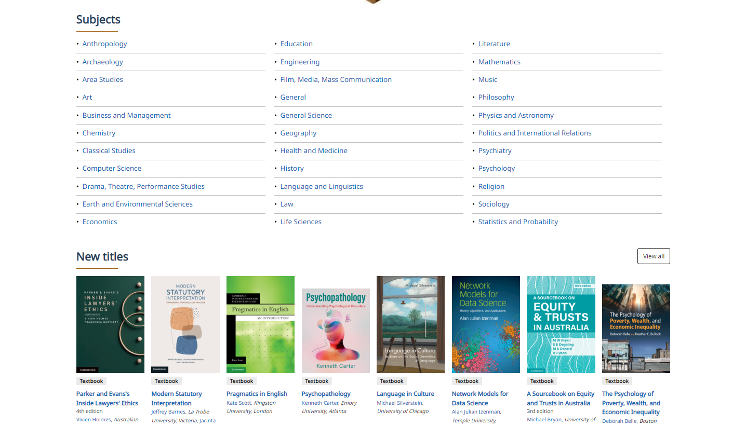

Textbook Landing Pages

By selecting a specific book, you will be taken to its landing page. Here, you can find information about the book (e.g., table of contents, author details, reviews, prices, and ISBN as well as any relevant metrics).

The landing page also enables you to buy an individual print copy of the textbook should you want to.

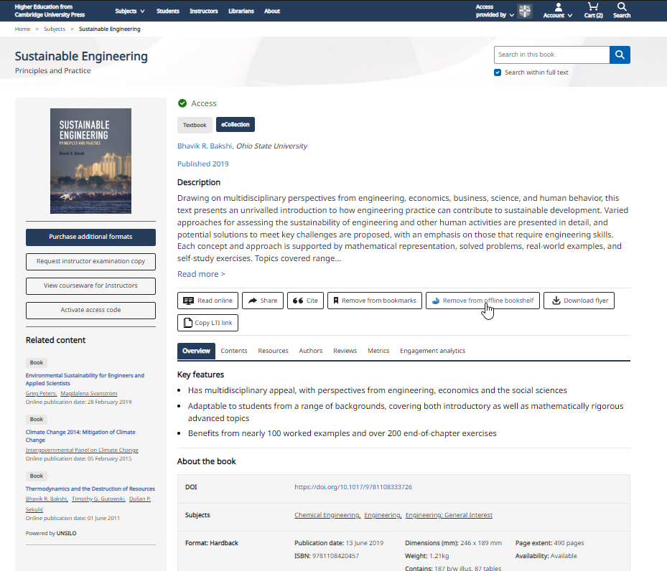

Resources
Resources are supplementary materials available to use with textbooks. If a textbook has a Resources tab, Resources exist for that title and can be viewed via that tab.

There are two types of resources: General Resources, which are free to download without restrictions, and Instructor Resources which require the user to be validated as an instructor.

Note: If the Resources tab is not visible, then no resources are available for that title.
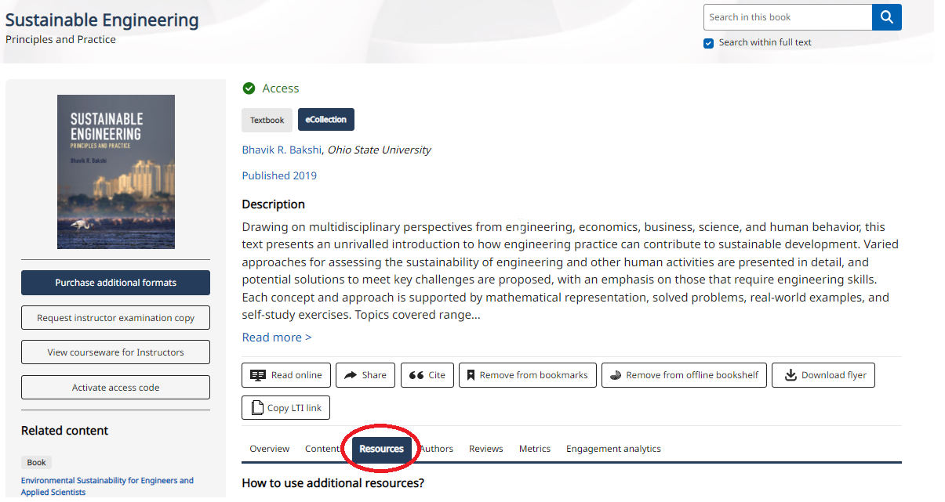

Instructor Resources
You must be logged in to an instructor account to request instructor resources for a textbook.
If you have not yet requested access to the instructor resources, you may see a padlock symbol next to the resources, you will need to request access by clicking ‘Unlock instructor resources’.
(If you need to be set up as an instructor after you have registered for an account, please go to your Account Settings within the Account Dashboard and select the “I am an Instructor” box underneath your organisation name).

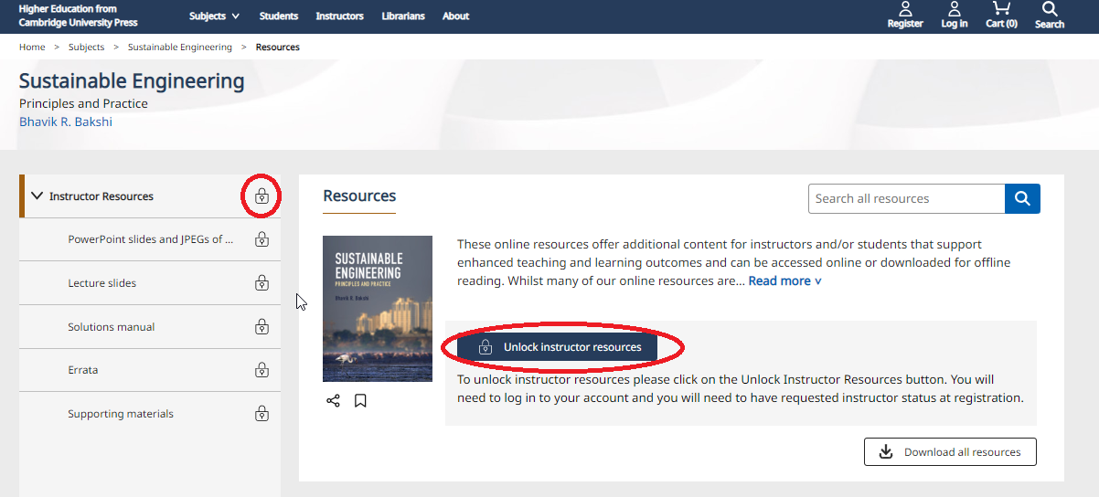

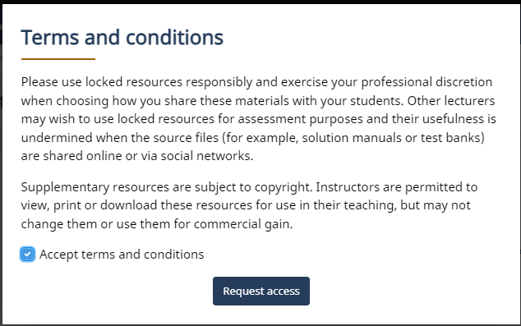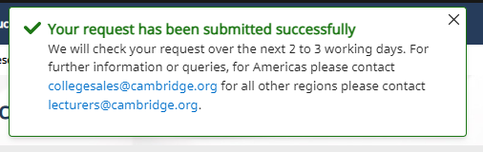

You will receive a response to your request via your registered email address.
If you have any queries about instructor resource requests, please email collegesales@cambridge.org for The Americas and lecturers@cambridge.org for the rest of the world.

When you have been provided with access, you will see green ticks next to the instructor resources, which means you can now access this content.
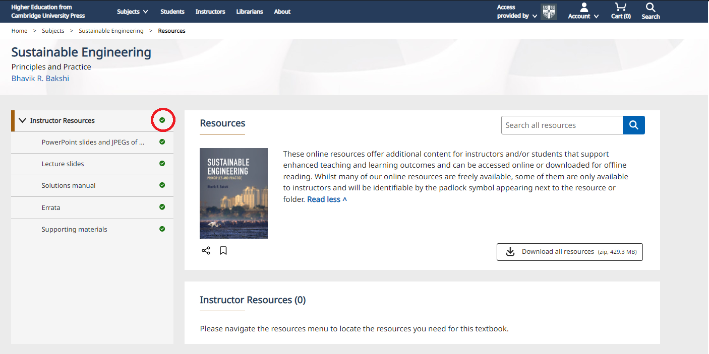

Requesting an examination copy

On the landing page for a title, you will see a “Request instructor examination copy” button beneath the book cover image. Clicking this will take you to a form where you may request an examination copy in print or electronic format.
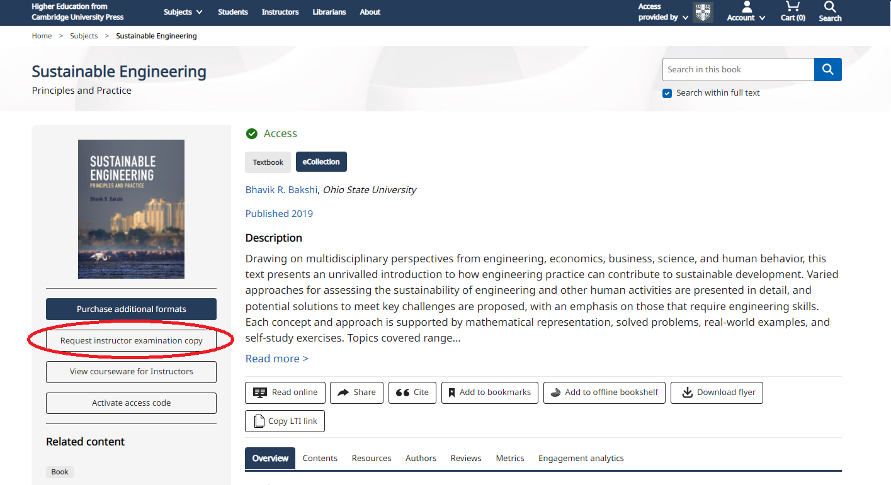

Website functionality and tools

Bookmarking
You can select Add to Bookmarks to enable you to easily find the textbook you are interested in again.

You must be logged in to a personal account to use bookmarks.
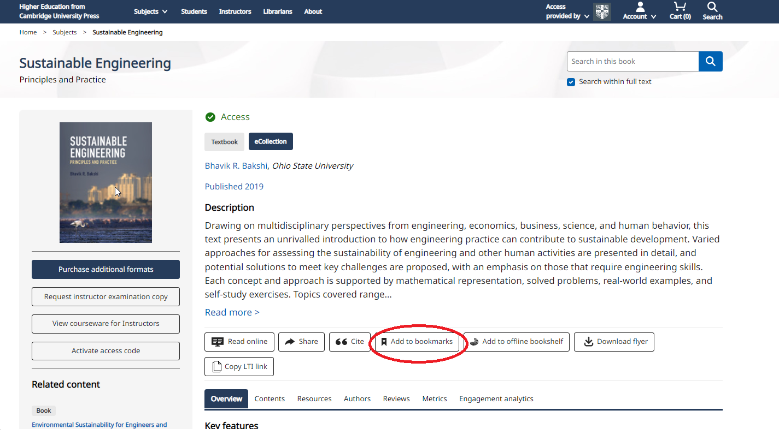

You can find your bookmarked textbooks in My Account.

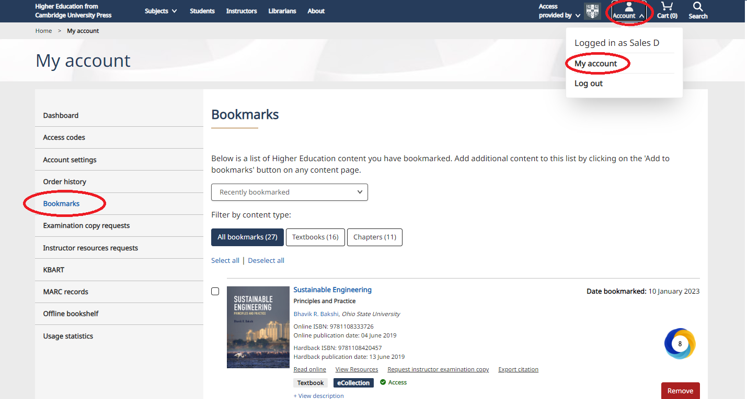

Citations
Watch this video to see how citations work.

Export citation functionality is conveniently located on multiple pages throughout the website.
From the citation tool pop up you can change the citation style by using the change selected format button.

You can copy and paste, or download the citation, or export to various citation tools.

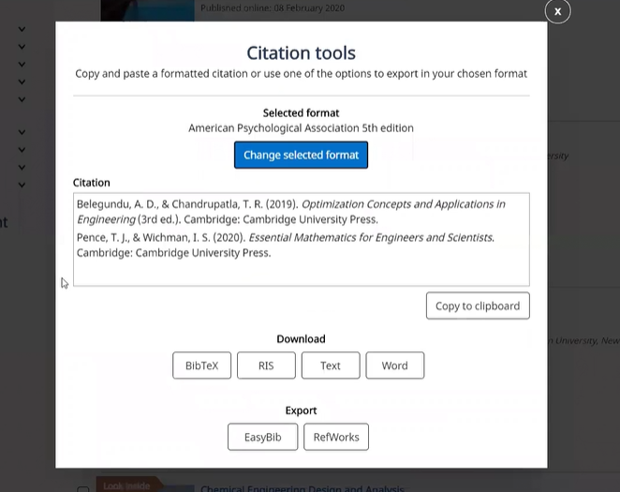

Linking textbooks within your Learning Management System

The button “Copy LTI link” appears on the book landing page.
You can use this functionality to link the ebook directly within your institutional Learning Management System (e.g. Blackboard, Moodle and Canvas).

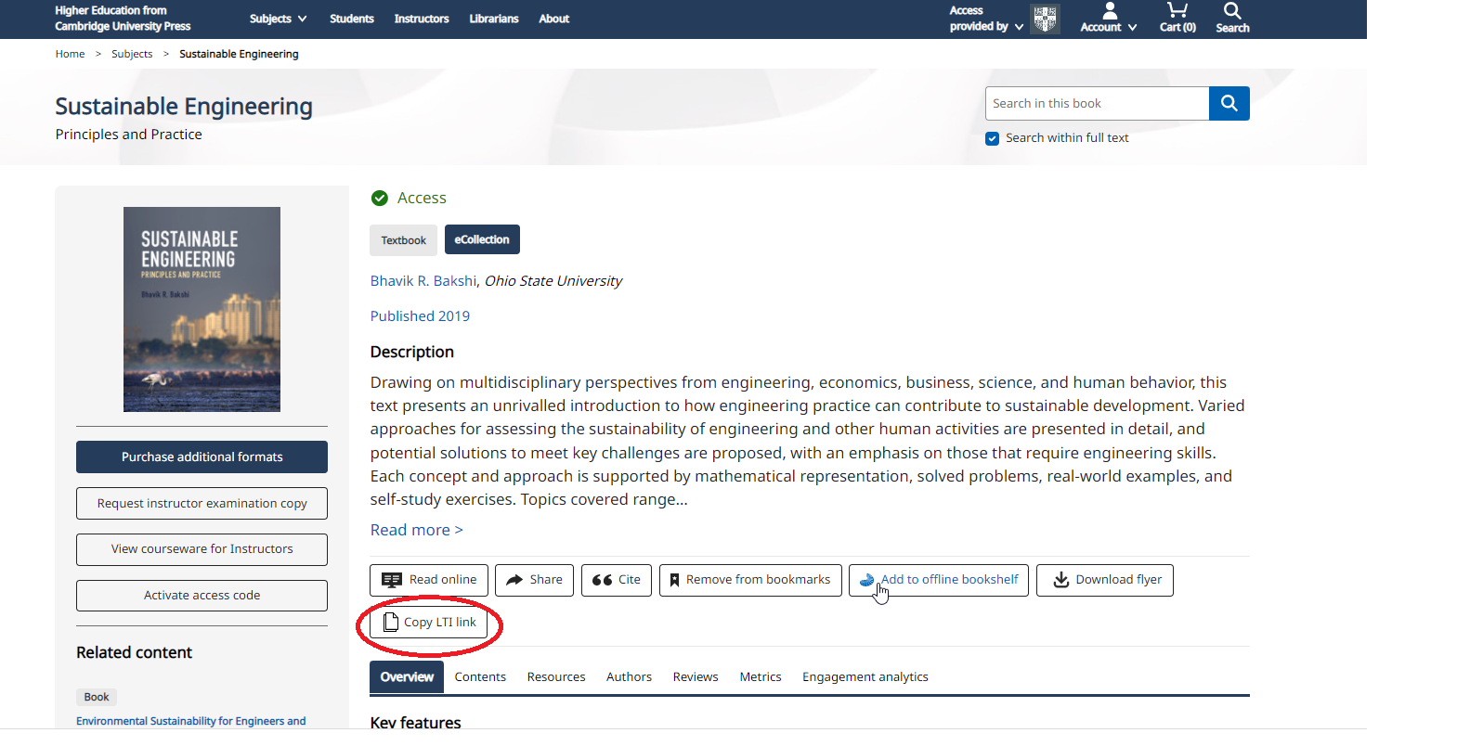

Deep links: list textbooks or individual chapters in your syllabi with ease
Deep link functionality helps instructors to easily share content with students, and it does this in a very granular way.
As an instructor, when you are creating a syllabi, if you would like your students to use just one chapter, you might choose to include the deep link for that chapter on the syllabus.
This will enable students to simply click on the link and they will be directed to the exact chapter that you would like them to read.
How to find deep links
On a book landing page, there is a tab to view ‘Contents’.
Navigate to the chapter within this table of contents that you wish to link to, by clicking on the title of the chapter.
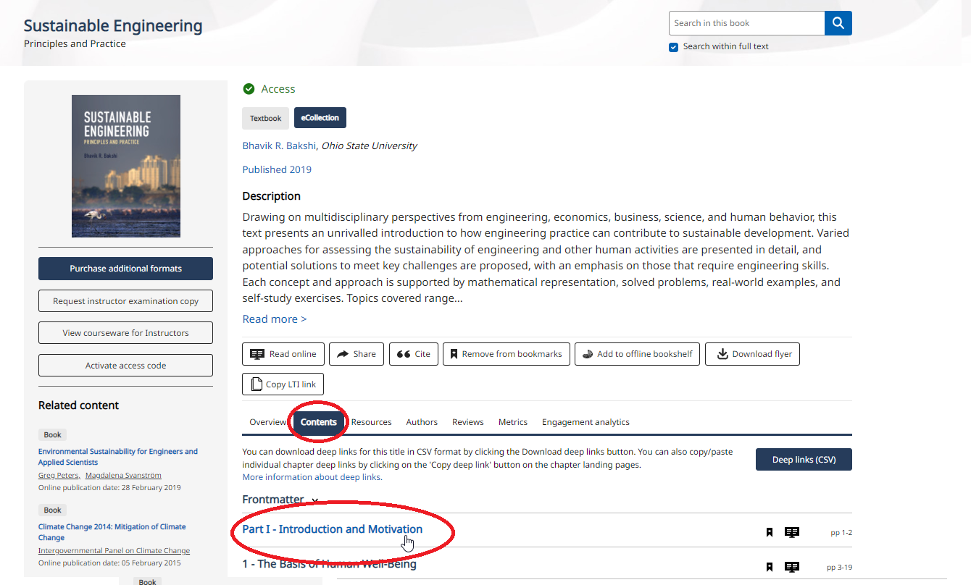

For example, this is the landing page for Part I of this textbook.
You will see the option to ‘Copy Deep Link’ via a button on the right hand side of the screen.

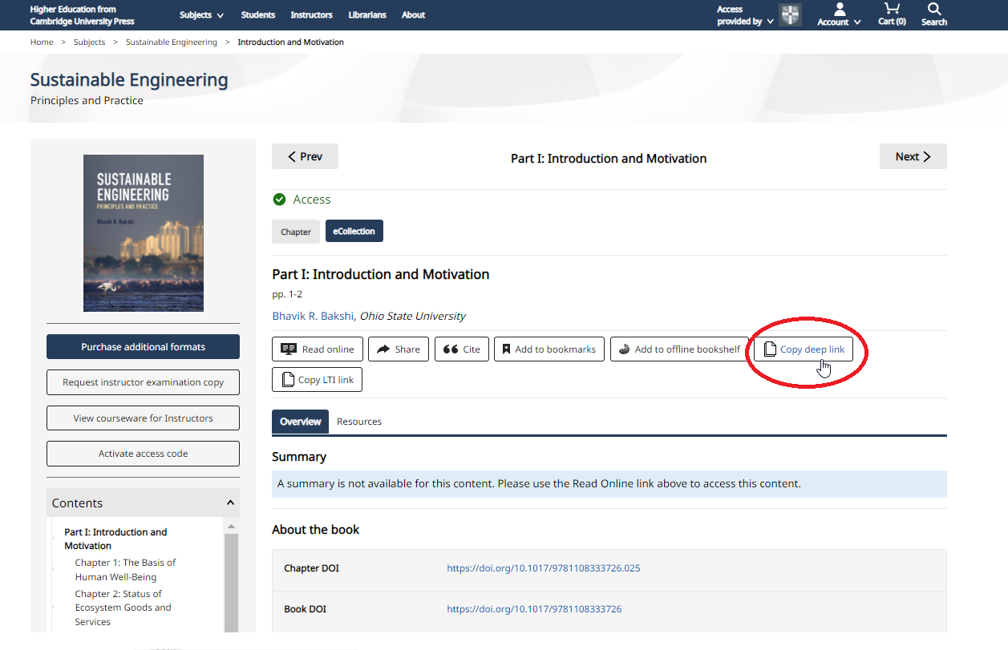

Reading a book (Cambridge Spiral eReader)

Once you have selected a textbook, follow the next steps to start reading online!
You can also watch these instructions in a video format.
To access the Spiral eReader, click the Read online button on the book landing page.

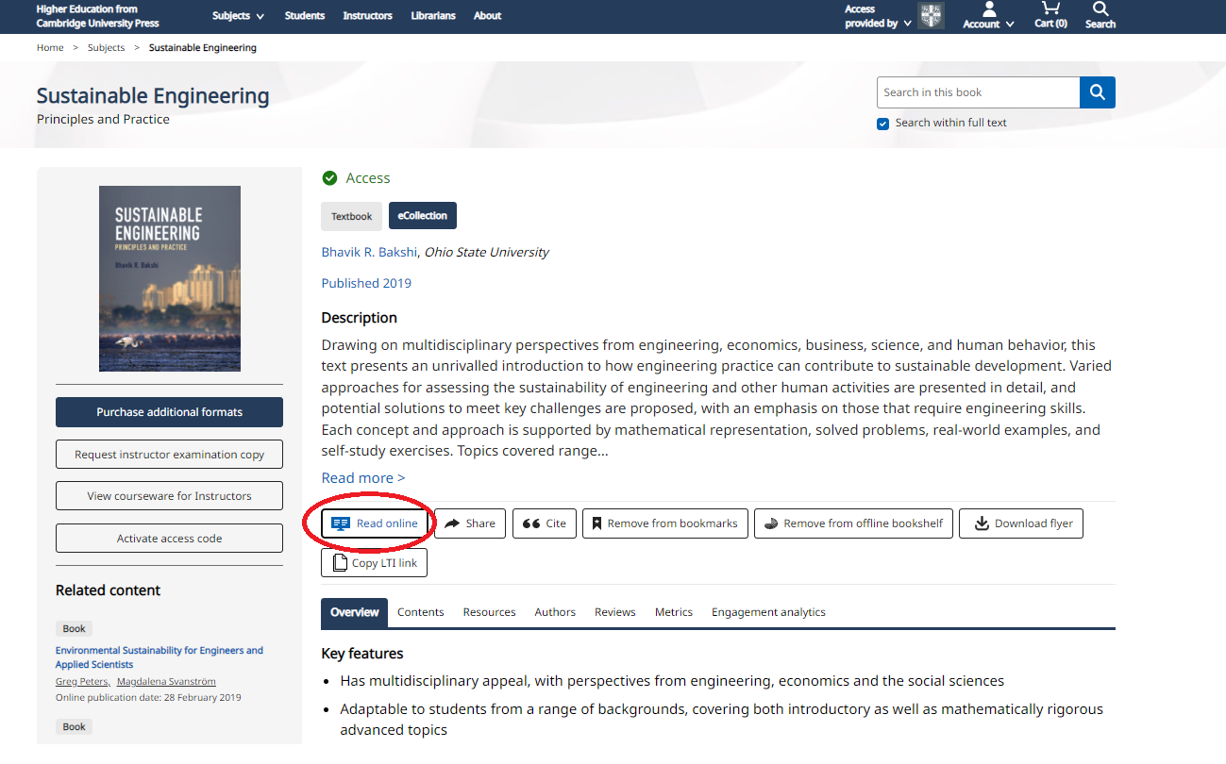

Functionality within Spiral eReader

The following instructions feature the Spiral eReader with full functionality.
To enable this functionality, you will need to be logged in via your personal account.
See instructions at the start of this document on how to create your personal account.

Adding Bookmarks
To add a bookmark, select the bookmark feature on the top right and click the text to drop the bookmark in.

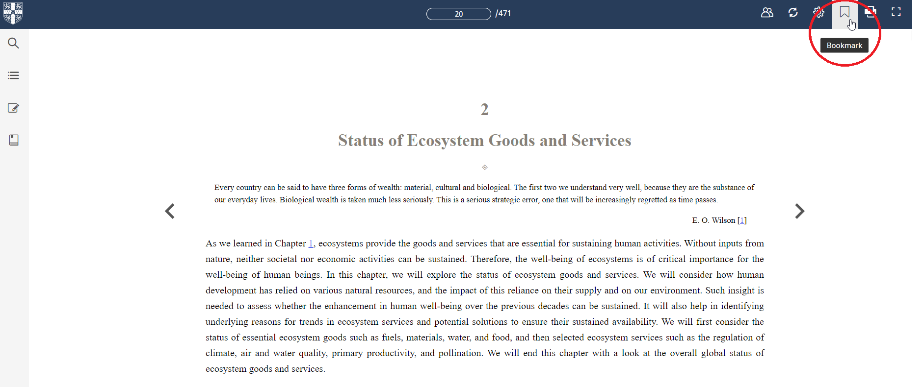

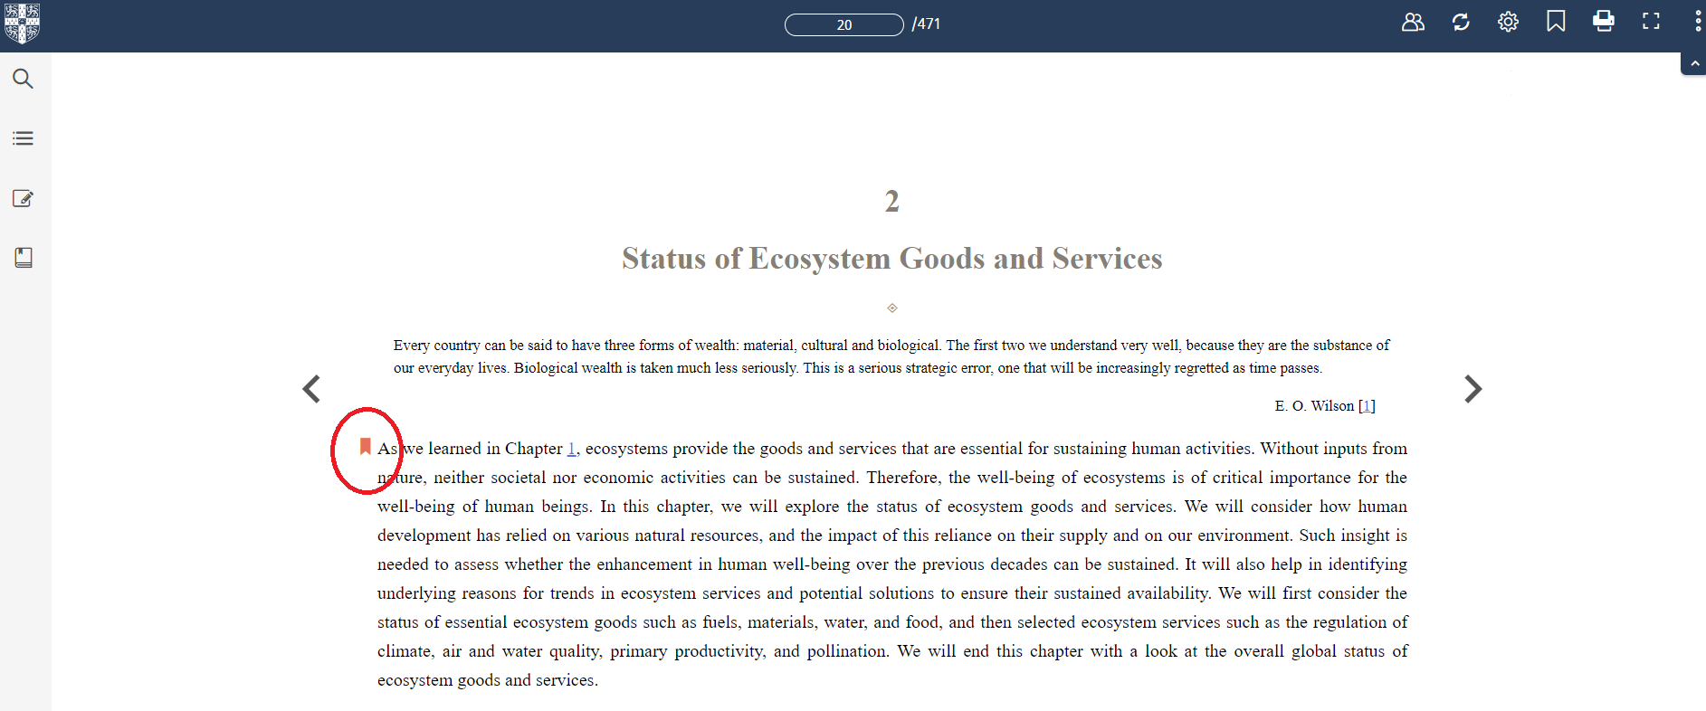

Bookmark menu
From the bookmark menu, you can view, edit or delete bookmarks.
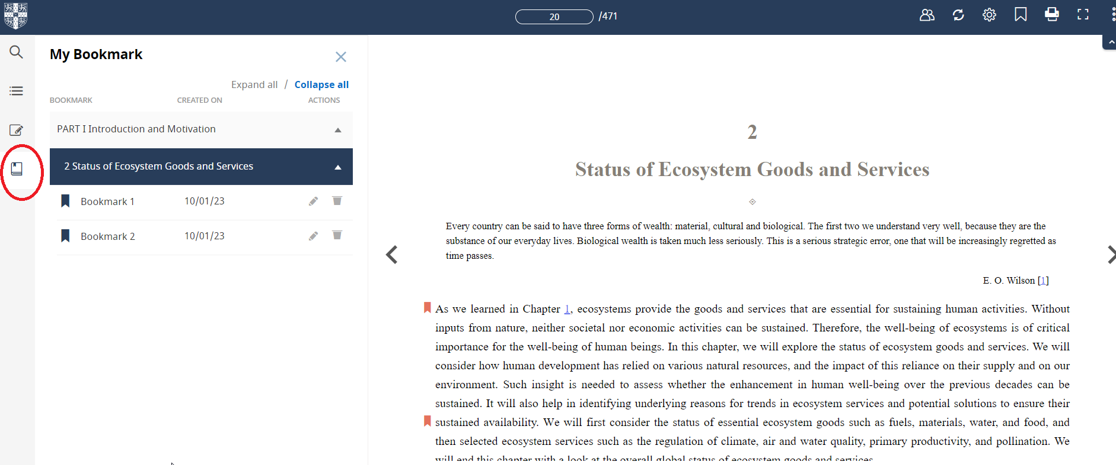

Creating Annotations
To use any of the annotation features, drag your cursor over the text you wish to highlight and the pop up with appear.
Highlighting: Click the highlights button, and choose the colour you wish to apply from the dropdown.
Weblinks: Click the ‘Weblink’ button to add a link to any url on the web.
Hyperlinks: Click the ‘Hyperlink’ button to link to any part of the textbook that you’re reading.
Notes: Click the ‘Note’ button to add a note to the text.
Coping and Printing: Click the ‘Copy’ button to copy up to 20% of the textbook. This will allow you to copy the text in order to paste onto another document or to print your selection.
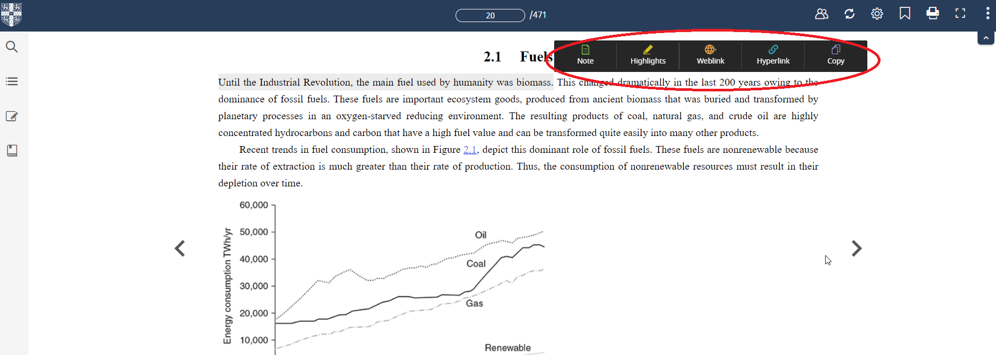

Editing Annotations: Annotations Menu

You can view, edit or delete annotations from the annotations menu on the left hand side.
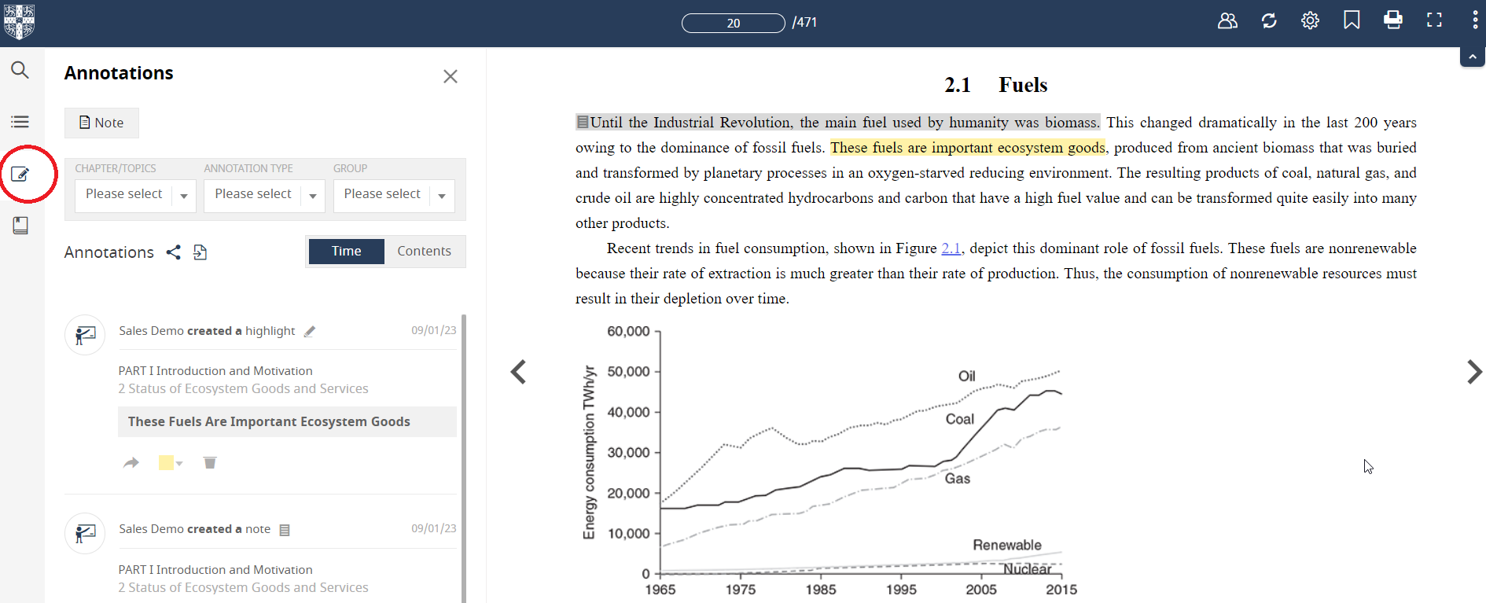

Printing pages
You can use the print icon in the top right hand corner to print up to 20% of a textbook .
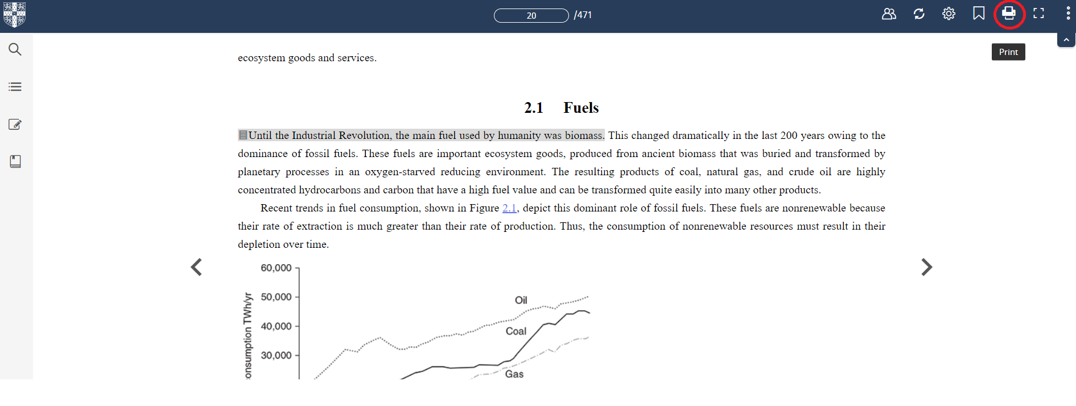

Increasing the font size
You can increase the font size on the page within the settings tab in the top right hand corner.
.
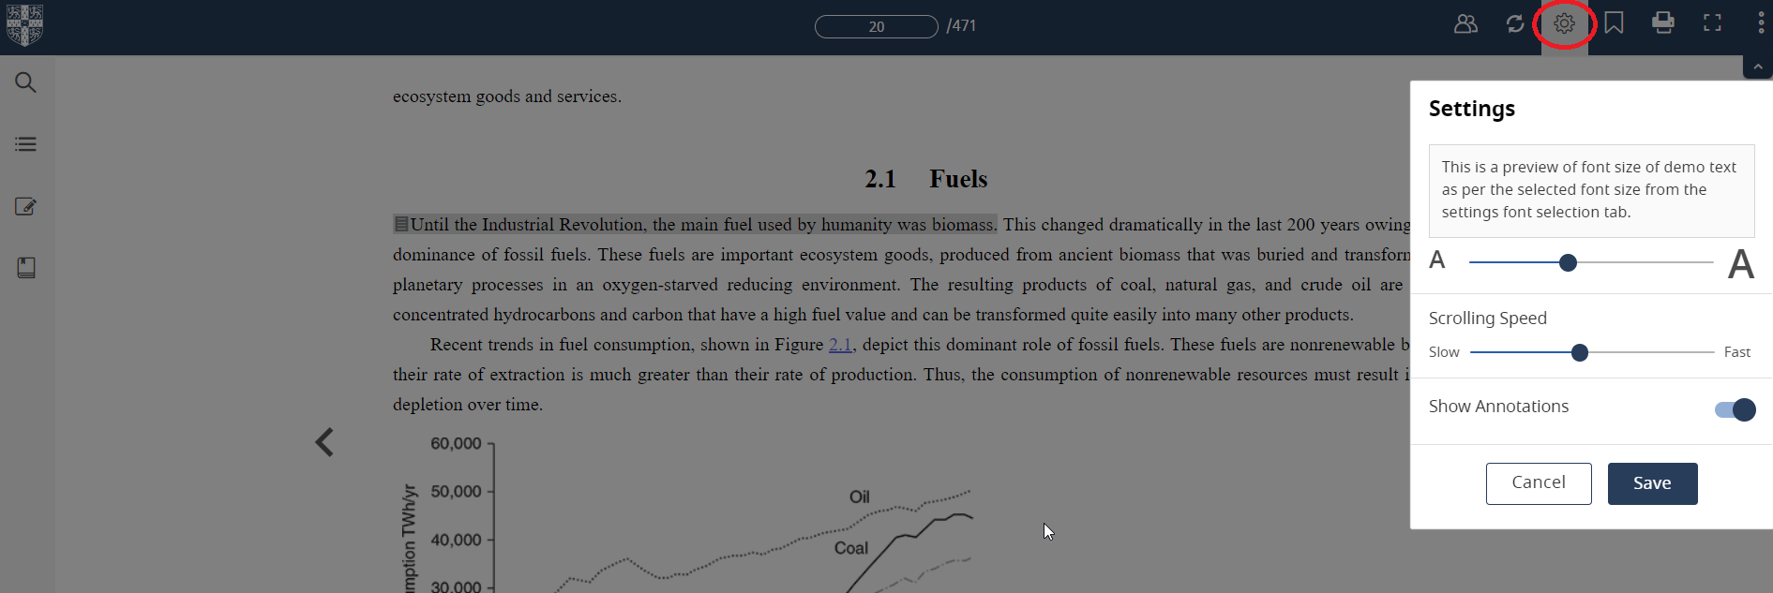

Group Mode: Sharing annotations with a Student Group
Instructions on groups and annotations can also be found in video format via our Group Annotations demo.
‘Group mode’ enables instructors to share textbook annotations with a student group.
For example, this ‘group mode’ allows an instructor to add some notes to the textbook, and then share this with a study group.

Creating a Group
Click on the Groups icon in the top right hand corner.

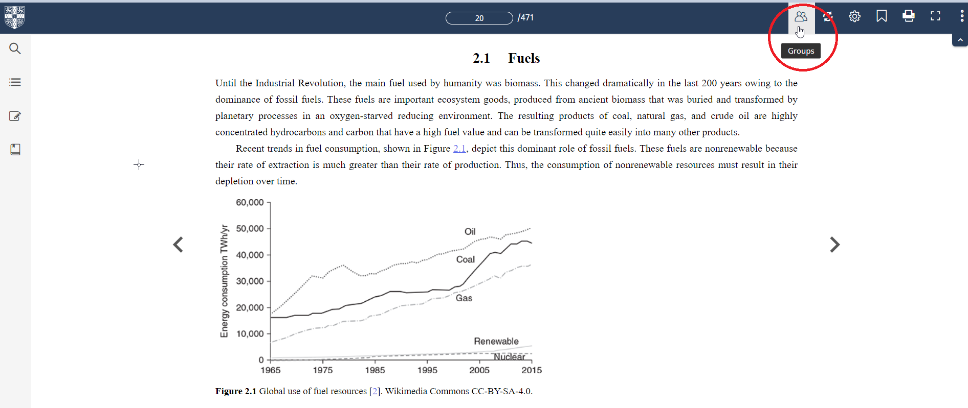

Then, click the orange button to ‘Create Group’. (This button will only appear for instructors at your institution who have an instructor account. Student users are not able to create groups and cannot share annotations).

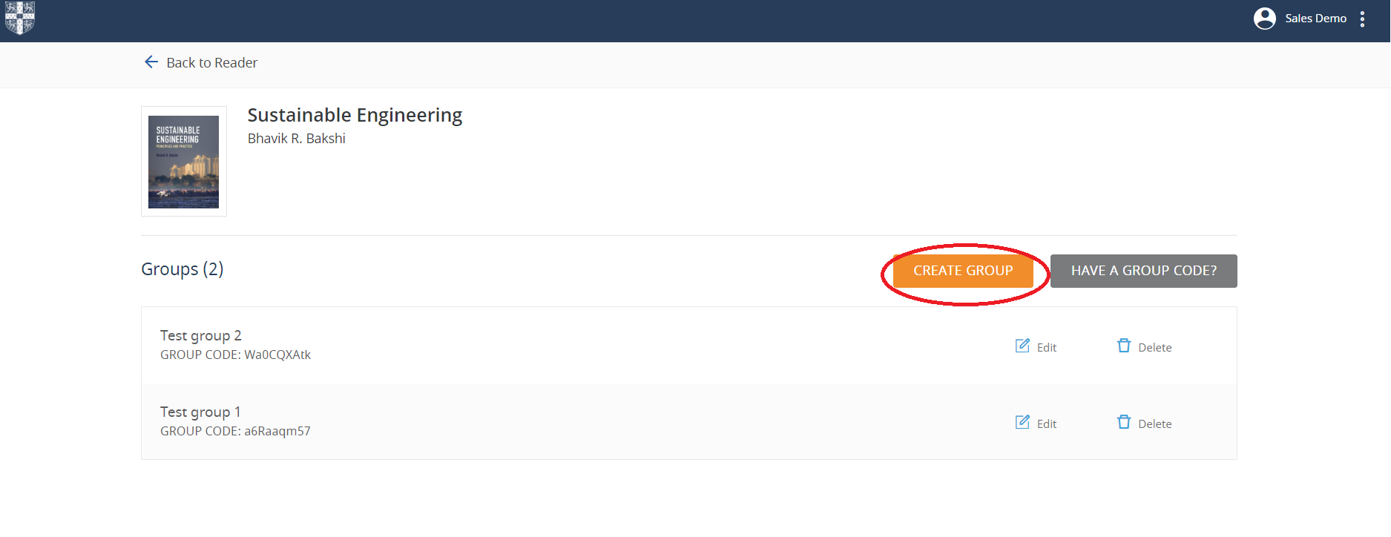

Choose a name for your group and press ‘submit’.

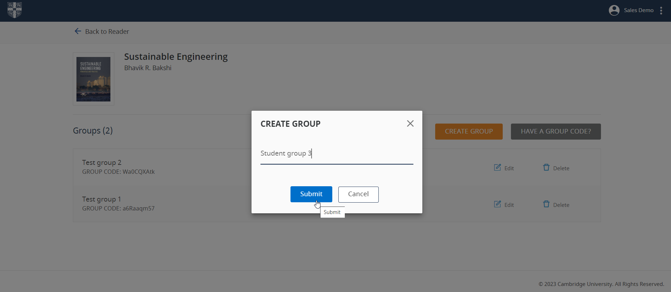

Your group will be created with a Group code displayed underneath the title.
You can now provide this code number to your student group. The next page in this document provides a template for this purpose.
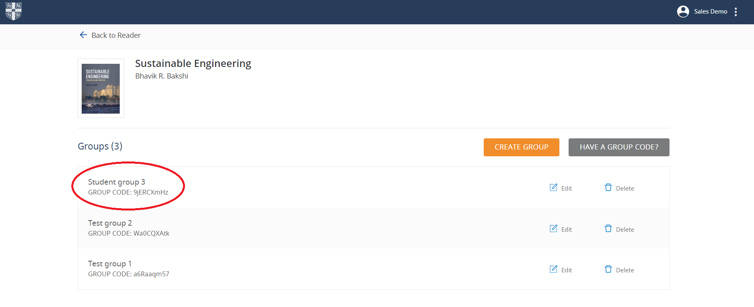

Template text: provision of Group Code to a Student Group
The following text provides a template for instructors to use when supplying a student group with a Group Code.

Higher Education from Cambridge University Press (cambridge.org/highereducation), is the home for Cambridge textbooks.
Within this website, the Cambridge University Press eReader, Cambridge Spiral, provides access to a full range of eTextbooks, alongside all available supplementary learning materials.
Access to this content has been provided by your institutional library subscription.
Your prescribed reading for [insert course/class details] is [textbook title].
Your instructor has provided annotations on this text within the Cambridge Spiral eReader.
To access the instructor annotations, please follow these steps:
- Login to your Cambridge Higher Education account
- Navigate to the landing page of [textbook title] on the Higher Education website
- Click the Read Online button. This will take you into the Cambridge Spiral eReader.
- Click on the ‘Groups’ icon in the top right hand corner
- Select this option: ‘Have a Group Code?’.
Please enter the following instructor group code [Group code]
Once this has been entered, you will be able to view your instructor’s annotations within your etextbook.
Your own personal student annotations will be private and will not be shared with the Group.
Textbook Resources and Supplementary Materials
This textbook may be accompanied by free supplementary materials, which can be accessed via the textbook’s product page on the Higher Education website.
Navigate to the “Resources” tab. If student materials are available for this textbook, they will be stored in the General Resources drop down, and you will be able to download all those that do not have a padlock symbol next to them.
For further information about the Cambridge textbook Spiral eReader and personal account setup, please refer to the document Higher Education from Cambridge University Press_Information for Students.

Group Mode: Accessing a group using an Group Code
Login to your Cambridge Higher Education account
Navigate to the landing page of the textbook on the Higher Education website
Click the Read Online button. This will take you into the Cambridge Spiral eReader.
Click on the ‘Groups’ icon in the top right hand corner
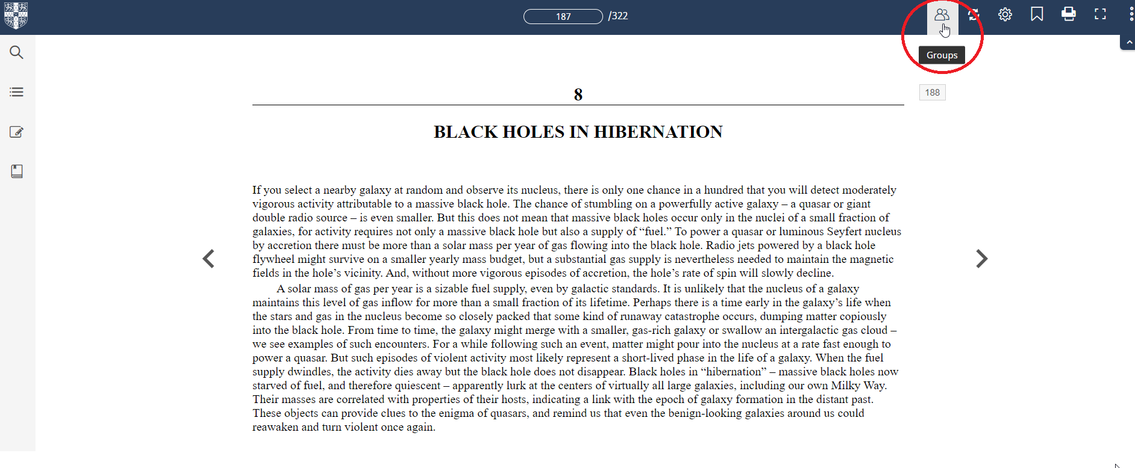
Select ‘Have a Group Code?’.
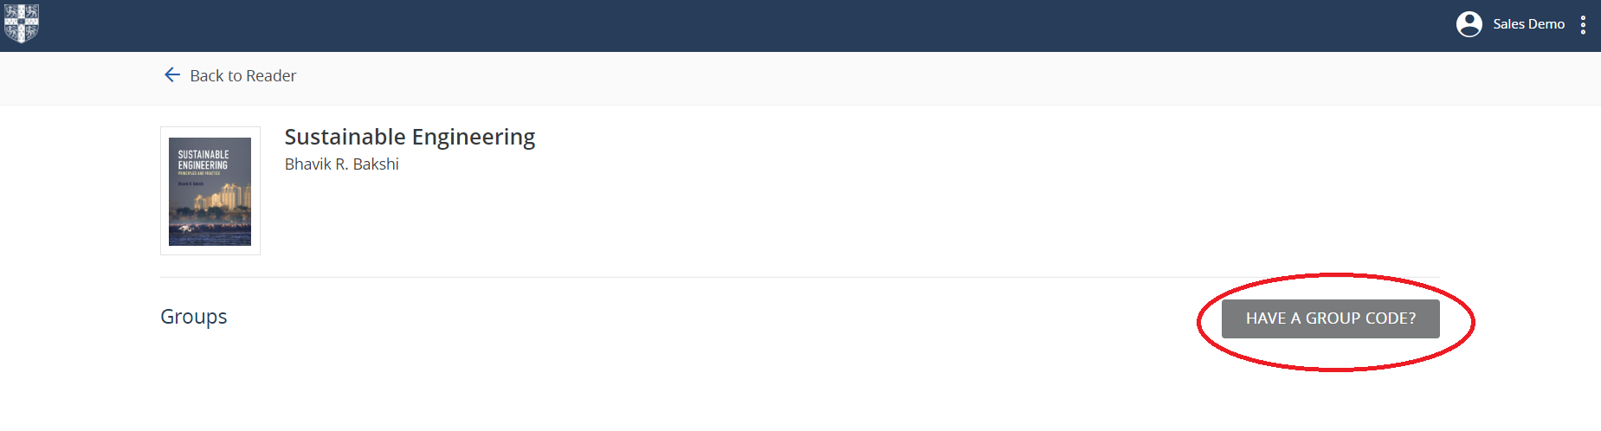

Please enter the Group Code that has been supplied to you. Once this has been entered, you will be able to see the instructor annotations within the etextbook.
Note: Your own personal annotations will be private and will not be shared with the Group.

Bulk Annotation Sharing
To select which annotations you would like to share with your group. Click on the annotations icon on the navigation panel on the left hand side of the screen. Then click on the share icon.
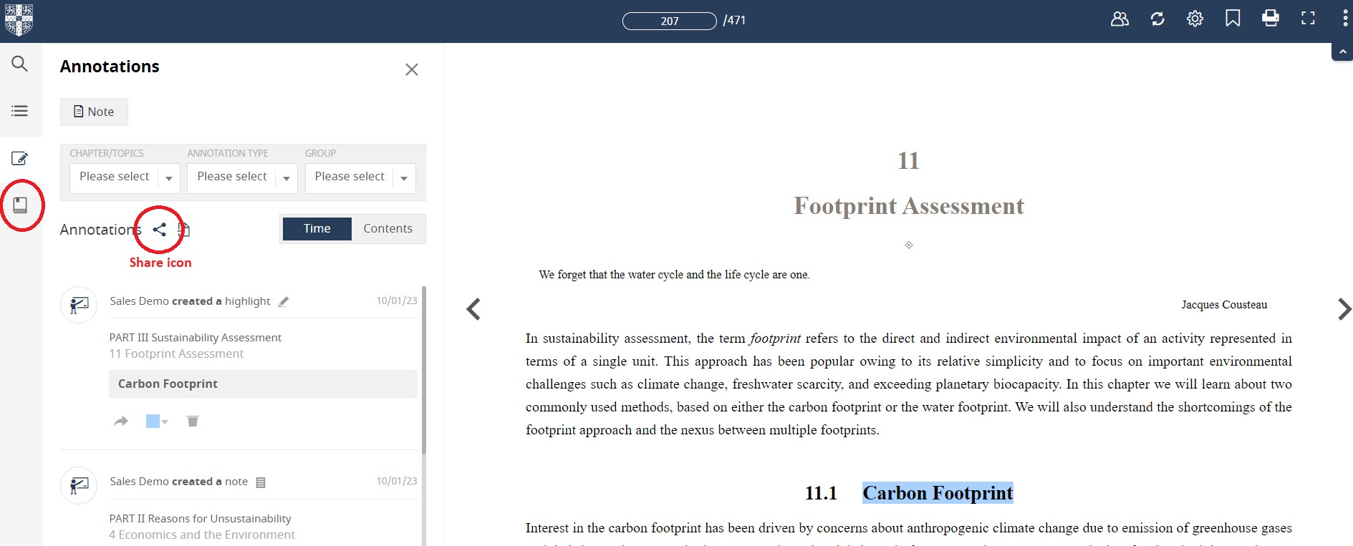

Your ‘Bulk Annotation Sharing’ pop up will appear. Here, you can choose which of your annotations can appear within each of your Groups. You can choose to select them all easily by clicking ‘All’ below the group name, if you wish to provide all of your annotations to your Group.

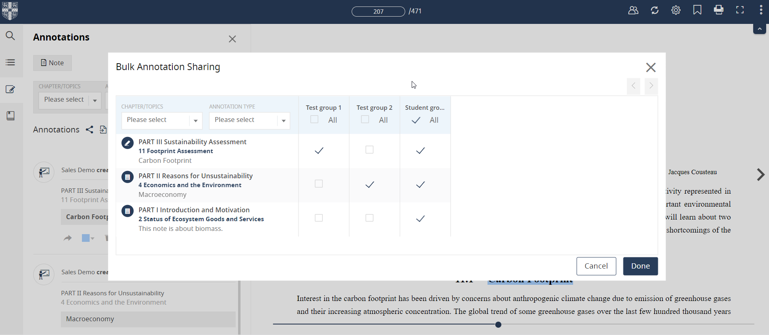

The Cambridge Spiral App
The Cambridge Spiral App will enable you to read online and offline, on campus and off campus.
Mobile and tablet versions of the app are available to download from Apple’s App Store and Google Play.
Desktop versions are also available to download for Windows and Mac.
Click here to view the Cambridge Spiral App download links.
When you install the App for the first time, this may take up to 5 minutes to complete.

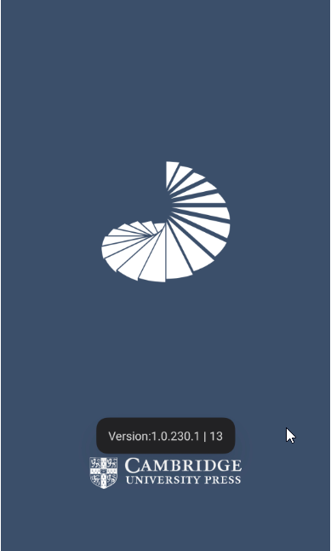

When you first open the Spiral App, you will be prompted to enter your login details and create as per the instructions earlier in this document.

Log in page (Windows app)  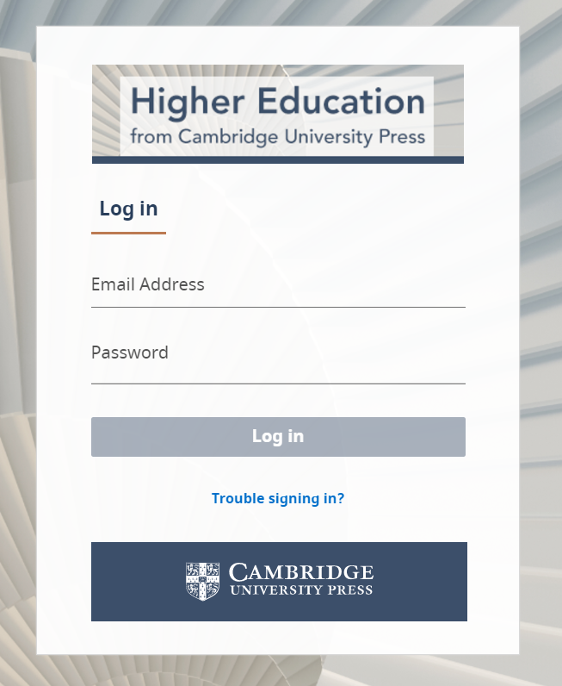 | Log in page (Android app)  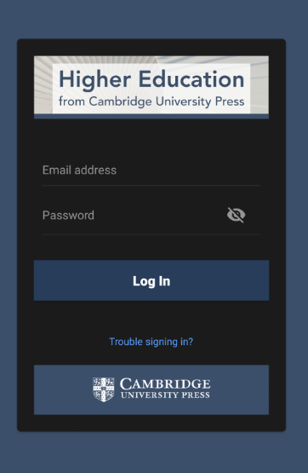

Offline and Online reading
The Spiral App allows online and offline reading.
When you open the Cambridge Spiral app, you will see your bookshelf, with titles you have recently read.
You can choose to make titles available for offline reading by clicking on the grey offline icon in the centre of the cover.
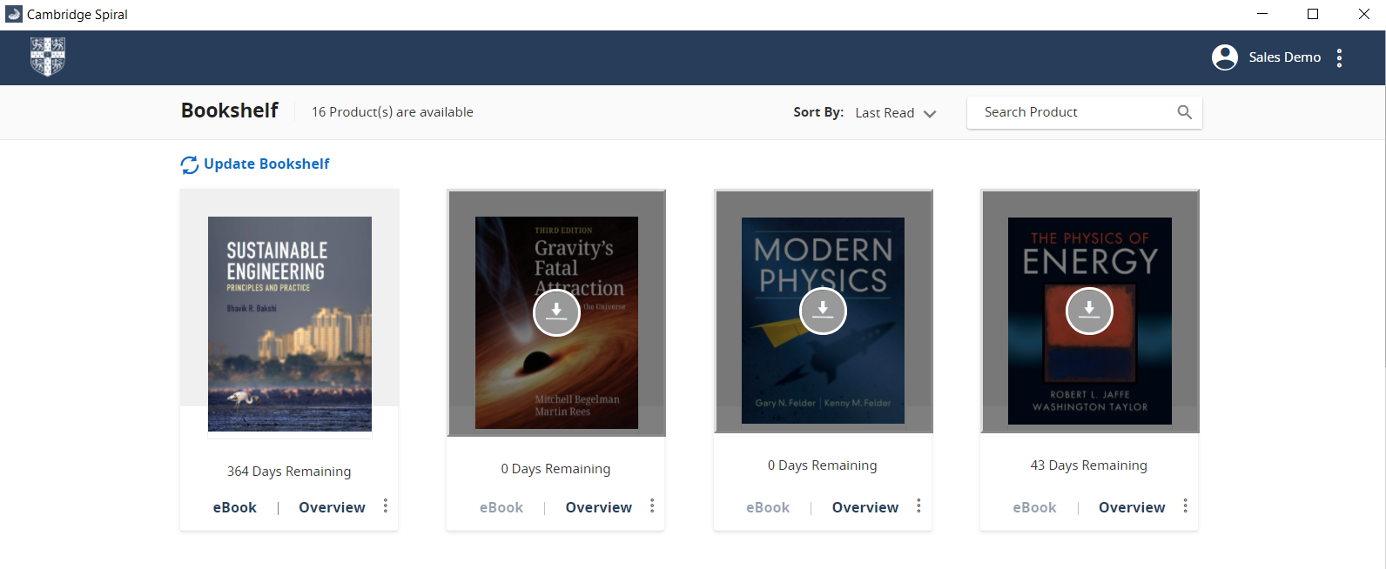

Adding books to your offline bookshelf
You may have up to 20 books in your offline bookshelf at the same time.
To add a book to your offline bookshelf, navigate to the landing page of the textbook on the Cambridge Higher Education website.
Click the button “Add to offline bookshelf’.
This will ensure that you will be available for you to read the textbook online and offline, on campus and off campus, within the Spiral App.
Please note that you will need to install the Spiral App prior to using this feature.
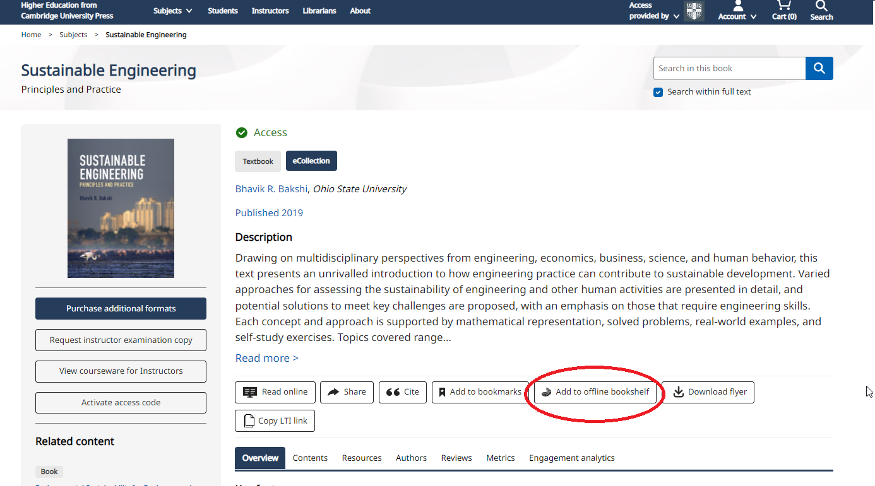

Sync functionality
When reading offline, the “sync” button can be used to ensure that any annotations that you add while reading offline will be synced within account once you are back online again.
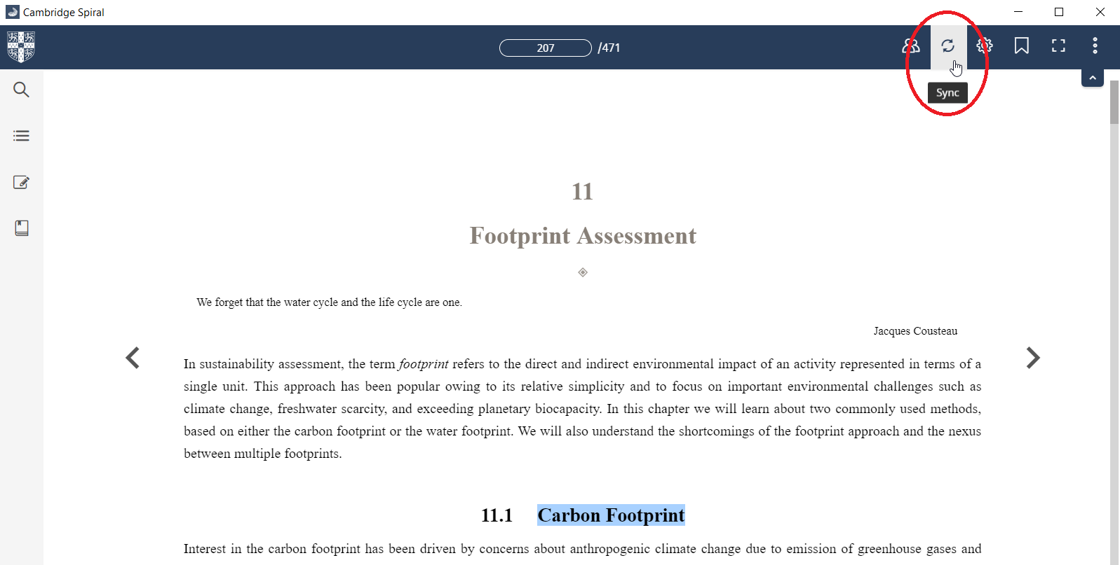

Reading on tablet or mobile
Login to the app on your tablet or mobile.
This enables you to read textbooks online and offline on your devices.
You can then use the textbook to study while at home, on the train, in a coffee shop - anywhere you like!
You will have access to all of the same functionality you have on the web browser / desktop App version.
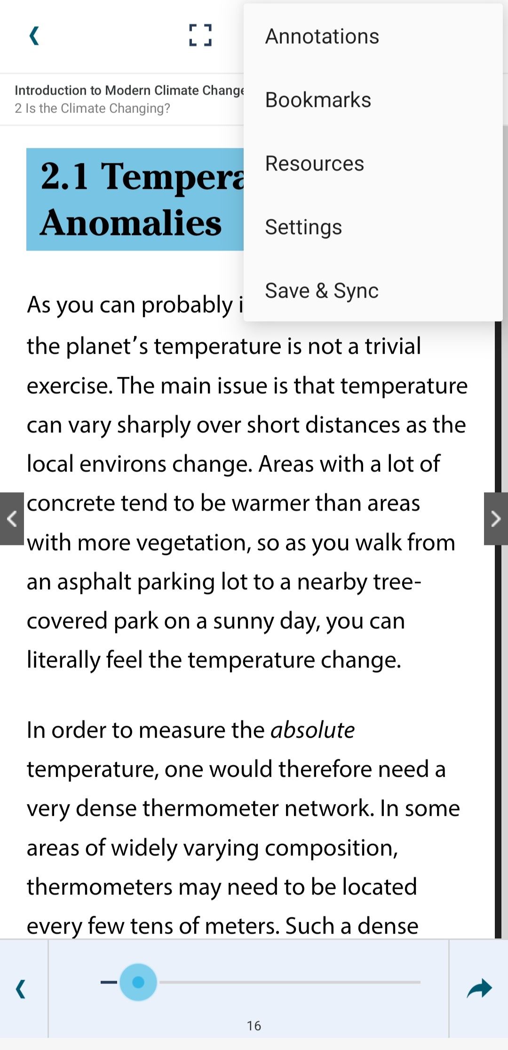 | 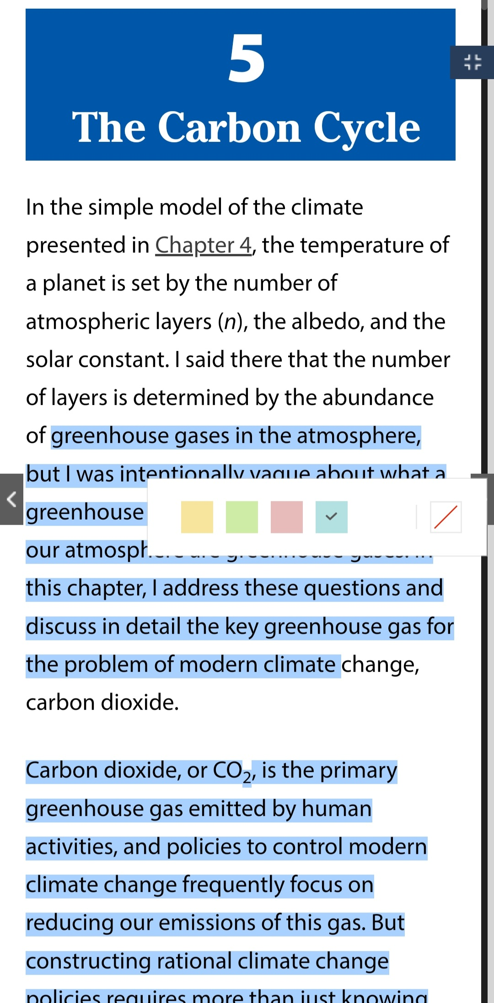 | 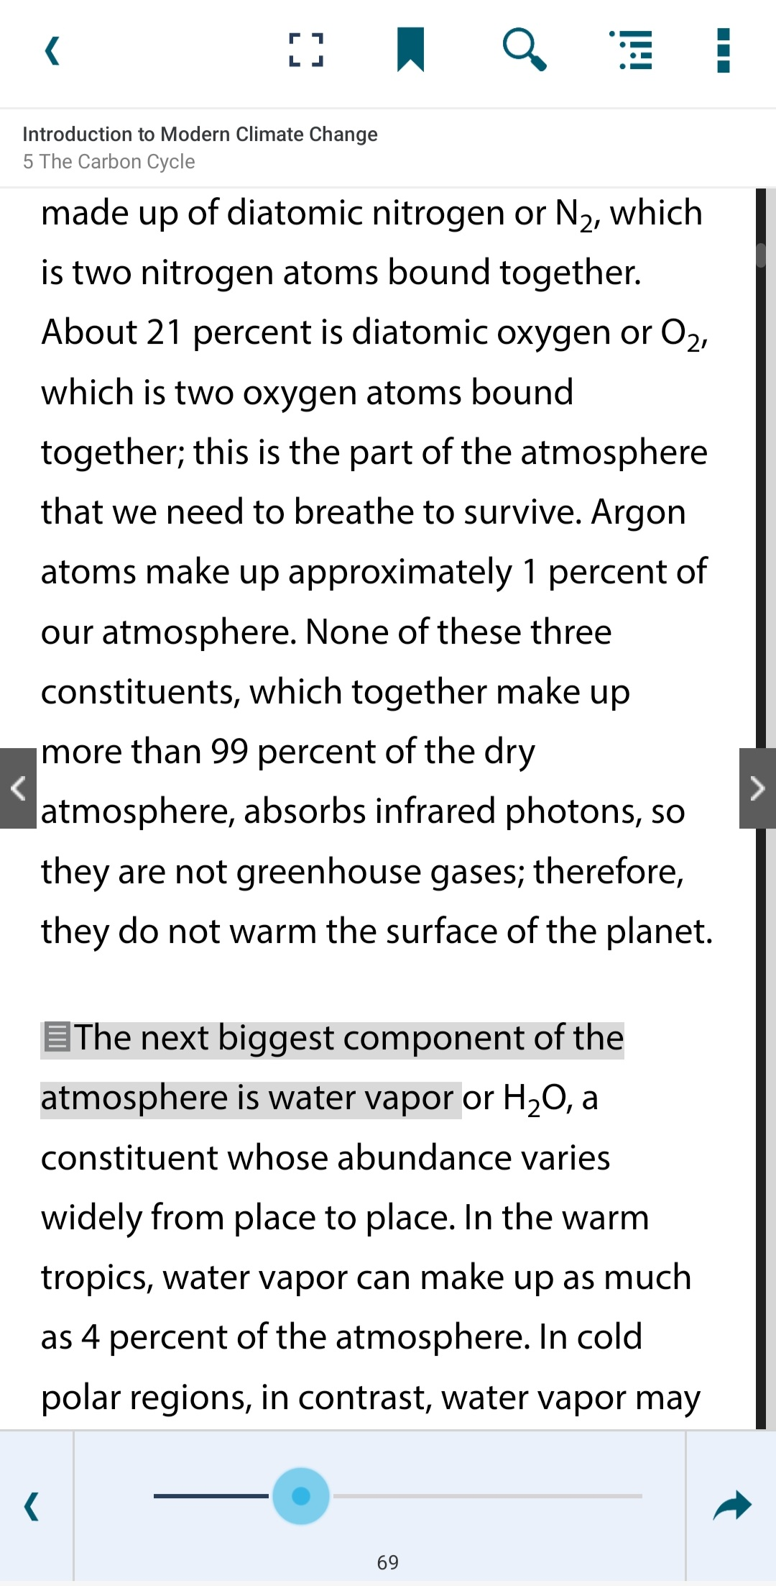

Information for Students

Please refer to the document ‘Higher Education from Cambridge_information for students”, which provides instructions for student users on how to log in and access textbooks.

Key contacts and further information

For further instructions and guidance, please watch our Higher Education website tour for instructors.
For faculty: for help regarding instructor access, resources, print desk copies and exam copies:
Americas: collegesales@cambridge.org
Rest of world: lecturers@cambridge.org

For students: If student users require help with systems or access, please visit
www.cambridge.org/highereducation/services/students
to search popular FAQs submit a query to our Technical Support team.

