

WIN A MAKEOVER WITH DULUX FOR YOUR LOCAL SPORTS CLUB!

Dulux and New Zealand Cricket are teaming up to give one lucky sports team a makeover for their local sports club.

Dulux is offering you the chance to nominate your club for a renovation and be in the draw to win some really cool prizes including:

- 100 litres of Dulux Premium Paint to refresh your facilities
- $1,000 NZD worth of sports gear of your choosing
- An exclusive experience with New Zealand Cricket team members
- A free colour consultation with a Dulux Colour Designer (worth up to $400 NZD)

Runner up prize will win 50 litres of Dulux Premium Paint and $500 NZD worth of sports gear.

To apply for your club to win a makeover, submit your entry on our website, showing us some photos of it currently and why your club is in need of a decorative renovation.

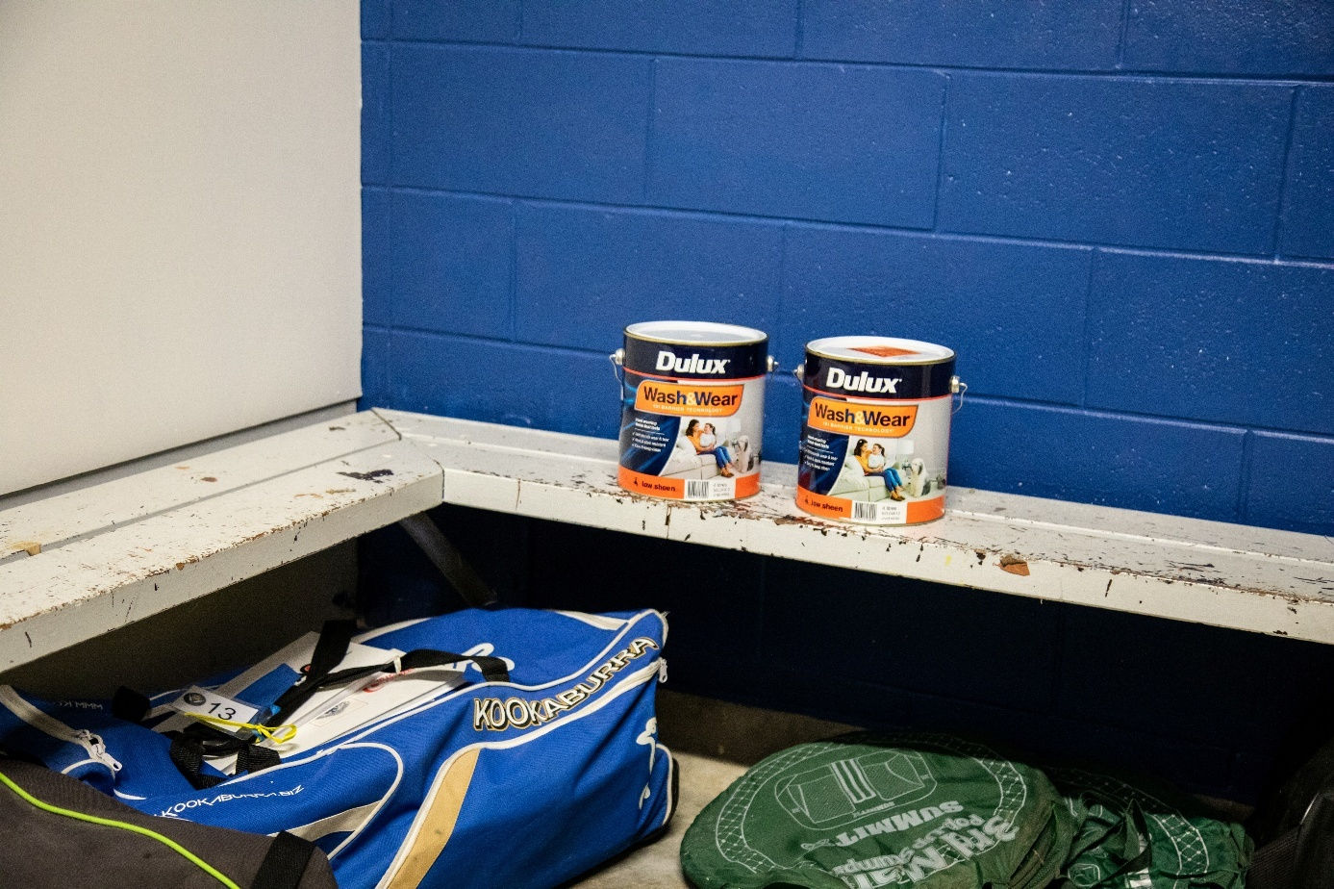

Terms and Conditions

WIN A DULUX SPORTS CLUB MAKEOVER

Competition details

Promotion Name | Dulux Sports Club Makeover Activation
Promoter | The Promoter is Dulux New Zealand, a division of DuluxGroup (New Zealand) Pty Ltd (2355191), of 150 Hutt Park Road, Gracefield, Lower Hutt, 5010, Wellington New Zealand.
Promotion Type | Game of skill
Promotion Period | The Promotion will commence at 7:30am, 15/12/2025 and finishes at 5:00pm on 08/03/2026 (Promotion Period).
Entry Restrictions | This promotion is open to all sports clubs based in New Zealand. Entrants under 18 years of age must get permission from a parent or guardian before entering. Employees (and their Immediate Families) of the Promoter, or any of their respective parent companies, subsidiaries or affiliated companies, or any agencies associated with this promotion are ineligible to enter. “Employees” means any directors, management, employees, concessionaires, consultants, officers and contractors or other such people who perform work under the control of another in exchange for payment. “Immediate Family(ies)” means any of the following: spouse, ex-spouse, de-facto spouse, child or step-child, parent, step-parent, grandparent, step-grandparent, uncle, aunt, niece, nephew, brother, sister, step-brother, step-sister or first cousin and the persons referred to above includes natural and non-natural relations (in the opinion of the Promoter).  The Promoter is responsible for determining whether a person is an eligible  entrant in its absolute discretion. The Promoter may require entrants to provide reasonable proof that they meet the requirements for entry in the Promotion.
How to enter | During the Promotion Period, entrants are required to fill out the online form on dulux.co.nz/club-makeover attaching some photos of your club (interior and/or exterior), telling us the name of your club and why your club is in need of a decorative renovation. Entrants must:  - complete the entry process by 08/03/2026;  - Submit at least one photo of your club  - Submit the name of your club  - Submit why you feel your club needs a decorative renovation.
Additional entry requirements | Any entry that contains content that the Promoter, in its sole discretion, considers to be offensive or inappropriate in any way or that the Promoter considers, in its sole discretion, to infringe any intellectual property rights or other rights of any person, property, corporation or entity, will be considered ineligible. The decision to accept or reject an entry is at the Promoter’s sole discretion and no correspondence will be entered into.  The Promoter, its affiliates and agents are not responsible in any way for the content or descriptions included by entrants, nor do they necessarily endorse the content or descriptions. Entries received must be the original work of the entrant. Entries received during the Promotion Period may be individually moderated by representatives of the Promoter. The Promoter may reject entries in its discretion if it considers the entries may be illegal, threatening, defamatory, invasive of privacy, infringing of intellectual property rights, indecent, libellous, hateful,  obscene, or otherwise injurious to third parties or are otherwise objectionable.
Judging criteria | Judging of entries will be undertaken by a panel of judges appointed by the Promoter. Judging will commence from 09/03/2026 at the offices of the Promoter. One individual entry, in the opinion of the judges, will be selected from all valid entries and judged as a winner and one individual entry as a runner up to receive a second place. The Promoter’s decision is final and no correspondence will be entered into. This is a game of skill and chance plays no part in determining the winner. Each entry will be individually judged based on originality  and creative merit of their entry. The judges may select additional reserve entries which they determine to be the next best, and record them in order, in the case an invalid entry or ineligible entrant is selected as the winner.

Notification | The winner will be announced on the 16/03/2026. The winner will be contacted by phone or email within 7 days of the announcement. If the winner has not made contact before 18/03/2026, or in the event an invalid entry or ineligible entrant is selected as the winner, the judges will select another winner from the remaining  entries which they determine to be the next best.
Publication Details | Competition results may be published on the following channels; the Dulux website, social media, email, New Zealand Cricket social media.
Prize details | Major Prize:  - Meet & Greet with New Zealand Cricket Players  - $1,000 worth of sports gear of your choosing  - 100 litres of Dulux Premium Paint (tinted to Dulux New Zealand colours only)  - A free colour consultation with a Dulux Colour Designer (worth up to $400 NZD).  Runners up Prize:  - $500 worth of sports gear of your choosing  - 50 litres of Dulux Premium Paint (tinted to Dulux New Zealand colours only)
Prize Restrictions/Additional terms | If any prize (or part of any prize) is unavailable, the Promoter, in its discretion, reserves the right to substitute the prize (or that part of the prize) with a prize to the equal value and/or specification.  Prizes are valued in New Zealand dollars. The Promoter accepts no responsibility for any variation in the Prize value. Prize winners are advised that tax implications may arise from their Prize winnings and they should seek independent financial advice prior to acceptance of their Prize.
Prize Claim and Fulfillment Date | Meet and Greet with 2 BLACKCAPS and 2 WHITE FERNS will be pending availability between New Zealand Cricket Players and the winning sports club. Meet and Greet date will be mutually agreed within 6 months of the winner being selected.  Paint and sports gear prizes must be claimed within 6 months of the end of the Promotional Period.
Unclaimed Prize  Arrangements | If a Prize is not claimed by the Prize Claim Date or the entry is deemed invalid, the next best entry, as determined by the judge(s) shall be awarded the Prize.
Trade Account Holders | Dulux Trade Account Holder Customers must not be in breach of the Promoter’s trading terms at any time during the Promotion Period and must not have overdue monies owing as at the closing date in order to be eligible to claim any prize.  Each Dulux Trade Account Holder Customer’s account must be paid in full by the agreed trading terms of the Dulux Trade Account to be eligible to claim any prize.  All other normal trading conditions of the Promoter apply.
Entry Limits | One entry per individual however multiple individuals can enter for the same club.
Additional Terms – Use of entries | By submitting an entry to the Promotion, each entrant assigns all rights in the entry to the Promoter and consents to the Promoter using the entry in any manner the Promoter wishes (including modifying, adapting or publishing the entry, whether in original or modified form, in whole or in part or not at all), by way of all media, without payment to the entrant (of royalties, compensation or otherwise). By submitting an entry, each entrant consents to any dealings with the entry that may otherwise infringe their moral rights in the entry. The Promoter may copy any content submitted as part of an entry, cause the content to be seen and/or heard in public, and communicate the content to the public. It may also allow third  parties to do these things.

Terms and Conditions

- Information on how to enter the Dulux Sport Club Makeover Competition and prizes form part of these Terms and Conditions. Participation in this competition is deemed acceptance of these Terms and Conditions.
- All entrants acknowledge that the Promoter can rely on these Terms and Conditions even if the Promoter only learns of a person’s ineligibility after the Promoter has awarded a prize to the ineligible person. Return of the prize or payment of its equivalent value to the Promoter may be required by the Promoter if this occurs.
- Each entrant is responsible for ensuring his or her familiarity with these Terms and Conditions at the time of participation. The Promoter’s decision not to enforce a specific restriction (whether communicated to an entrant or not) does not constitute a waiver of that restriction or of these Terms and Conditions generally.
- Incomplete and indecipherable entries and any entry which has incorrectly entered personal information or contact details shall be deemed an invalid entry. No responsibility is accepted by the Promoter for late, lost, misdirected, ineligible or illegible/inaudible entries (including lost, stolen, forged, defaced or damaged proof of entry or things required by the Verification Requirements).
- The Promoter’s decision in relation to any aspect of these Term and Conditions and the Promotion is final and binding on every person who enters. No correspondence will be entered into.
- The Promoter may, in its sole discretion, declare any or all entries made by an entrant invalid, and/or prohibit further participation by an entrant in this Promotion or a prize event/activity if the entrant:
  - disrupts, annoys, abuses, threatens, harasses or attempts to do any of these things to the Promoter, another entrant or potential entrant of, or anyone else associated with, this Promotion;
  - submits an entry that is not in accordance with these Terms and Conditions or who tampers with the entry process; or
  - engages in conduct in relation to this Promotion which is misleading, deceptive, fraudulent or damaging to the Promoter's goodwill or reputation.
- If this Promotion is interfered with in any way or is not capable of being conducted as reasonably anticipated due to any reason beyond the reasonable control of the Promoter, the Promoter reserves the right, in its sole discretion, to the fullest extent permitted by law to modify, suspend, terminate or cancel the Dulux Sports Club Competition, as appropriate.
- Entries must be the entrant's original work. The Promoter reserves the right to verify, or to require the entrant to verify, that the entry is the entrant's original work. If an entry cannot be verified to the Promoter's satisfaction, the entry will be deemed invalid.
- An entrant's entry must not include:
  - any image or voice of any other person without that person's express consent. Entrants warrant that if any such content is included, they have obtained the express consent of the relevant person;
  - any content that contravenes any law, infringes the rights of any person or is obscene, offensive, potentially defamatory, discriminatory, indecent or otherwise objectionable or inappropriate (which includes, without limitation, any content involving nudity, malice, excessive violence or swearing); and
  - any literary, dramatic, musical or artistic work, any audio-visual or sound recording, or any other item in which copyright subsists, unless the entrant is entitled to do so. If an entrant has any doubts about whether they have the right to include any content (for example, recorded music) they must not include it. By including any such content in their entry, the entrant warrants that they have the permission of the relevant copyright owner to do so and that this permission allows the Promoter to use the entry in accordance with these Terms & Conditions.
- The Promoter may, in its absolute discretion, edit, modify, delete, remove or take-down any part of an entrant's entry.
- Entries must be received by the Promoter and will be deemed to have been received at the time of receipt by the Promoter. Online and other electronic entries are deemed to have been received at the time of receipt into the promotion database and not at the time of transmission by the entrant.
- Each entrant acknowledges that there may be inherent risks involved in entering this Promotion or taking or participating in the prize(s). Any entrant, prize winner and/or participants in a Promotion event may be required to sign an acknowledgement of risk and waiver of liability for participation in the Promotion or a Prize event and to expressly acknowledge that entry into this Promotion or participation in a Promotion event or Prize may be inherently dangerous, and that if they choose to participate they will do so at their own risk. A reasonable level of health and fitness may be required. The Promoter reserves the right to preclude participation of anyone refusing to sign the acknowledgement/waiver or any person who is suffering from asthma, epilepsy, significant back or neck problems, physical or mental disabilities, or is pregnant or in the Promoter's sole discretion is not able or suitable to participate in any of the experiences for reasons of the participant's own or anyone else's safety.

- Any costs associated with accessing the Promotion website are the entrant’s responsibility and are dependent on the internet service provider used. Entrants must submit their entries and/or claims manually using an internet browser.
- The Promoter is not responsible for any problems or technical malfunction of any telephone network or lines, computer on-line systems, communication network, computer equipment, software, technical problems or traffic congestion on the Internet or at any web site, or any combination thereof, including any error, omission, alteration, tampering, deletion, theft, destruction, transmission interruption, communications failure or otherwise, injury or damage to entries or to participants' or any other person's computer related to or resulting from participation in or down-loading any materials in this Promotion. If the Promotion is not capable of being conducted due to circumstances beyond the Promoter's control, including due to any technical or communications problems, the Promoter reserves the right to amend, suspend or cancel the competition subject to approval from any relevant authority.
- Errors and omissions may be accepted at the Promoter's discretion. Failure by the Promoter to enforce any of its rights at any stage does not constitute a waiver of those rights. If there is a dispute as to the identity of an entrant, the Promoter reserves the right, in its sole discretion, to determine the identity of the entrant.
- As a condition of claiming a prize, the Participant may be required to (at the Promoter’s discretion) sign any legal documentation as and in the form required by the Promoter and/or prize suppliers in their absolute discretion, including but not limited to a legal release and indemnity form.
- The Promoter may communicate or advertise this competition using Facebook and/or Instagram or another social media platform. However, the competition is in no way sponsored, endorsed or administered by, or associated with, Facebook or Instagram or any other social media platform. Entrants are providing their information to the Promoter and not to Facebook or Instagram. Each entrant completely releases Facebook and Instagram from any and all liability in connection with this Promotion.
- The prize(s) and/or parts of the prize(s) is/are not transferable or exchangeable and cannot be taken as cash (unless the prize is cash). If a prize, or an element of a prize, is unavailable for any reason, the Promoter reserves the right to substitute another prize of equal or greater value for that prize, or element of it, subject to the approval of any relevant authority. The Promoter and its representatives will not be liable for any damage to or delay in transit of prizes.
- The use of any automated entry software or any other mechanical or electronic means that allows an entrant to automatically enter the Promotion repeatedly is prohibited and will render entries submitted using such means as invalid.
- Except for any liability that cannot be excluded by law, the Promoter (including its officers, employees and agents) excludes all liability (including negligence), for any personal injury; or any loss or damage (including loss of opportunity); whether direct, indirect, special or consequential, arising in any way out of the Promotion, including, but not limited to, where arising out of the following: (a) any technical difficulties or equipment malfunction (whether or not under the Promoter’s control); (b) any theft, unauthorised access or third party interference; (c) any entry or prize claim that is late, lost, altered, damaged or misdirected (whether or not after their receipt by the Promoter) due to any reason beyond the reasonable control of the Promoter; (d) any variation in prize value to that stated in these Terms and Conditions; (e) any tax liability incurred by a winner or entrant; or (f) use of the prize.
- The Promoter and its associated agencies and companies will not be liable for any loss (including, without limitation, indirect, special or consequential loss or loss of profits), expense, damage, personal injury, illness or death which is suffered or sustained (whether or not arising from any person’s negligence) in connection with this competition or accepting or using any prize, except for any liability which cannot be excluded by law (in which case that liability is limited to the minimum allowable by law). Nothing in these conditions restricts, excludes or modifies or purports to restrict, exclude or modify any statutory consumer rights under any applicable law including Consumer Guarantees Act 1993 (NZ)
- Entrants irrevocably consent and assign to the Promoter all intellectual property including copyright in the images submitted by them during this competition. Entrants also irrevocably consent to the Promoter using their name, likeness, image and/or voice in the event they are a winner (including photograph, film and/or recording of the same) in any media for an unlimited period without remuneration for the purpose of promoting this competition (including any outcome), and promoting any products manufactured, distributed and/or supplied by the Promoter.
- The Promoter collects personal information in order to conduct the Promotion and may, for this purpose, disclose such information to third parties required for the provision of the Prize. Entry is conditional on providing this information. The Promoter may disclose the information for those purposes to its related bodies corporate and contractors. If entrants do not provide the information requested they will not be able to enter the Promotion.
- In addition to the privacy term set out above, if the entrant has ticked the "opt-in" box, the Promoter may also use personal information entrants provide to send information about the Promoters products and services (including via electronic means), and may disclose the information to its related bodies corporate, agencies and contractors (including call centres, advertising agencies and direct mail houses) the Promoter engages for that purpose. CAUTION: Any attempt to deliberately undermine the legitimate operation of this Promotion may be a violation of criminal and civil laws and should such an attempt be made, whether successful or not, the Promoter reserves the right to refer the matter to law enforcement authorities and/or to seek damages or such other civil remedies as the Promoter may determine from time to time to the fullest extent permitted by law.
- The Promoter is bound by the New Zealand Information Privacy Principles, contained in the Privacy Act 2020 (NZ). A copy of the Promoter's privacy policy can be viewed at https://www.dulux.co.nz. To request access to, or to update, personal information the Promoter holds about them, entrants can contact the office of the Promoter.

