Research programme
The National Strategy to Reduce Gambling Harms was launched in April 2019 and ran until April 2022. This document is archived content which appeared in the Reducing Gambling Harms hub, and refers to activity to reduce gambling harms during that time.

All links on these pages open in a new tab.
The Gambling Commission's 2018 to 2022 research programme (PDF) is required to progress the delivery of the National Strategy to Reduce Gambling Harms. It is based on six core research themes.
These themes have been set on the advice of the Advisory Board for Safer Gambling (ABSG).

Theme 1: Gambling related harms
"We need to develop a way to comprehensively understand and measure the harms caused by gambling."

Theme 2: Patterns of play
"We need to understand how gambling behaviour varies across different products and environments, and which characteristics are most strong associated with harm."

Theme 3: Changes in gambling behaviour over time
"We need to understand how gambling behaviour changes over time and why people move in and out of harmful play."

Theme 4: What works in harm-minimisation?
"We need to use evaluations to assess the effectiveness of interventions, and identify best practice in industry-based harm minimisation."

Theme 5: Education and prevention
"We need to understand what works in preventative education through insights provided by research and evaluation."

Theme 6: Treatment
"We need to understand what works in gambling treatment and build the evidence base to help formulate an effective and inclusive approach to treating gambling related harms."
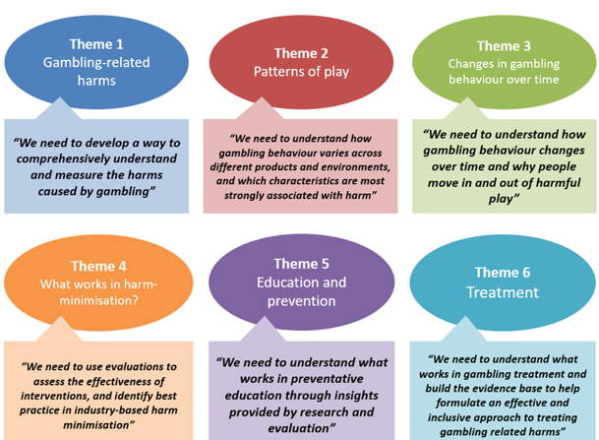
These themes will enable us to be ambitious in our research objectives and deliver large scale projects which will provide robust evidence to feed into a complex, evolving policy environment and support the Evaluation enabler of the National Strategy to Reduce Gambling Harms.
It will allow the research to be commissioned through consortium teams which encourage the involvement of experts and specialists new to the field of gambling.

Research governance
The Gambling Commission own the research programme and set the research questions on the advice of ABSG. Currently, the Commission and GambleAware both take responsibility for the commissioning of the research necessary to underpin the strategy.
The majority of funding for commissioned research is either supplied voluntarily by the industry or becomes available through regulatory settlements.

Defining, measuring and monitoring gambling-related harms
The overall aim of this theme is to help us better understand the nature of gambling-related harms and how they can be reduced which will help us move away from simply identifying the number of problem gamblers within a population.
Improving our understanding of gambling-related harms is the underpinning principle of the Prevention and Education theme of the National Strategy to Reduce Gambling Harms.
We know that gambling-related harms take many forms, with negative impacts possible on peoples’ resources, relationships and health and include those experienced by other people, not just the gambler – including families, children of gamblers, employers, communities and society more generally.
Harms can be temporary, episodic or longer term in nature, and can occur at all levels of gambling participation.
We know that harms from gambling can extend beyond the gambler to their friends, family, community and society.
We need to develop a way to comprehensively measure the harms caused by gambling and their cost to society.
This will allow us to understand the scale of the issue and whether we've successfully reduced harms, and more effectively target interventions.
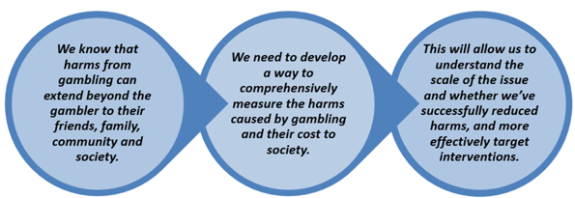

Research projects

Measuring gambling-related harm
Measuring gambling-related harms: a framework for action (PDF) is a report published by the Gambling Commission, ABSG, and GambleAware. This report agreed a preliminary working definition of gambling-related harms and adapted models of how harms sit within broader eco-social and prevention models.
Measuring gambling-related harms: methodologies and data scoping study (PDF). This study considered different methodologies for estimating social costs of gambling-related harms and makes recommendations as to which methods are most feasible. Understanding and measuring gambling-related harms is one of the Gambling Commission’s top priorities. More information is available in the methodologies and data scoping study project brief (PDF).
The work was completed by the Care Policy and Evaluation Centre at the London School of Economics. It has also produced an accompanying costing guide: Methods for assessing costs of gambling related harms and cost effectiveness of interventions (PDF) outlining economic approaches to measuring gambling-related harms and cost-effectiveness of interventions.
The report was considered whilst forming the next steps on measuring gambling harms, impact and success (PDF) published in July 2020.

Gambling-related suicide
Suicide is one of the most serious of the possible harms associated with gambling and one of the priority themes identified in the framework. Using existing data sets, this project focuses on providing insights into rates of suicides, suicide attempts, suicide ideation and self-harm which are associated with problem gambling. This will compare prevalence between those reporting different risk factors.
Work on this project has been conducted by Dr Heather Wardle and Swansea University. Read the gambling-related suicide project brief (PDF) for more information.

Outputs
There are three outputs from this research. These reports are:
- Problem gambling and suicidal thoughts, suicide attempts and non-suicidal self-harm in England (PDF) evidence from the Adult Psychiatric Morbidity Survey 2007.
- Exploring problem gambling, loneliness and lifetime suicidal behaviours (PDF) a cross-sectional study using the Adult Psychiatric Morbidity Survey 2007.
- Scoping current evidence and evidence-Gaps in research on gambling-related suicide (PDF)

Children and young people
Measuring gambling-related harms among children and young people: a framework for action (PDF) is a report published by Ipsos MORI and follows a similar approach to that set out in the framework for action, to develop a dedicated framework to measure harms experienced by children and young people.
This includes developing and piloting a set of survey questions to improve our understanding of the dimensions of harm experienced by children as a result of their own or someone else’s gambling’. You can read more about the questions in the analysis report of the Young People's Omnibus pilot findings (PDF).
You can also find out more about problem gambling screens and the difference between problem gambling and gambling related harm.

Patterns of play
We need to understand how patterns of play vary across different environments, products and characteristics. The research required in this area, as outlined in the ‘Research to inform action’ section of the National Strategy to Reduce Gambling Harms, will help us better understand if, how and why some gambling products are more harmful than others.
Answering these questions will involve analysis of real play data provided by the gambling industry, and linking it to data on the socio-economic, demographic and low-risk/moderate-risk/problem gambling status of gamblers using different products.
To achieve this, all sectors of the gambling industry will need to regularly share data and make it available for research.
We also aim to establish an open repository for industry data, which would allow data to be collected and retained on an ongoing basis for harm-minimisation and research purposes.
This is a complex task, but will contribute efficiencies and benefits to researchers, industry, policy-makers and other key stakeholders. It will enable multiple research projects to be conducted from the same datasets and minimise the burden placed on both the industry and research participants.
We have a reasonable understanding of patterns of play on certain types of gaming machine, but this has been limited to play with sessions.
We need to analyse industry data to explore how patterns of play vary across other products and environments, and which characteristics are most strongly associated with harm.
This will help us to encourage safer play and target interventions and regulatory change where they will be most effective.
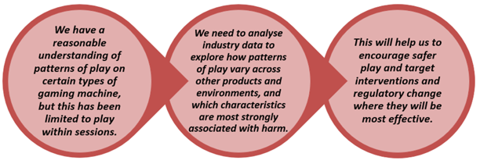

Research projects

Using industry data to understand patterns of play
Research into patterns of play for online gambling was led by NatCen and the University of Liverpool. They analysed one year’s gambling data from nearly 140,000 accounts across seven operators that were active in 2018-19.
The research team published findings on expenditure across betting and gaming products, the distribution of losses and use of SG tools for different demographic groups. The headline findings were published in an interim report of March 2021 (PDF).
Subsequently, a survey was conducted with respondents giving consent for their responses to be linked to their observed play data. This highlighted the correlation between those that gambled on gaming products in 2018-19, higher reported expenditure on other products at the time and greater likelihood of experiencing recent gambling-related harms. The report was published in June 2022 alongside a more detailed account data report and data tables for both phases of the research.

Analysing bank transactional data
In addition to analysing industry data to explore patterns of play, we are also keen to learn more from bank transaction data. GambleAware commissioned the Behavioural Insights Team (BIT) to conduct research, with two reports published in 2021: Monzo data analysis (PDF) and HSBC data analysis (PDF) .
Amongst the findings, BIT identified that Monzo’s gambling block was used by both gamblers and non-gamblers, but gamblers were more likely to use the tool after increased gambling activity and were more likely to subsequently lift the blocks. They also found that more engaged gamblers spent more on unarranged overdraft fees (HSBC) and transferred less money into savings pots (Monzo).
The research highlights the potential of financial industry data to predict, identify and mitigate gambling harms in both the short and long term, as well as highlighting the potential for more nuanced interactions and tools that might benefit gamblers.

Gambling Data Centre
As part of this programme of work we need to identify an approach to establishing a Gambling Data Centre to store data and make it available for further use and secondary research.
The University of Leeds produced a scoping study for how this independent repository of gambling industry data (PDF) could be structured. The recommendations are being explored further with relevant stakeholders.

Changes in gambling behaviour over time
Existing population surveys such as the Health Surveys and Welsh Problem Gambling Survey are effective at monitoring rates of gambling participation and the prevalence of problem gambling. They are limited, however, in exploring how gamblers’ behaviour changes over time.
It is increasingly recognised that gambling behaviour can be fluid and variable, where changes in intensity of engagement over time are the norm and patterns of problematic gambling unstable. For this reason, longitudinal research is necessary to explore gambling trajectories, including movement in and out of problem gambling status.
We envisage the findings of this longitudinal research will ultimately be used to inform the development of safer gambling policy and enable us to better understand where policy changes should be targeted.
It will also inform the development of effective prevention and treatment approaches. However, we also recognise that we will need help understanding how the findings will inform policy.
We know that harmful gambling can be episodic and is often non-linear as people move in and out of harmful play.
We need to understand how gambling behaviour changes over time, and why some people move in and out of harmful play whilst others do not.
This will allow us to make gambling safer by learning from gamblers who continue to play safely, and exploring the triggers that can lead to harm.
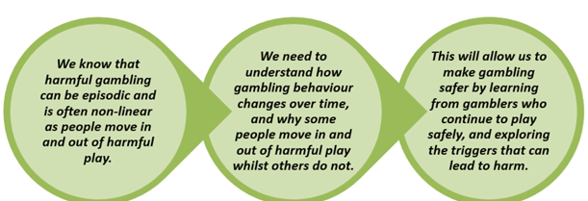

Research projects
In order to develop a longitudinal study of this kind, we commissioned a Longitudinal Study of Gambling (PDF) to conduct a rapid consultation and explore the methodological options for conducting longitudinal research and make recommendations on which approach or approaches will most effectively answer the research questions.
The consultation and review have been completed by NatCen and Dr Heather Wardle. More information is available in the longitudinal scoping invitation to tender (PDF).
We continue to consider and develop opportunities to understand how gambling behaviour changes over time, including in our recent research on consumer journeys and our research on youth gambling.

What works in industry-based harm-minimisation
Through the National Strategy to Reduce Gambling Harms, the Commission sets an expectation that the gambling industry should evaluate the impact of the interventions and harm-minimisation tools they develop.
With Collaboration as a key strategy enabler, we encourage the use of collaborative pilots (established with industry input) to test interventions, evaluate their effectiveness, and identify good practice. This will enable us to collectively improve our understanding of which interventions work, for whom, and in what circumstances.
There are some areas where evaluations are being led by the Commission, working in conjunction with ABSG and GambleAware. We intend to use evaluations from across the industry to generate good practice principles and consolidate the key lessons learnt to enable ongoing improvement of both interventions and evaluations.
There has been some piloting by operators of new interventions and approaches to harm-minimisation.
We now need to make better use of evaluations to understand the effectiveness of interventions, and identify best practice in harm minimisation.
This will help to identify which interventions work, for whom, and under what circumstances.
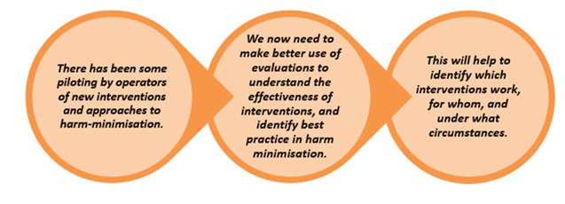

Research projects

Evaluation of the impact of Multi-Operator Self-Exclusion Schemes and awareness and barriers to self-exclusion
This is an evaluation of all of the multi-operator self-exclusion schemes. This work will also provide insight into self-exclusion from individual operators.
The evaluation has been split into two phases:

Phase 1
Phase 1 has focused on effectiveness of the process of planning and implementation of the Multi Operator Self-Exclusion Schemes, including enablers and barriers to each scheme running efficiently and has provided baseline evidence of the impact of the schemes, including awareness and perceptions of them amongst gamblers.

Phase 2
Phase 2 will evaluate how effective multi-operator self-exclusion schemes are in modifying harmful gambling behaviours and identify improvements that can be made to the schemes to improve their effectiveness in the short and medium term, by engaging with a larger sample of scheme users.
More information about the project is available in the Multi-operator self-exclusion schemes invitation to tender (PDF)
The Process and Impact Evaluation of the Multi-Operator Self-exclusion Schemes (PDF) is the phase 1 report completed by Ipsos Mori.

Applying Behavioural Insights to Reduce Problem Gambling
This research, conducted by the Behavioural Insights Team (BIT) for GambleAware, involves exploring the ways that behavioural science can be used to reduce harmful play online.
The first phase, completed in 2018, explored methods of reducing risky play in online environments and tested behavioural science informed messages with two operators, with the aim of increasing uptake of Safer Gambling tools. BIT found that making the tools more accessible (reducing friction) increased uptake, but that normative messaging did not. The Applying behavioural insights to design better safer gambling tools report (PDF) is available.
The second phase of this work, completed in 2021, involved piloting and evaluating the effectiveness of two interventions to reduce risky play across the industry: Anchoring and Commitment Devices.

The Anchoring research investigated the influence of pre-defined financial dropdown options on the decision of an individual when setting a deposit limit. The trial included the finding that the removal or reduction of the pre-defined options resulted in a significant decrease in the deposit limit set by the individual. The report on Applying behavioural insights to design better safer gambling tools (PDF) is available on the GambleAware website.
The Commitment Devices trial investigated the impact of asking an individual to provide a reason (‘commitment’) for setting their deposit limit at their chosen threshold. BIT found that presenting customers with the option of providing a reason decreased take-up of the deposit limit tool. Those that did set a limit in the trial groups selected lower deposit limits after a period of increased activity, but subsequent gambling activity did not vary.

Developing gambling industry best-practice for harm-minimisation: Safer gambling messaging
Revealing Reality are building on their previous research into collaborative innovation to identify good practice and inspire change with a new phase of work focused on safer gambling messaging. Read the Responsible Gambling: Collaborative innovation identifying good practice and inspiring change report (PDF).
Working with operators from a variety of sectors, safer gambling messages will be developed, tested and refined to produce recommendations and good practice guidance for industry. Depending on findings, there will then be the potential for a large-scale pilot, which would be evaluated by the Behavioural Insights Team.

Prevention and education
In principle, prevention of harm is better than cure. The role of education therefore, as a key form of prevention, needs to be better understood.
This will provide the evidence to inform the development of a collective and clear prevention plan, as set out in the new National Strategy to Reduce Gambling Harms, which identifies the right mix of interventions to be applied at both the population and individual level.
This will need to consider approaches suitable for mainstream audiences, groups which are particularly vulnerable to harm, and children and young people.
We know that education is relatively effective at improving knowledge and changing attitudes, but evidence of behaviour change is inconclusive.
We need to understand what works in preventative education through insights provided by research and evaluation.
This will help us to develop a national strategic plan to make that preventative education is delivered in the most effective way.

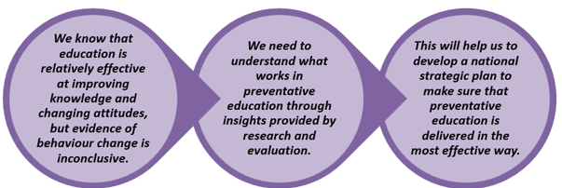

Research projects

Understanding the impact of advertising on children, young people and vulnerable people
This project explored the content and tone of gambling marketing and advertising and its effect on behaviour and perceptions of children, young people, and vulnerable people.
It assesses whether there are specific characteristics of advertising that are particularly harmful to these groups. Improving our understanding in this area will help us explore whether changes to the way gambling products are advertised could prevent harm.
This has been completed by a consortium led by Ipsos Mori and the Institute for Social Marketing at the University of Stirling. The Interim Synthesis Report (PDF) was published in July 2019 which explored the exposure, tone and format of gambling related marketing and advertising.
The Final Synthesis Report (PDF) was published in March 2020 which adds further findings on the impact of gambling marketing and advertising on children, young people and vulnerable adults, and extends a set of recommendations for the gambling and advertising industries, regulators and further research.

Treatment
Treatment and Support remains at the heart of the National Strategy to Reduce Gambling Harms as one of the two strategic priorities. As part of the research programme, we need to make sure that the treatment available to those who need it is effective and accessible.
This applies to treatment provided by GambleAware-funded services, whilst also recognising that people may need support with issues related to gambling in other settings – including mainstream healthcare or wider addiction services. For example, alcohol, substance abuse and misuse, or debt advice.
More research is needed on what works in treatment. A programme of research is already underway and it will be important that we apply the findings to future commissioning decisions, and find more ways to combine research with treatment to understand what works, and for who.
GambleAware has developed improved systems to gather data to inform the commissioning of treatment.
We need to understand what works in gambling treatment and build the evidence base to inform an effective and inclusive approach to treating gambling-related harms.
This will inform a national strategic plan to provide the right kind of treatment where it is most needed, in the most effective way.
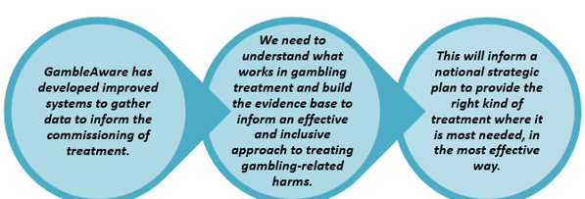
The Rapid Evidence Review: Effective Treatment and Support for Problem Gambling (PDF) is a report completed by Gambling Research Exchange (GREO).
This is an up to date review of the international evidence on treatment and support for gambling problems, ranging from primary care to specialist services and brief to intensive interventions, in order to identify the efficacy of these interventions.
This research has helped us understand what interventions work best, for who and why. It will ultimately inform the range of treatment services currently offered by GambleAware.
More information is available in the GREO project brief (PDF).

Treatment delivery gap analysis
This project involved a mixed methods approach of the current provision to determine where needs are, and are not, being met in terms of geography, demographics and severity of harm.
This research also explored the profile of ‘affected others’ who are those that have experienced harm as a result of someone else’s gambling; and provided new insights into the characteristics of this group. The findings will be used by policy makers to inform future commissioning and fundraising decisions.
Work on this project has been conducted by NatCen, ACT Recovery and YouGov.
More information is available in the gap analysis project brief (PDF) and gap analysis project invitation to tender (PDF).

Outputs from this research
The seven outputs are:
- Treatment Needs and Gap Analysis in Great Britain – A Synthesis of Findings (PDF) (May 2020) - NatCen Social Research.
- Gambling Treatment and Support (PDF) (March 2020) YouGov.
- An assessment of the accuracy of survey estimates of the prevalence of problem gambling in the UK (PDF) (March 2020) Professor Patrick Sturgis, London School of Economics.
- Gambling Treatment Services Needs Assessment Report (PDF) ACT Recovery.
- A Rapid Evidence Assessment of Gambling Treatment Services (PDF) July 2019, NatCen Social Research.
- Secondary Data Analysis of the Data Reporting Framework and the Health Survey for England (PDF) October 2019, NatCen Social Research.
- A Needs Assessment for Treatment and Support (PDF) October 2019, NatCen Social Research.

Evaluation of GambleAware funded treatment system
An independent evaluation of the current treatment and support system for those affected by difficulties with gambling, funded by GambleAware.
The overall programme aim is to deliver an objective, independent evaluation of the current GambleAware funded treatment and support system. This a system-level evaluation not an impact evaluation of system components or services.
The work has been conducted by Leeds Beckett University with a phase one report (PDF) published in 2020.
More information is available in the treatment evaluation project brief (PDF) and invitation to tender (PDF).

