EV Home Charger Questionnaire
Please complete all sections

Personal Details

Name of Primary Vehicle User (employee)
Installation Address
Contact Number

Property Information

Is the property | ☐ Owned by employee  ☐ Owned by other  ☐ Rented  ☐ Leased
Can our engineer be permitted access to the property wi-fi network during commissioning of the charger? | ☐ Yes  ☐ No  ☐ Not applicable
Do you experience any issues with mobile signal at the install location? | ☐ Yes  ☐ No  ☐ Not applicable
Do you have solar?  Do you have battery storage?  Do you have a heat pump? | ☐ Yes ☐ No  ☐ Yes ☐ No  ☐ Yes ☐ No

Electrical Equipment

Please provide your electricity supply MPAN Number:

This can be found on your electricity bill usually in a box marked ‘Supply Number’. It is 21 digits long and begins with ‘S’. You will only need the last 12 or 13 digits. You will not find your property’s MPAN on your meter box. Do not confuse it with your customer reference number, which can also be found on the bill. (Refer to Example 1 shown in the attached Appendix) or contact your local electricity supplier.

Is the electricity meter at the property a Pre-payment Meter? | ☐ Yes  ☐ No
How many consumer units (fuse boards) exist at the premises?

Photos - Electrical Equipment

Please provide a close-up photo of your electricity meter and cut out (service head). Refer to Example 2 in the attached Appendix.

Please provide a close-up photo to show the service head fuse size. Refer to Example 3 in the attached Appendix.

Please provide a close-up photo to show the individual circuits of the consumer unit (fuse board). Circuit identification is essential. Refer to Example 4 in the attached Appendix.

As part of the installation, an O-PEN device (also known as a Matt:e) will need to be installed. This is best located close to the consumer unit. Refer to Example 8 in the attached Appendix.

Please provide a photo to show the consumer unit and surrounding wall.

Charger Location and Route

Please describe the proposed location of the charger.
For example: 3 metres from electricity meter by front door, consumer unit (fuse board) the other side of wall requiring drilling through 1 internal wall and 1 external wall. Outside can be attached to the wall.

Please provide a sketch of the cable route from the consumer unit (fuse board) to the charger.

Please provide a photo of the route from the consumer unit (fuse board) to the charger, clearly showing any walls or obstructions

Please provide a photo of the proposed location of the EV Charge Point and surrounding area

Recommended height of charger  EV socket-outlet recommended to be installed within 0.75 to 1.2 metres from Finished Floor Level (FFL), with the top of displays between 1.2 and 1.4 metres from FFL | 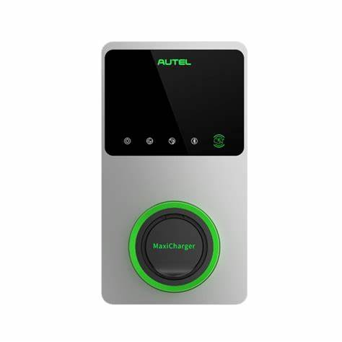  Charger for illustrative purposes only
If the heights mentioned above cannot be achieved, are you happy to deviate from the recommended installation heights? | ☐ Yes  ☐ No
Gas Meter

Please locate your gas meter:

- If the meter is sited within the property, it can usually be found within the vicinity of the boiler or under the stairs.

- If the meter is sited outside the property, it will usually be wall or floor mounted inside a box and will require a utility key to open. Refer to Example 5 in the attached Appendix.

Provide a photo of the connection of the pipe exiting the gas meter to your property. This should have a green and yellow sleeving attached. Refer to Example 6 in the attached Appendix.

Water Supply

Please locate your incoming water supply and valve (commonly referred to as a ‘stopcock’). Take a photo of the earth bonding, this should be a green and yellow sleeved cable. Refer to Example 7 in the attached Appendix.

Check List

Please ensure you have attached the following images:

☐ A close-up photo of your electricity meter and cut out (service head).

☐ Close-up photo showing service head fuse size.

☐ A close-up showing individual circuits on the consumer unit (fuse board).

☐ Photo showing the consumer unit (fuse board) and the surrounding wall.

☐ A sketch of the cable route from the consumer unit (fuse board) to the charger location.

☐ Photo of the route from consumer unit (fuse board) to the charger location, clearly showing any
walls or obstructions.

☐ A photo of the proposed location of the EV Charge point and surrounding area.

☐ A photo of the gas supply earth bonding (green and yellow sleeved cable).

☐ A photo of the water supply earth bonding (green and yellow sleeved cable).

Office Use Only
Remedial Works Recommended:

APPENDIX
Example 1: Below is an example of an MPAN number which is often printed in two rows, with the bottom row being the main number you will need.

In this example the number is: 91 0112 1214 151

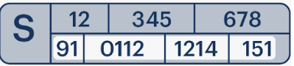

Example 2: Electricity Meter and Cut Out (service head)
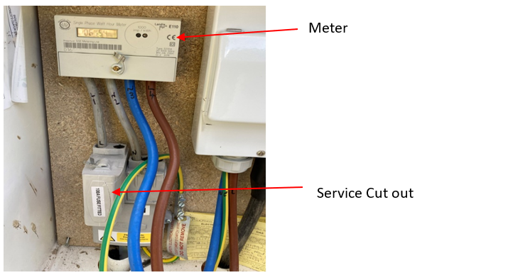

Example 3: Service head fuse size
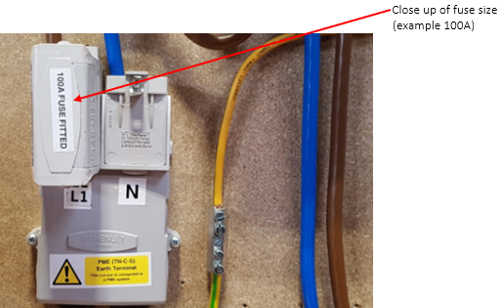

Example 4: Individual circuits on a consumer unit (fuse board)

Example 5: External Gas Meter Box and Key  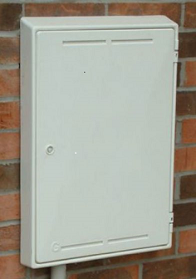 | Example 6: Gas meter connection with green and yellow sleeving attached

Example 7: Incoming Water Supply and Valve (stop cock) with green and yellow sleeving attached.
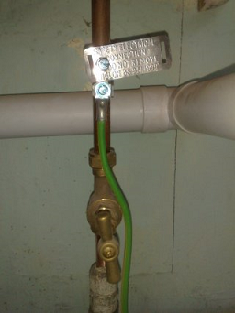

Example 8: Picture of O-PEN device (also known as a Matt:e) to be installed close to the consumer unit. Please note some models may vary slightly from the picture below.

Dimensions 274mm x 225mm x 106mm

