The future of finance with #1 Silicon Valley accelerator Plug and Play
- Nethone, a global tech company offering AI-powered KYU (Know Your Users) - joined the Fintech accelerator at Plug and Play, a startup ecosystem and venture fund, connecting industry-leading corporations with relevant startups.
- Polish tech company joins 25 other startups and growth-stage companies for a 3-months innovation platform, graduating at Plug and Play’s Fall Summit 2019.
- It’s the second Program led by Silicon Valley accelerator that Nethone was chosen to be part of. The first covered the travel & hospitality vertical.

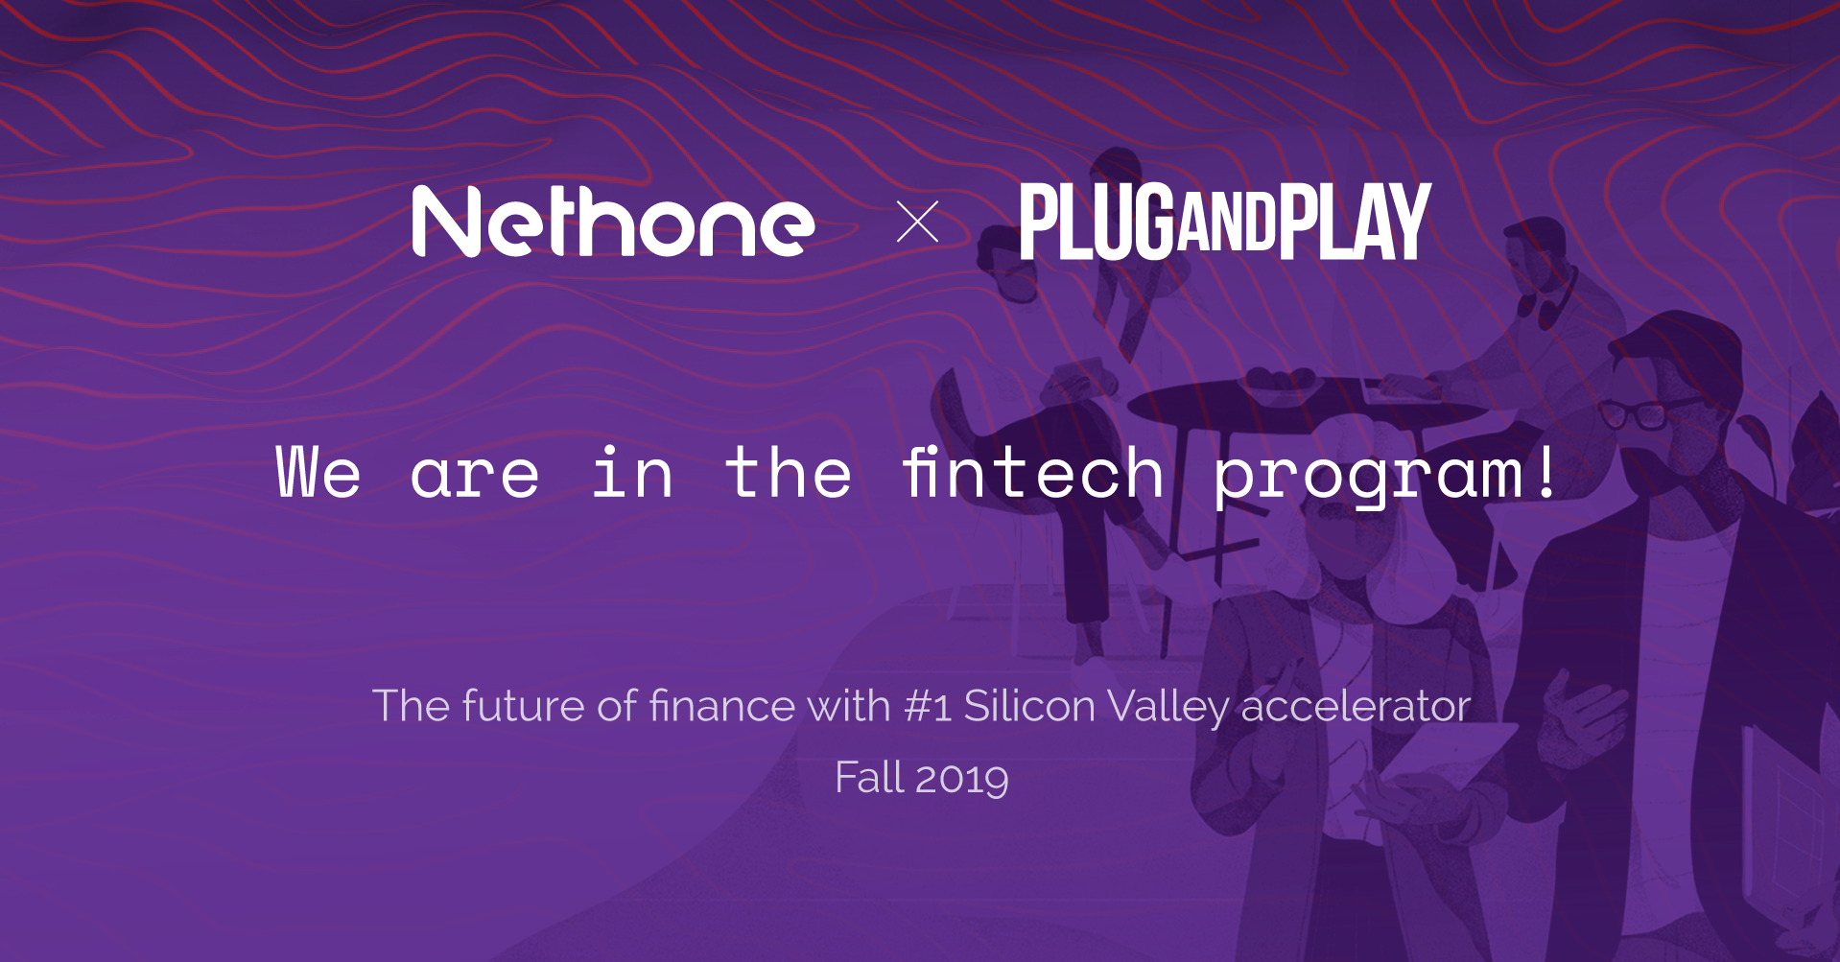

Nethone's AI-driven solution helps to gain more loyal customers and prevents fraud using a proprietary Know Your User analytics system. A few weeks after successfully finishing the Travel & Hospitality Program, once again, thanks to the votes of Plug and Play's corporate partners, Nethone was selected into the Fall 2019 batch for the fintech vertical.
Plug and Play Fintech was launched in 2015 and has accelerated 200+ fintech startups and invested in 50 of them. To forward the mission, they have expanded the offices to NYC, Paris, Abu Dhabi, Frankfurt, Tokyo, Singapore, and China.

“The goal of our participation in the 12-week accelerator program is to connect to the world’s largest financial institutions and launch pilot programs, POCs, and robust business development opportunities with the program partners’, explains Rodrigo Camacho, CCO at Nethone, who pitchedduring the Selection Day at the end of July. “Institutions operating in the finance sector are always interested in boosting the speed with which they innovate, especially in the fraud prevention area. Nethone is ready to deliver the best possible online filter for incoming users to make sure the trust pinned in banks or other financial institutions is not breached”.

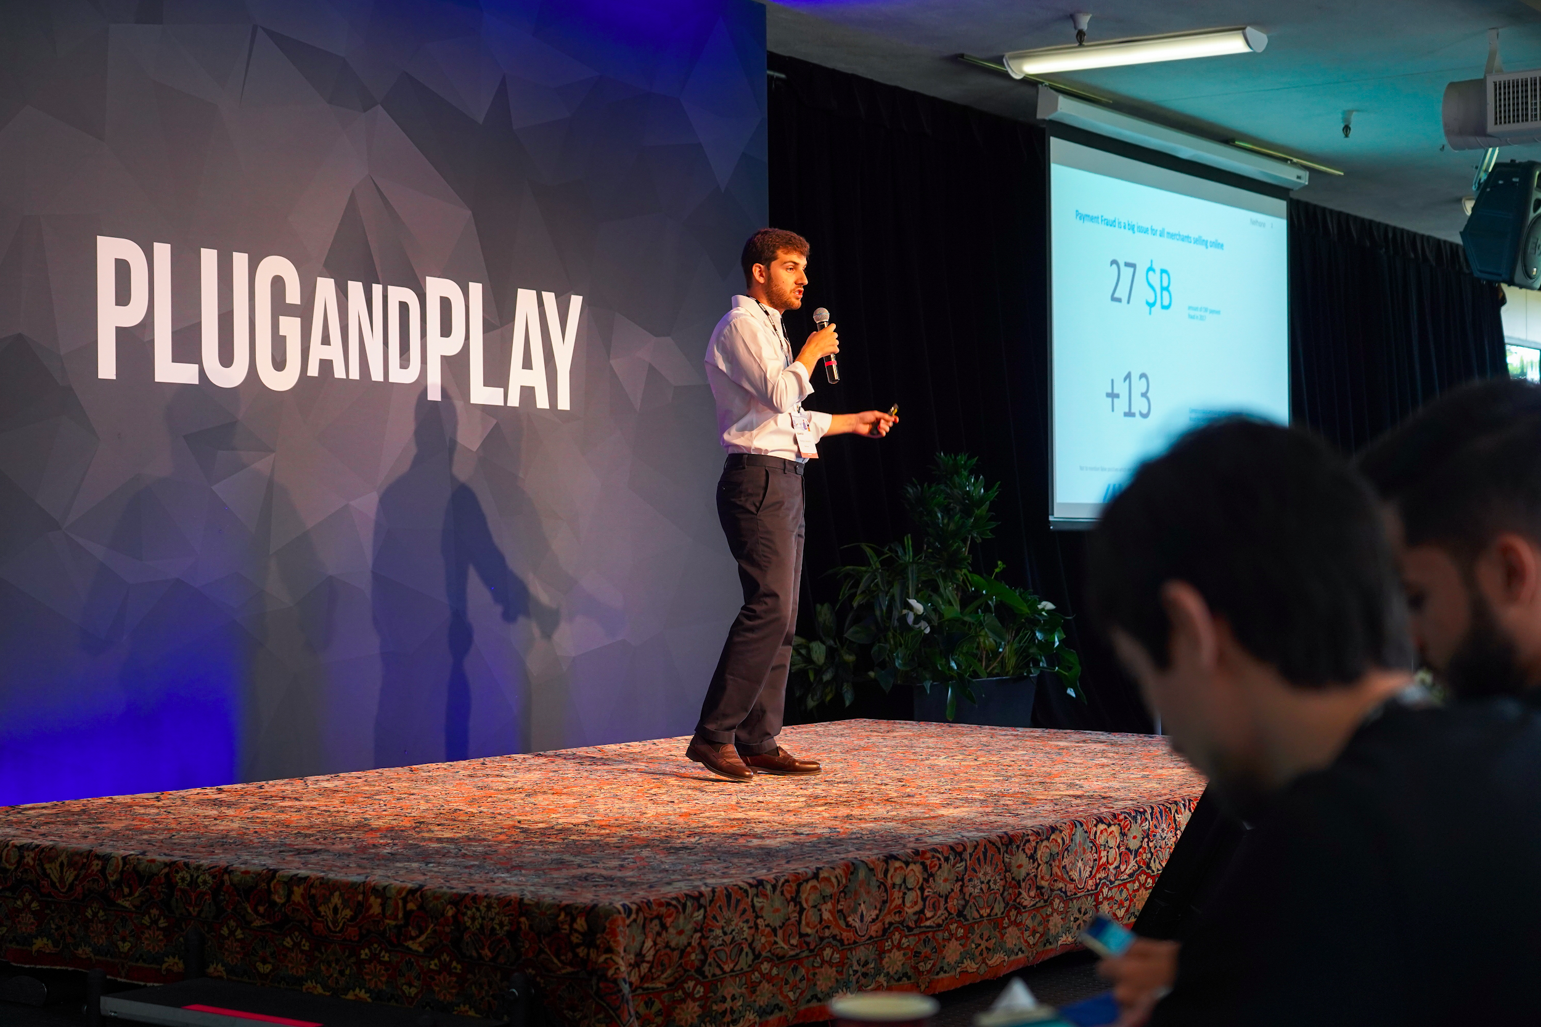

Nethone has developed and thoroughly tested AI fraud prevention models, fully adjusted to the sector that deals with money and selling online. It combines the role of a hub: for financial institutions’ data and over 5000 attributes gathered by the proprietary profiler. It renders precise recommendations for fraud prevention, helps to assess the risk score and segment clients.

“Excited to be part of the Fall 2019 batch selected by Plug and Play! We are anxious to talk and cooperate with financial institutions looking for both innovative solutions to integrate within their organisation and portfolio investments”, comments Hubert Rachwalski, CEO of Nethone. “Participation in the Fintech Program will be another challenge that our company is successfully facing and we look forward to developing new opportunities with our partners. We are gaining momentum and this cooperation will help us grow even faster”.

Plug and Play is the ultimate innovation platform, bringing together the best startups, investors, and the world’s largest corporations. Headquartered in Silicon Valley, it has built accelerator programs, corporate innovation services, and an in-house VC to make technological advancement progress faster than ever before. To give startups the necessary resources to succeed in Silicon Valley and beyond, it is now active in 25 locations globally, including U.S., China, France, Germany, The Netherlands, Singapore, Indonesia, and Mexico.

Nethone has been providing fraud prevention services to the travel, e-commerce, and digital lending industries since 2016. From the start, the Poland-headquartered company has been serving clients all around the world.

About Nethone
Nethone is a global provider of KYU (Know Your User) solutions based on artificial intelligence which helps enterprises transform threats and challenges into accurate, profitable business decisions. Nethone's solutions allow companies to simultaneously protect themselves against losses and increase profits. Such solutions include i.e. top-class security against fraud, real-time tools for adaptive segmentation and customer retention, and behavioral analysis in banking systems to prevent account takeover. More information about the company can be found at nethone.com.

Media contact:
Magdalena Kowalska
Marketing & PR Manager
magdalena.kowalska@nethone.com
+48 502 581 918

